Logical programs links

<https://www.w3resource.com/javascript-exercises/fundamental/index.php>

Design patters, singletone, conteht,

<https://addyosmani.com/resources/essentialjsdesignpatterns/book/>

above is javascript design patterns

<https://www.w3resource.com/javascript-exercises/fundamental/index.php>

<https://www.youtube.com/watch?v=miiM5JJgrQo&list=PLkBfv4fGBau-q9tGBUgVoGClRsSBiiZm8>

<https://medium.com/sonyamoisset/reverse-a-string-in-javascript-a18027b8e91c>

Reverse STRING

|  |
| --- |
| 1.function reverseString(str) { |
|  | return str; |
|  | } |
|  | reverseString("hello"); |

**2.split(), reverse() and join()**

|  |  |
| --- | --- |
|  | function reverseString(str) { |
|  | // Step 1. Use the split() method to return a new array |
|  | var splitString = str.split(""); // var splitString = "hello".split(""); |
|  | // ["h", "e", "l", "l", "o"] |
|  |  |
|  | // Step 2. Use the reverse() method to reverse the new created array |
|  | var reverseArray = splitString.reverse(); // var reverseArray = ["h", "e", "l", "l", "o"].reverse(); |
|  | // ["o", "l", "l", "e", "h"] |
|  |  |
|  | // Step 3. Use the join() method to join all elements of the array into a string |
|  | var joinArray = reverseArray.join(""); // var joinArray = ["o", "l", "l", "e", "h"].join(""); |
|  | // "olleh" |
|  |  |
|  | //Step 4. Return the reversed string |
|  | return joinArray; // "olleh" |
|  | } |
|  |  |
|  | reverseString("hello"); |

3.Chaining the three methods together:

|  |
| --- |
| function reverseString(str) { |
|  | return str.split("").reverse().join(""); |
|  | } |
|  | reverseString("hello"); |

Factorial 5!

<https://www.freecodecamp.org/news/how-to-factorialize-a-number-in-javascript-9263c89a4b38/>

function factorialize(num) {

if (num === 0 || num === 1)

return 1;

for **(var i = num - 1; i >= 1; i--)** {

num *= i;

}

return num;

}

factorialize(5);

function factorialize(num) {

// If num = 0 OR num = 1, the factorial will return 1

if (num === 0 || num === 1)

return 1;

// We start the FOR loop with i = 4

// We decrement i after each iteration

for (var i = num - 1; i >= 1; i--) {

// We store the value of num at each iteration

num = num * i; // or num *= i;

/*

num var i = num - 1 num *= i i-- i >= 1?

1st iteration: 5 4 = 5 - 1 20 = 5 * 4 3 yes

2nd iteration: 20 3 = 4 - 1 60 = 20 * 3 2 yes

3rd iteration: 60 2 = 3 - 1 120 = 60 * 2 1 yes

4th iteration: 120 1 = 2 - 1 120 = 120 * 1 0 no

5th iteration: 120 0 120

End of the FOR loop

*/

}

return num; //120

}

factorialize(5);

……………………………………………………………………X…………………………………

Palindrome

<https://www.freecodecamp.org/news/two-ways-to-check-for-palindromes-in-javascript-64fea8191fd7/>

function palindrome(str) {

return true;

}

palindrome("eye");

function palindrome(str) {

// Step 1. Lowercase the string and use the RegExp to remove unwanted characters from it

var re = /[\W_]/g; // or var re = /[^A-Za-z0-9]/g;

var lowRegStr = str.toLowerCase().replace(re, '');

// str.toLowerCase() = "A man, a plan, a canal. Panama".toLowerCase() = "a man, a plan, a canal. panama"

// str.replace(/[\W_]/g, '') = "a man, a plan, a canal. panama".replace(/[\W_]/g, '') = "amanaplanacanalpanama"

// var lowRegStr = "amanaplanacanalpanama";

// Step 2. Use the same chaining methods with built-in functions from the previous article 'Three Ways to Reverse a String in JavaScript'

var reverseStr = lowRegStr.split('').reverse().join('');

// lowRegStr.split('') = "amanaplanacanalpanama".split('') = ["a", "m", "a", "n", "a", "p", "l", "a", "n", "a", "c", "a", "n", "a", "l", "p", "a", "n", "a", "m", "a"]

// ["a", "m", "a", "n", "a", "p", "l", "a", "n", "a", "c", "a", "n", "a", "l", "p", "a", "n", "a", "m", "a"].reverse() = ["a", "m", "a", "n", "a", "p", "l", "a", "n", "a", "c", "a", "n", "a", "l", "p", "a", "n", "a", "m", "a"]

// ["a", "m", "a", "n", "a", "p", "l", "a", "n", "a", "c", "a", "n", "a", "l", "p", "a", "n", "a", "m", "a"].join('') = "amanaplanacanalpanama"

// So, "amanaplanacanalpanama".split('').reverse().join('') = "amanaplanacanalpanama";

// And, var reverseStr = "amanaplanacanalpanama";

// Step 3. Check if reverseStr is strictly equals to lowRegStr and return a Boolean

return reverseStr === lowRegStr; // "amanaplanacanalpanama" === "amanaplanacanalpanama"? => true

}

palindrome("A man, a plan, a canal. Panama");

#### Without comments:

function palindrome(str) {

var re = /[\W_]/g;

var lowRegStr = str.toLowerCase().replace(re, '');

var reverseStr = lowRegStr.split('').reverse().join('');

return reverseStr === lowRegStr;

}

palindrome("A man, a plan, a canal. Panama");

………………………………………………………………………….X………………………………………….

Swaping of two numbers

var x = 10;

var y = 20;

var tmp = x;// third var

x = y;

y = tmp;

alert("Value of X=" + x + " and value of Y=" + y);

var x = 10;

var y = 20;

[x, y] = [y, x];

alert("Value of X=" + x + " and value of Y=" + y);

Longest word

<https://www.freecodecamp.org/news/three-ways-to-find-the-longest-word-in-a-string-in-javascript-a2fb04c9757c/>

Longest word for loop

function findLongestWord(str) {

var strSplit = str.split(' ');

var longestWord = 0;

for(var i = 0; i < strSplit.length; i++){

if(strSplit[i].length > longestWord){

longestWord = strSplit[i].length;

}

}

return longestWord;

}

findLongestWord("The quick brown fox jumped over the lazy dog");

2.

function findLongestWord(str) {

// Step 1. Split the string into an array of strings

var strSplit = str.split(' ');

// var strSplit = "The quick brown fox jumped over the lazy dog".split(' ');

// var strSplit = ["The", "quick", "brown", "fox", "jumped", "over", "the", "lazy", "dog"];

// Step 2. Sort the elements in the array

var longestWord = strSplit.sort(function(a, b) {

return b.length - a.length;

});

/* Sorting process

a b b.length a.length var longestWord

"The" "quick" 5 3 ["quick", "The"]

"quick" "brown" 5 5 ["quick", "brown", "The"]

"brown" "fox" 3 5 ["quick", "brown", "The", "fox"]

"fox" "jumped" 6 3 ["jumped", quick", "brown", "The", "fox"]

"jumped" "over" 4 6 ["jumped", quick", "brown", "over", "The", "fox"]

"over" "the" 3 4 ["jumped", quick", "brown", "over", "The", "fox", "the"]

"the" "lazy" 4 3 ["jumped", quick", "brown", "over", "lazy", "The", "fox", "the"]

"lazy" "dog" 3 4 ["jumped", quick", "brown", "over", "lazy", "The", "fox", "the", "dog"]

*/

// Step 3. Return the length of the first element of the array

return longestWord[0].length; // var longestWord = ["jumped", "quick", "brown", "over", "lazy", "The", "fox", "the", "dog"];

// longestWord[0]="jumped" => jumped".length => 6

}

findLongestWord("The quick brown fox jumped over the lazy dog");

function findLongestWord(str) {

var longestWord = str.split(' ').sort(function(a, b) { return b.length - a.length; });

return longestWord[0].length;

}

findLongestWord("The quick brown fox jumped over the lazy dog");

……………………………………X………………………………………………………..

Find the largest number

<body>

<p>Click the button to compare numbers and return the highest.</p>

<button onclick="myFunction()">Try it</button>

<p id="demo"></p>

<script>

function myFunction() {

var a = Math.max(5, 10);

var b = Math.max(0, 150, 30, 20, 38);

var c = Math.max(-5, 10);

var d = Math.max(-5, -10);

var e = Math.max(1.5, 2.5);

var x = a + "<br>" + b + "<br>" + c + "<br>" + d + "<br>" + e;

document.getElementById("demo").innerHTML = x;

}

</script>

</body>

</html>

function largestOfFour(mainArray) {

// Step 1. Map over the main arrays

return mainArray.map(function(subArray) { // Step 3. Return the largest numbers of each sub-arrays => returns [5,27,39,1001]

// Step 2. Return the largest numbers for each sub-arrays with Math.max() method

return Math.max.apply(null, subArray);

});

}

largestOfFour([[4, 5, 1, 3], [13, 27, 18, 26], [32, 35, 37, 39], [1000, 1001, 857, 1]]);

function largestOfFour(mainArray) {

return mainArray.map(function(subArray) {

return Math.max.apply(null, subArray);

});

}

largestOfFour([[4, 5, 1, 3], [13, 27, 18, 26], [32, 35, 37, 39], [1000, 1001, 857, 1]]);

* Secong largest simply by sort
* <script>
* var numbers = [1, 5, 12, 3, 7, 15, 9];
* // Sorting the numbers array simply using the sort method
* numbers.sort(); // Sorts numbers array
* alert(numbers); // Outputs: 1,12,15,3,5,7,9
* /* Sorting the numbers array numerically in ascending order
* using the sort method and a compare function */
* numbers.sort(function(a, b){
* return a - b;
* });
* alert(numbers); // Outputs: 1,3,5,7,9,12,15
* </script>

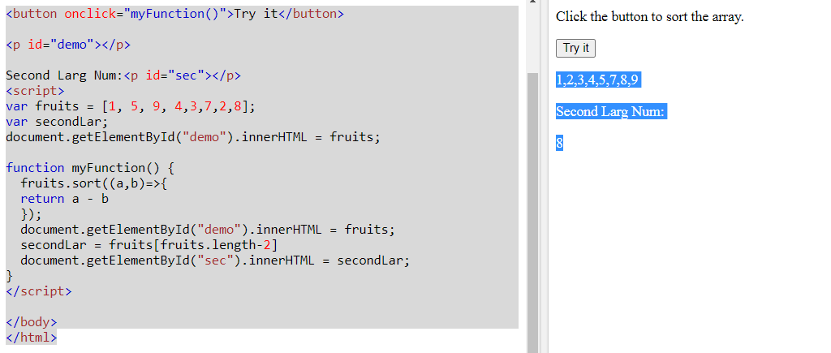

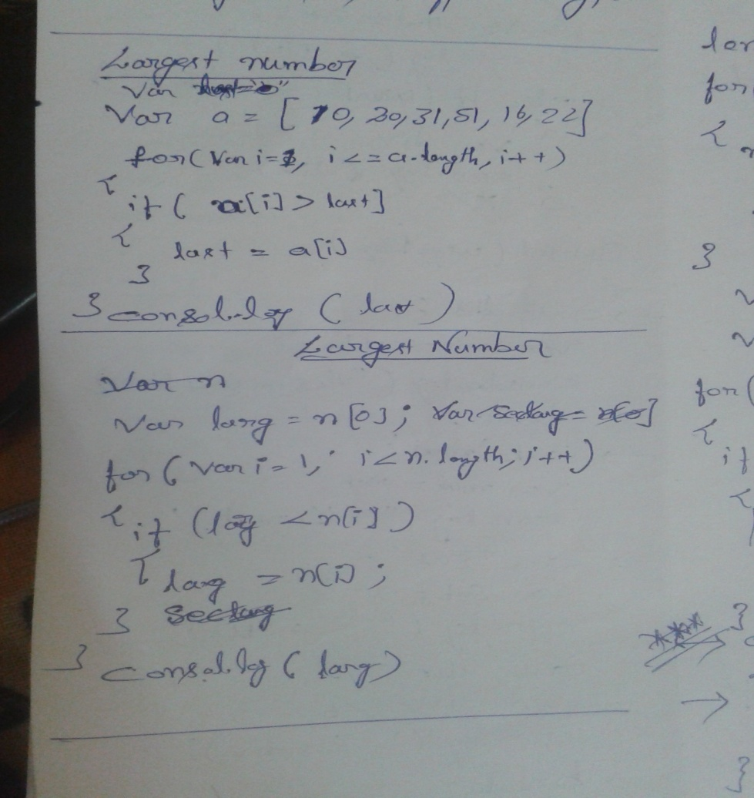

2nd lagest number

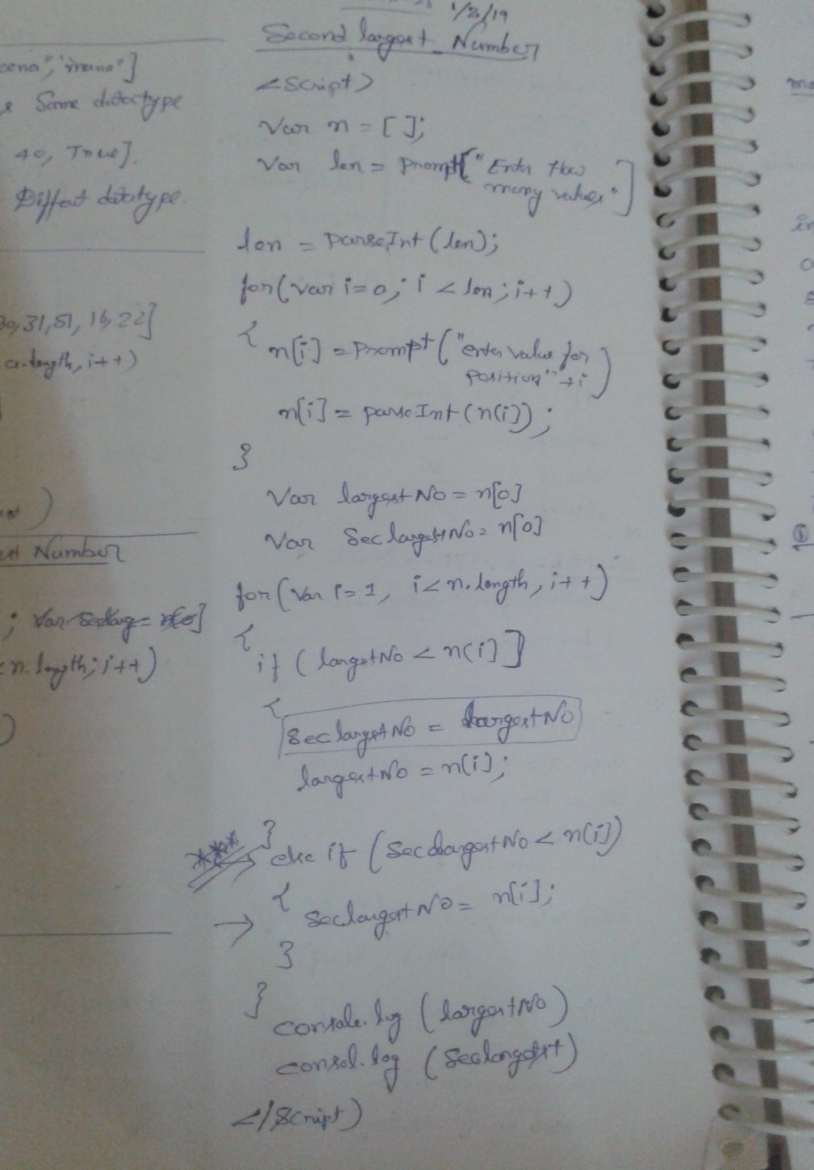

Check idea

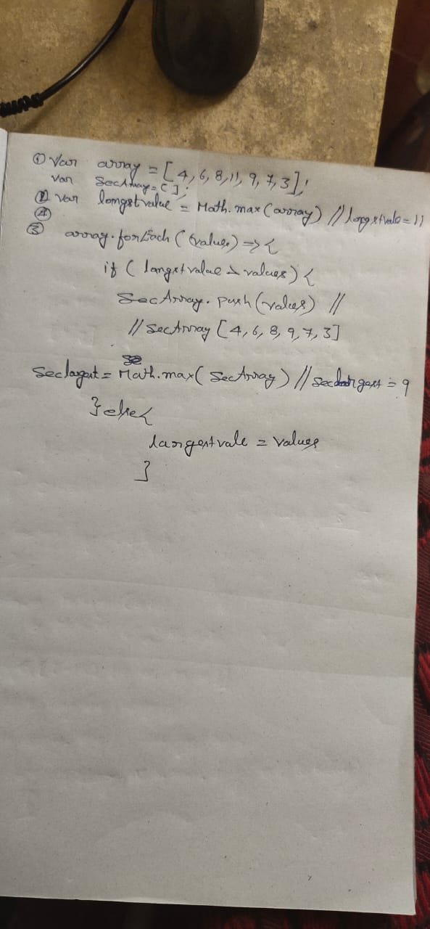

………………………………………………………………………..X………………………………………………..

**Create Elements:**

* Using Java Script, we can create elements dynamically.
* For that we are using createElement() method, which is available in document object

***Create div tag with Hello world content:***

* create empty div tag.
* var divEle = document.**createElement**('div');
* Result: <div></div>
* prepare content.
* var content=document.**createTextNode**('Hello world');
* Result: Hello world
* append this content into div.
* divEle**.append**(content);
* Now divEle is look like <div>Hello world</div>

***Ex:***

<!DOCTYPE html>

<html>

<head>

<script>

function fnCreateElement() {

var ele = document.createElement('div');

var content = document.createTextNode('hello...');

ele.append(content);

//Add above div tag under body

var bodyRef=document.querySelector('body');

bodyRef.appendChild(ele);

}

</script>

</head>

<body>

<input type="button" value="create element" onclick="fnCreateElement()" />

</body>

</html>

…………………………………………………………………………………………………………X

Repeat the string

<https://www.freecodecamp.org/news/three-ways-to-repeat-a-string-in-javascript-2a9053b93a2d/>

function repeatStringNumTimes(string, times) {

var repeatedString = "";

while (times > 0) {

repeatedString += string;

times--;

}

return repeatedString;

}

repeatStringNumTimes("abc", 3);

also

function repeatStringNumTimes(string, times) {

//Step 1. If times is positive, return the repeated string

if (times > 0) { // (3 > 0) => true

return string.repeat(times); // return "abc".repeat(3); => return "abcabcabc";

}

//Step 2. Else if times is negative, return an empty string if true

else {

return "";

}

}

repeatStringNumTimes("abc", 3);

And again, without comments:

function repeatStringNumTimes(string, times) {

if (times > 0)

return string.repeat(times);

else

return "";

}

repeatStringNumTimes("abc", 3);

You can use a **ternary operator** as a shortcut for the if/else statement, like this:

**times > 0 ? string.repeat(times) : "";**

This can be read as:

if (times > 0) {

return string.repeat(times);

} else {

return "";

}

Remove duplicate from an array

<https://www.tutorialrepublic.com/faq/how-to-remove-duplicate-values-from-a-javascript-array.php>

* <script>
* // Defining function to get unique values from an array
* function getUnique(array){
* var uniqueArray = [];
* // Loop through array values
* for(i=0; i < array.length; i++){
* if(uniqueArray.indexOf(array[i]) === -1) {
* uniqueArray.push(array[i]);
* }
* }
* return uniqueArray;
* }
* var names = ["John", "Peter", "Clark", "Harry", "John", "Alice"];
* var uniqueNames = getUnique(names);
* console.log(uniqueNames); // Prints: ["John", "Peter", "Clark", "Harry", "Alice"]
* </script>

Remove dublicates by **Spread operator**

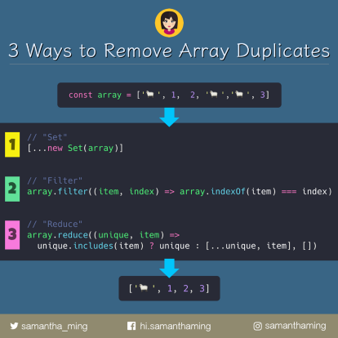

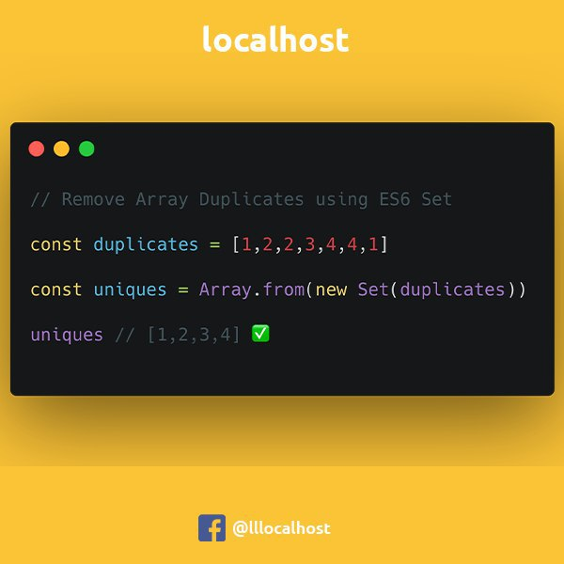

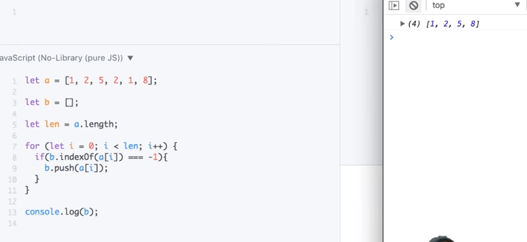

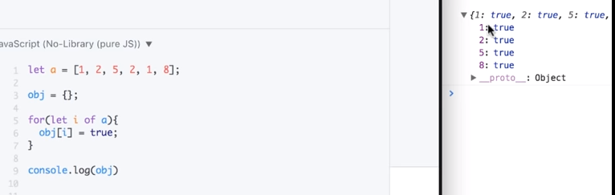

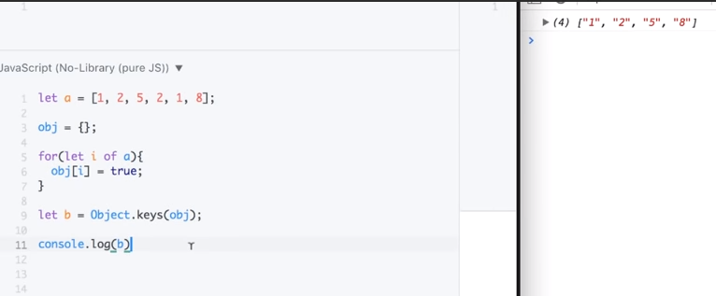

ES-2016

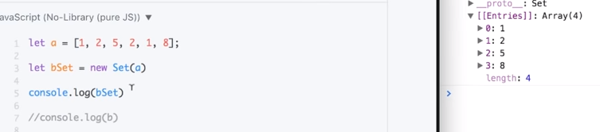

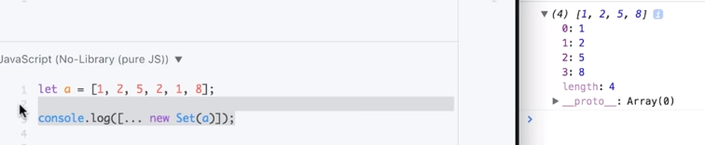

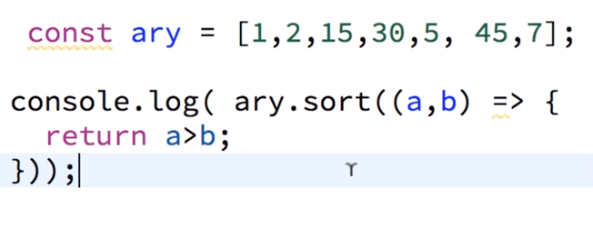

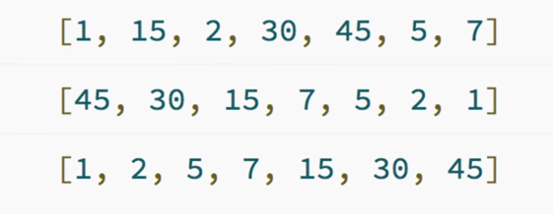

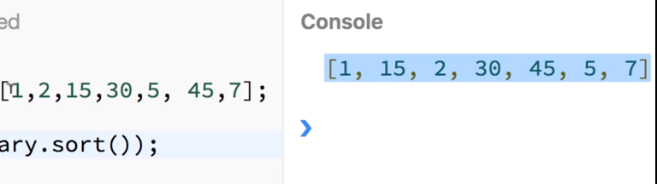

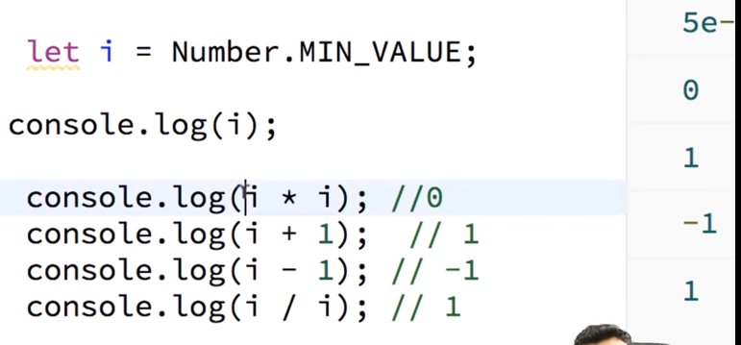

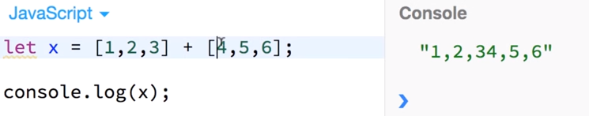

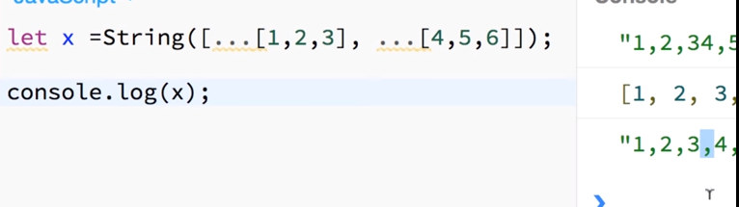

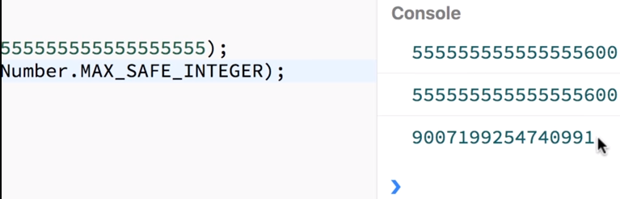

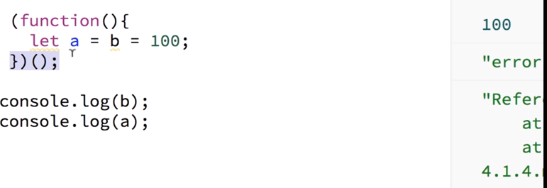

……………………………………………………………………………………………………………………

**Reverse a string without reverse() method**

var str="kiran"

var strArr=str.split();

strArr

["kiran"]

var strArr=str.split("");

strArr

(5) ["k", "i", "r", "a", "n"]

var b=[]

undefined

strArr.forEach((value,index)=>{

b.unshift(value);// adding values from front

})

undefined

b

(5) ["n", "a", "r", "i", "k"]

b.join("")

"narik"

……………………………………………………………………………………………………………………..

Even Numbers in an Array

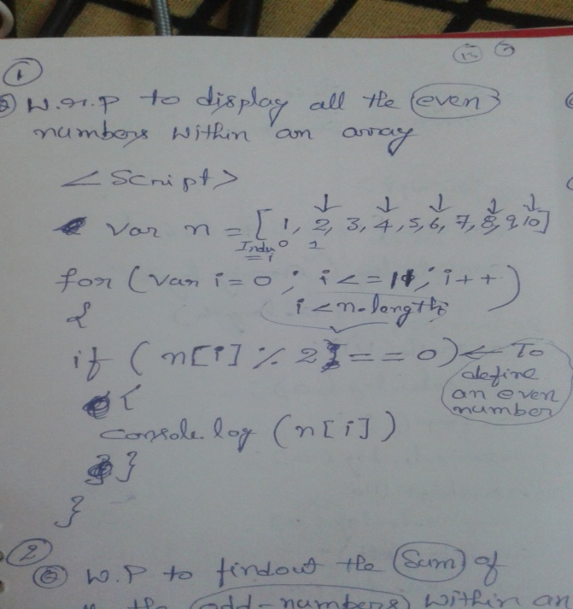

Sum of odd numbers

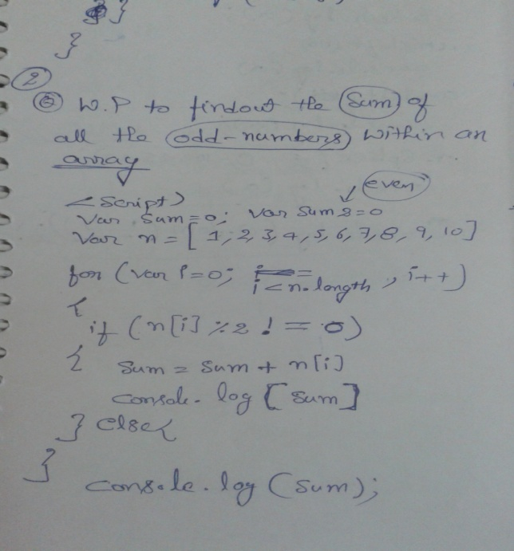

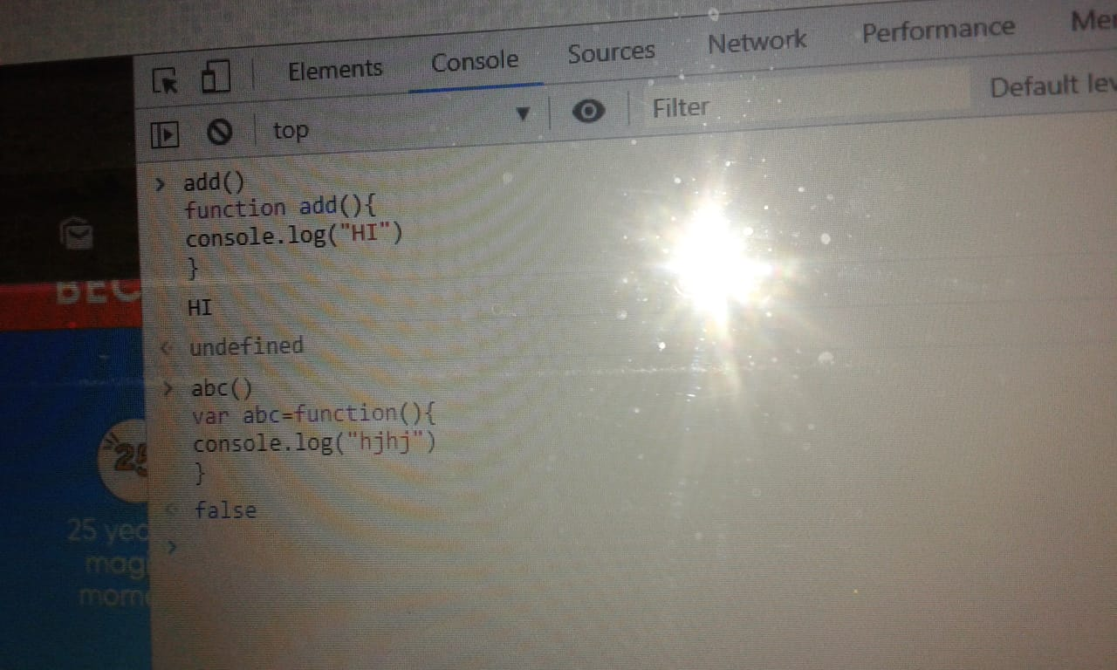

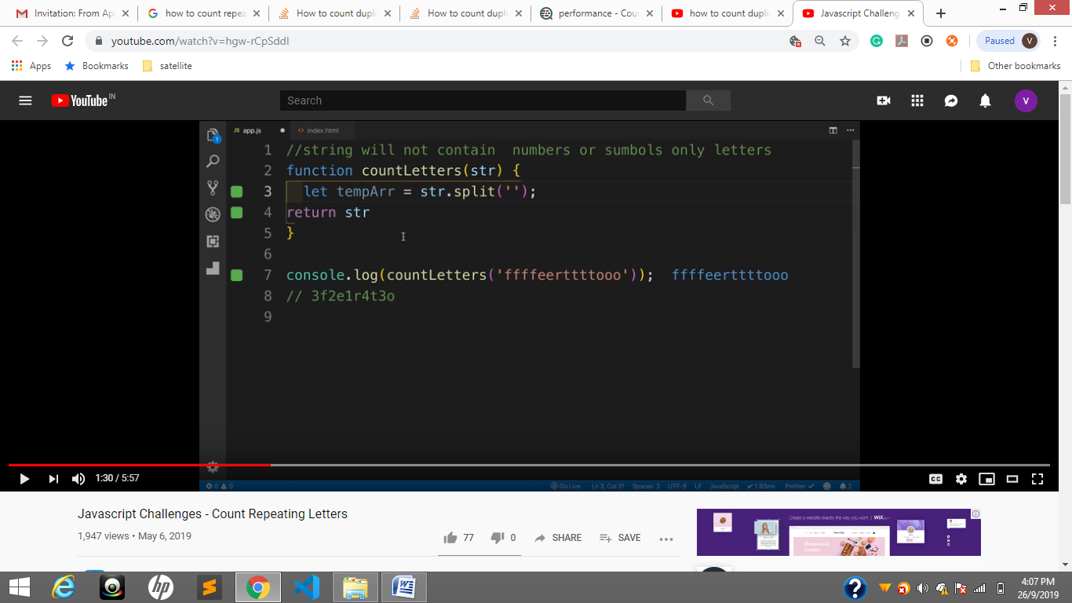

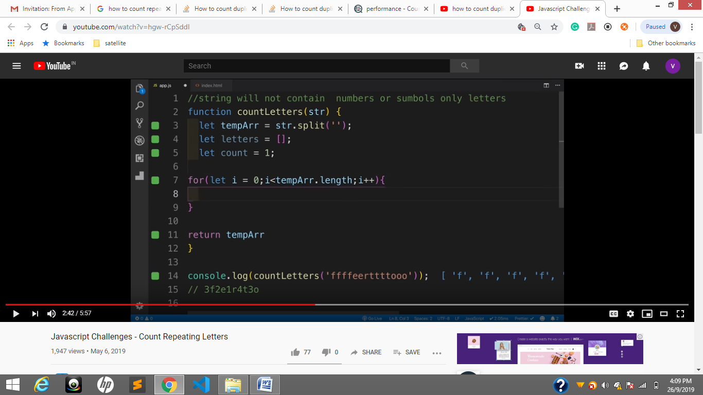

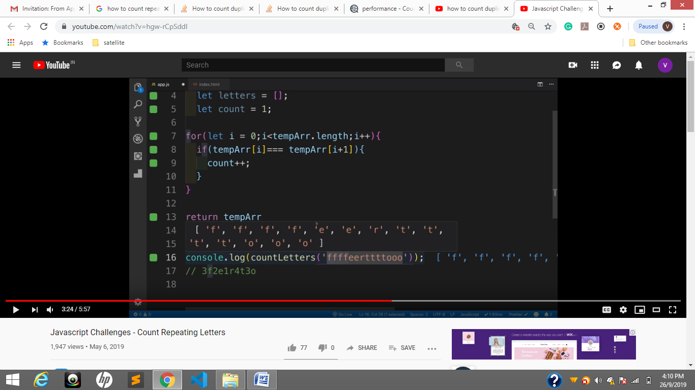

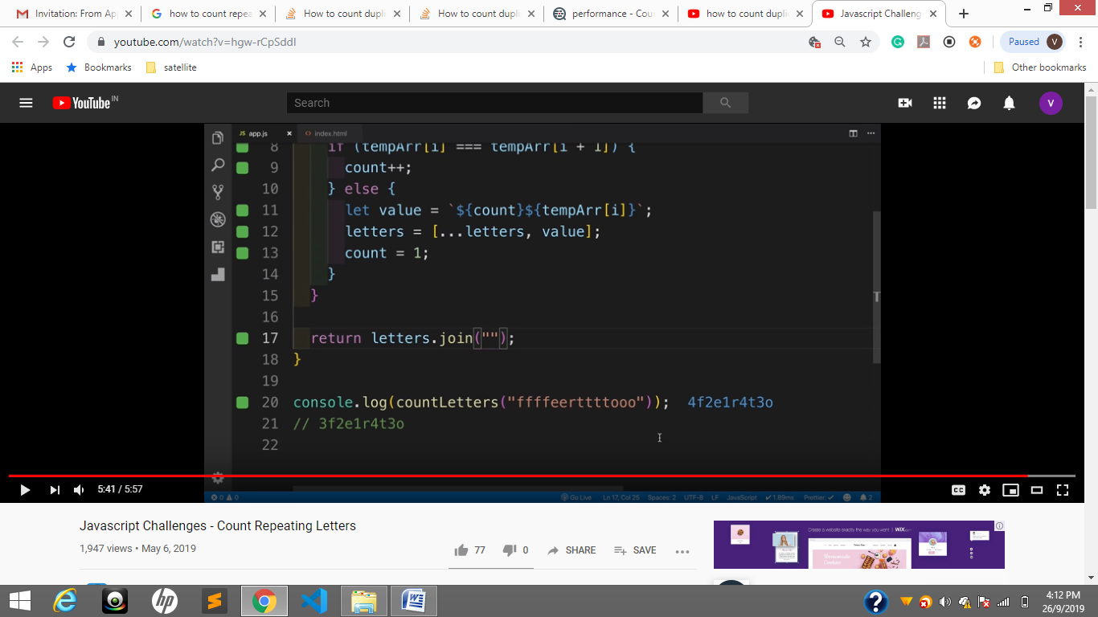

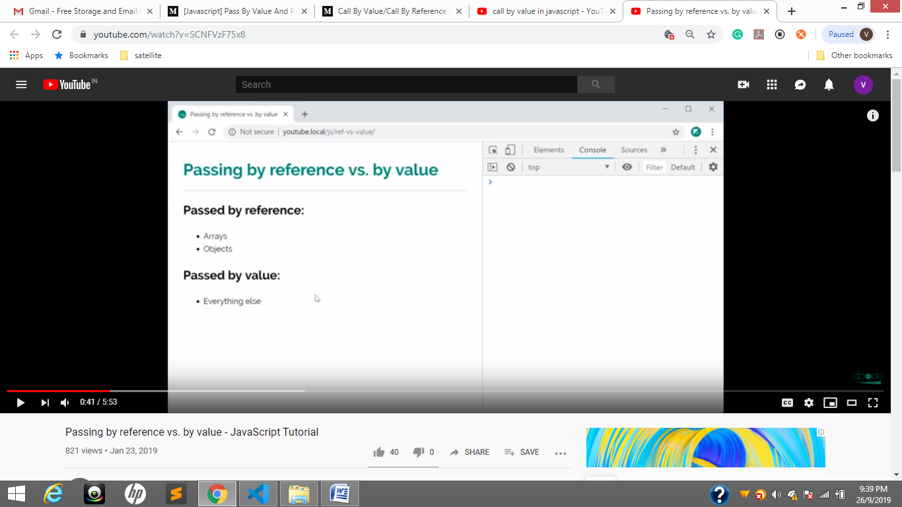

Pass by value will copy of data string, numbers

Pass by Reference does not copy data ;;;even if you pass value it refer to data

Objects and arrays are passed by references

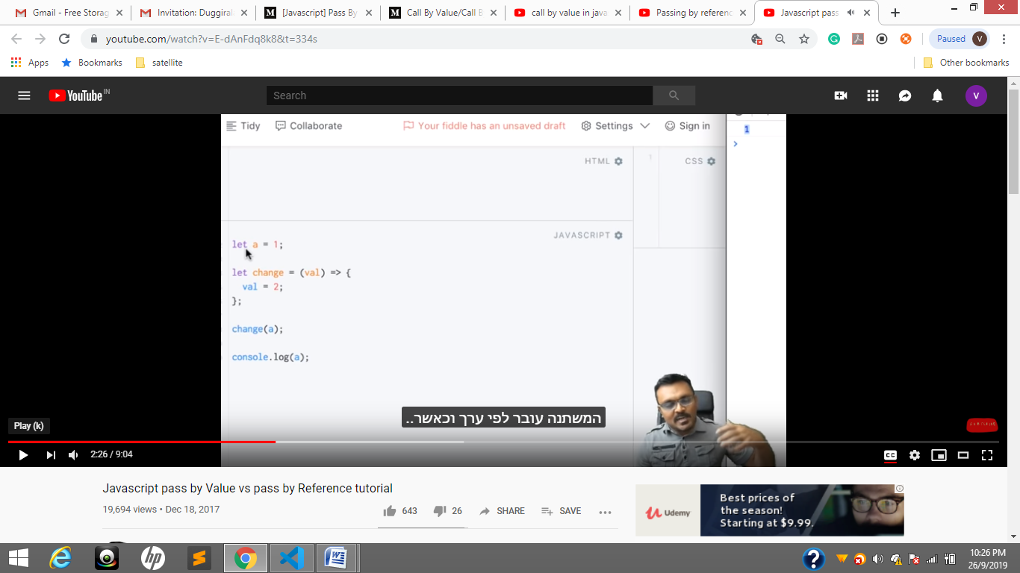

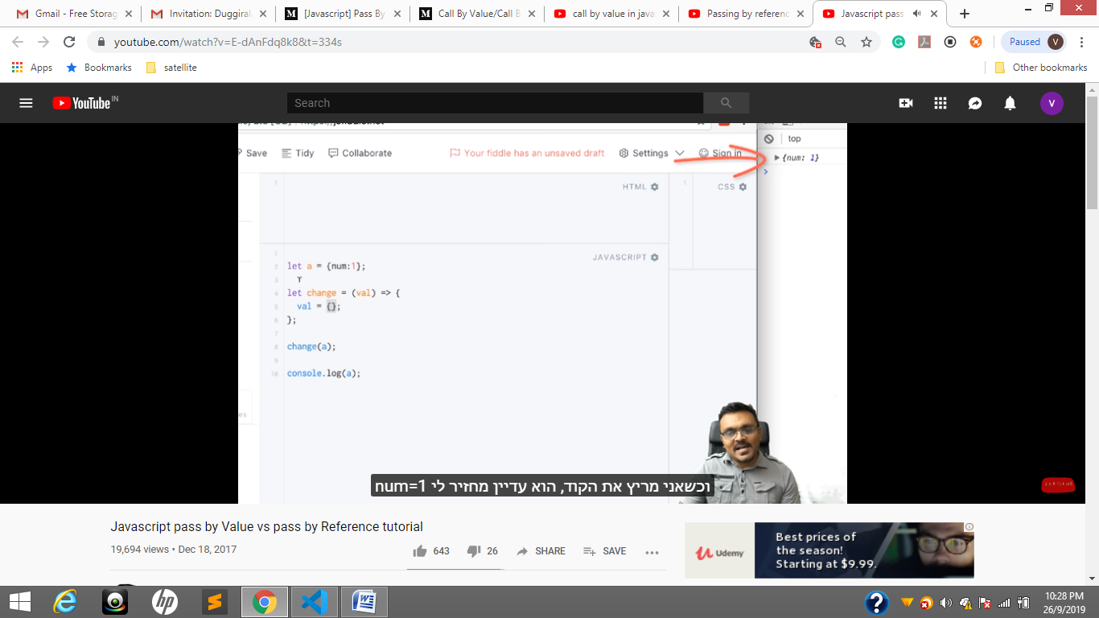

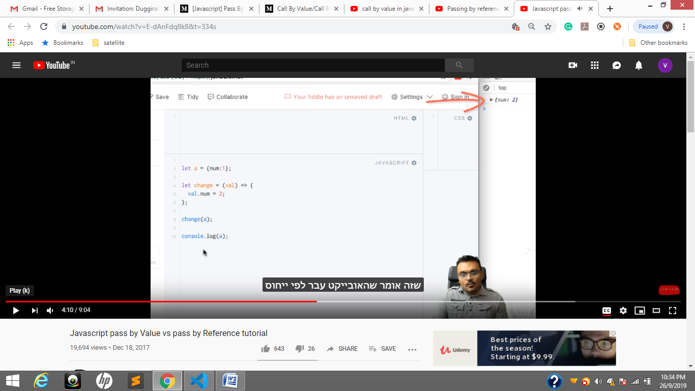

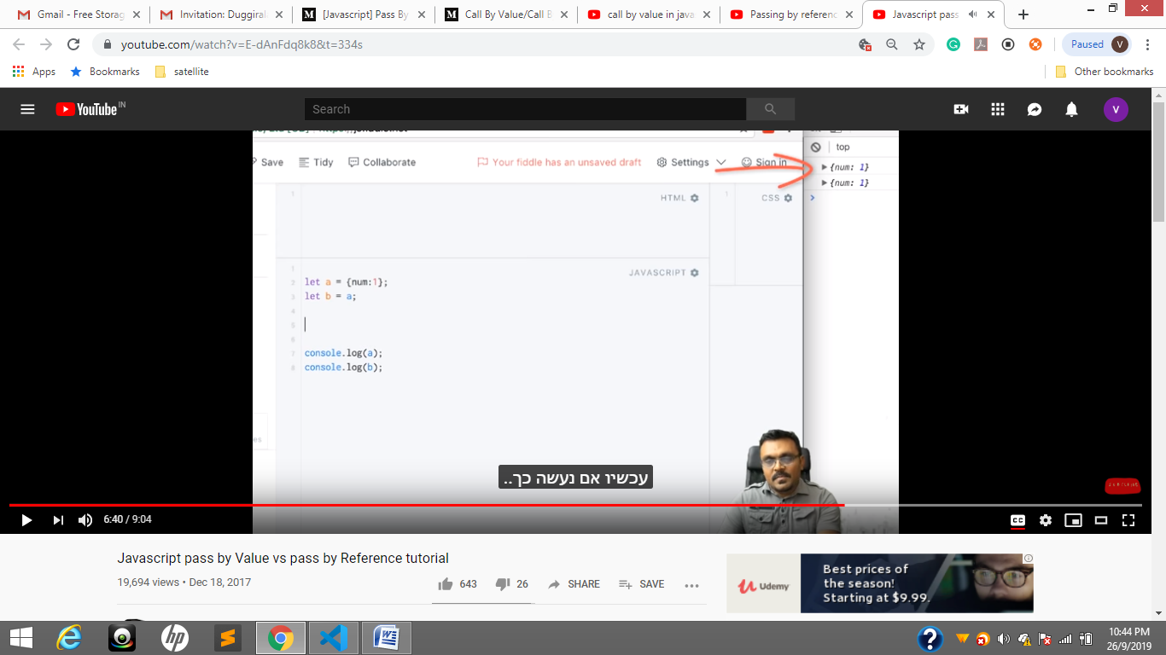

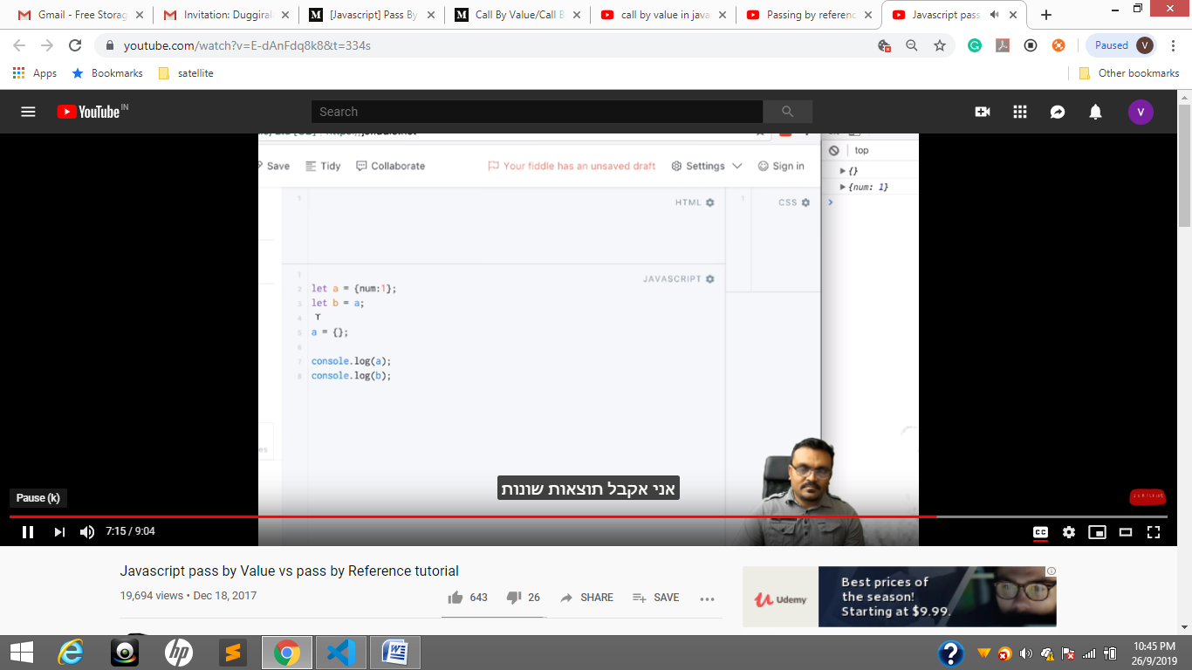

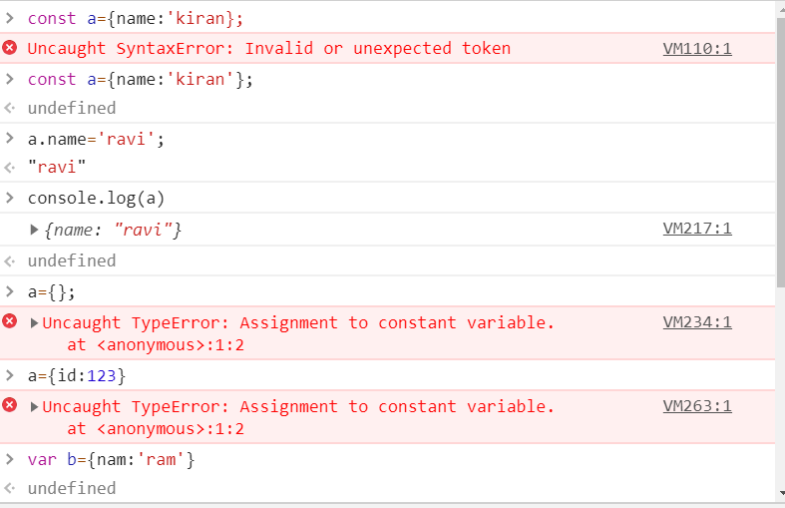

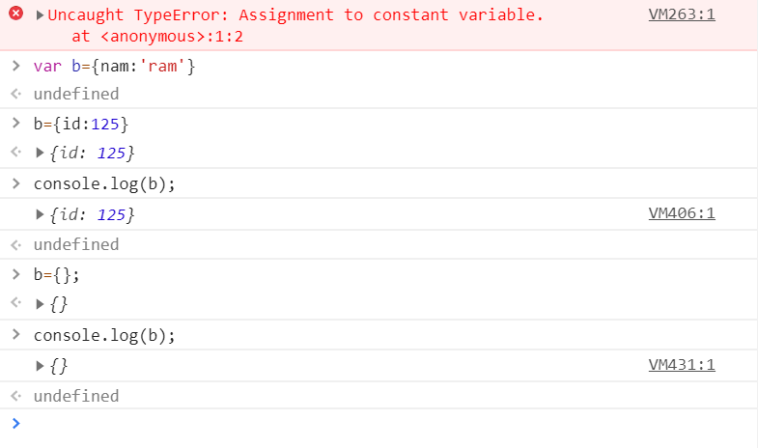

***Let hi; // undefined -- value declared but not assigned***

***Let hello = null; //null -- value declared and assigned ---- hello value Is =null***

***Null’ in JavaScript***

‘Null’ is a keyword in JavaScript that signifies ‘no value’ or nonexistence of any value. If you wish to shred a variable off its assigned value, you can simply assign ‘null’ to it. Besides this, like any other object, it is never implicitly assigned to a variable by JavaScript.  
An example of explicit null assignment is –

|  |  |
| --- | --- |
| 1  2 | var some_item= null;  console.log(some_item) |

Upon execution, the code will print null.

‘***Undefined’ in JavaScript***

‘Undefined’ is a global variable that JavaScript creates at run time. This global variable is assigned to an object in one of the following cases –

1. Declared but not defined –  
JavaScript assigns ‘undefined’ to any object that has been declared but not initialized or defined. In other words, in a case where no value has been explicitly assigned to the variable, JavaScript calls it ‘undefined’.

2. Array index or object property that does not exist.

3. A function parameter that has not been supplied.

4. The return value of functions that have to but don’t return a value.

An illustration of this assignment is shown in the following –

|  |  |
| --- | --- |
| 1  2 | var item;  console.log(item) |

Upon execution, the code will print undefined.

***Difference in Type –***

‘Null’ is an object with a valid value, no properties, is non-mutable, and only a single instance of the same exists in the system at all times. In case you wish to verify the object nature of ‘null’, you can use the ‘typeof’ operator. The use of the same will give the output as ‘object’. However, if you use the ‘typeof’ operator on an object that belongs to one of the points mentioned in the ‘undefined’ list, you will get the object type as ‘undefined’.

***Conversion to Primitive Types –***

A major difference between ‘null’ and ‘undefined’ is in the way they are converted to primitive types. When you perform arithmetic conversion on ‘**null’, the value determined is 0**. This conversion can be verified using the following code snippet.

|  |  |
| --- | --- |
| 1  2 | var v1= 5+ null;  console.log(v1) |

Upon execution, this output of this code will print 5.  
However, ‘undefined’ does not carry out any such conversion. If you try to add ‘undefined’ to a numeral, you will get NaN or Not-a-Number. The following code snippet illustrates this facet of ‘undefined’.

|  |  |
| --- | --- |
| 1  2 | var v2= 5+ undefined;  console.log(v2) |

Upon execution, the code will print NaN.

var express = require('express');

var router = express.Router();

var mongodb = require('mongodb');

//var bodyparser=require('body-parser');

var url = 'mongodb://localhost:27017';

router.post("/login-details",function(req,res){

    //query

    var uid=req.body.uid;

    var pwd=req.body.pwd;

 var dataObj={

     "uid":uid,

     "pwd":pwd,

 }

    //upto here query ends

 var mongoClient=mongodb.MongoClient;

 //connection

 mongoClient.connect(url,{useNewUrlParser: true}, function(error, client){

     if(error){

         res.send("db connection error")

     }

 // database and collection names

 var db = client.db("shopping");

 var collection=db.collection("products");

 //now insert

     collection.findOne(dataObj,function(error,response){

        if(error){

            res.send({"login":"fail"});

        }else{

            res.send(response);

            console.log("login sucessfully")

        }

     })

    })

 })

module.exports = router;

### What is Node.js? Where can you use it?

Node.js is server-side scripting based on Google’s V8 JavaScript engine. It is used to build scalable programs, especially web applications that are computationally simple but are frequently accessed.  
  
You can use [Node.js in developing](https://www.simplilearn.com/developing-java-and-node-js-application-with-mongodb-tutorial-video) I/O intensive web applications like video streaming sites. You can also use it for developing: Real-time web applications, Network applications, General-purpose applications, and Distributed systems.

### Why use Node.js?

Node.js makes building scalable network programs easy. Some of its advantages include:

* + It is generally fast
  + It almost never blocks
  + It offers a unified programming language and data type
  + Everything is asynchronous
  + It yields great concurrency

### What are the features of Node.js?

Node.js is a single-threaded but highly scalable system that utilizes JavaScript as its scripting language. It uses asynchronous, event-driven I/O instead of separate processes or threads. It can achieve high output via single-threaded event loop and non-blocking I/O.

### How else can the JavaScript code below be written using Node.Js to produce the same output?

console.log("first");  
setTimeout(function() {  
    console.log("second");  
}, 0);  
console.log("third");

**Output:**

first  
third  
second

In Node.js version 0.10 or higher, setImmediate(fn) will be used in place of setTimeout(fn,0) since it is faster. As such, the code can be written as follows:

console.log("first");  
setImmediate(function(){  
    console.log("second");  
});  
console.log("third");

### How do you update NPM to a new version in Node.js?

You use the following commands to update NPM to a new version:  
  
$ sudo npm install npm -g  
/usr/bin/npm -> /usr/lib/node_modules/npm/bin/npm-cli.js  
npm@2.7.1 /usr/lib/node_modules/npm

### Why is Node.js Single-threaded?

Node.js is single-threaded for async processing. By doing async processing on a single-thread under typical web loads, more performance and scalability can be achieved as opposed to the typical thread-based implementation.

### Explain callback in Node.js.

A callback function is called after a given task. It allows other code to be run in the meantime and prevents any blocking.  Being an asynchronous platform, Node.js heavily relies on callback. All APIs of Node are written to support callbacks.

### What is callback hell in Node.js?

Callback hell is the result of heavily nested callbacks that make the code not only unreadable but also difficult to maintain. For example:  
  
query("SELECT clientId FROM clients WHERE clientName='picanteverde';", function(id){  
  query("SELECT * FROM transactions WHERE clientId=" + id, function(transactions){  
    transactions.each(function(transac){  
      query("UPDATE transactions SET value = " + (transac.value*0.1) + " WHERE id=" + transac.id, function(error){  
        if(!error){  
          console.log("success!!");  
        }else{  
          console.log("error");  
        }  
      });  
    });  
  });  
});

### How do you prevent/fix callback hell?

The three ways to prevent/fix callback hell are:

* + Handle every single error
  + Keep your code shallow
  + Modularize – split the callbacks into smaller, independent functions that can be called with some parameters then joining them to achieve desired results.

The first level of improving the code above might be:

var logError = function(error){  
    if(!error){  
      console.log("success!!");  
    }else{  
      console.log("error");  
    }  
  },  
  updateTransaction = function(t){  
    query("UPDATE transactions SET value = " + (t.value*0.1) + " WHERE id=" + t.id, logError);  
  },  
  handleTransactions = function(transactions){  
    transactions.each(updateTransaction);  
  },  
  handleClient = function(id){  
    query("SELECT * FROM transactions WHERE clientId=" + id, handleTransactions);  
  };

query("SELECT clientId FROM clients WHERE clientName='picanteverde';",handleClient);

You can also use Promises, Generators and Async functions to fix callback hell.

### Explain the role of REPL in Node.js.

As the name suggests, REPL (Read Eval Print Loop) performs the tasks of – Read, Evaluate, Print and Loop. The REPL in Node.js is used to execute ad-hoc Javascript statements. The REPL shell allows entry to javascript directly into a shell prompt and evaluates the results. For the purpose of testing, debugging, or experimenting, REPL is very critical.

### Name the types of API functions in Node.js.

There are two types of functions in Node.js.:

* + **Blocking functions** - In a blocking operation, all other code is blocked from executing until an I/O event that is being waited on occurs. Blocking functions execute synchronously.

For example:  
const fs = require('fs');  
const data = fs.readFileSync('/file.md'); // blocks here until file is read  
console.log(data);  
// moreWork(); will run after console.log  
  
The second line of code blocks the execution of additional JavaScript until the entire file is read. moreWork () will only be called after Console.log

* + **Non-blocking functions** - In a non-blocking operation, multiple I/O calls can be performed without the execution of the program being halted. Non-blocking functions execute asynchronously.

For example:

const fs = require('fs');  
fs.readFile('/file.md', (err, data) => {  
  if (err) throw err;  
  console.log(data);  
});  
// moreWork(); will run before console.log

Since fs.readFile () is non-blocking, moreWork () does not have to wait for the file read to complete before being called. This allows for higher throughput.

### Which is the first argument typically passed to a Node.js callback handler?

Typically, the first argument to any callback handler is an optional error object. The argument is null or undefined if there is no error.

Error handling by a typical callback handler could be as follows:

function callback(err, results) {  
    // usually we'll check for the error before handling results  
    if(err) {  
        // handle error somehow and return  
    }  
    // no error, perform standard callback handling  
}

### What are the functionalities of NPM in Node.js?

NPM (Node Package Manager) provides two functionalities:

* + An online repository for Node.js packages.
  + Command-line utility for installing packages, version management and dependency management of Node.js packages.

### What is the difference between Node.js and Ajax?

Node.js and Ajax (Asynchronous JavaScript and XML) are the advanced implementations of JavaScript. They all serve entirely different purposes.

Ajax is primarily designed for dynamically updating a particular section of a page’s content, without having to update the entire page.

Node.js is used for developing client-server applications.

### Explain chaining in Node.js.

Chaining is a mechanism whereby the output of one stream is connected to another stream creating a chain of multiple stream operations.

### What are “streams” in Node.js? Explain the different types of streams present in Node.js.

Streams are objects that allow the reading of data from the source and writing of data to the destination as a continuous process.  
  
There are four types of streams.

* + <Readable> to facilitate the reading operation.
  + <Writable> to facilitate the writing operation.
  + <Duplex> to facilitate both read and write operations.
  + <Transform> is a form of Duplex stream that performs computations based on the available input.

### What are the exit codes in Node.js? List some exit codes.

Exit codes are specific codes that are used to end a “process” (a global object used to represent a node process).  
  
Examples of exit codes include:

* + Unused
  + Uncaught Fatal Exception
  + Fatal Error
  + Non-function Internal Exception Handler
  + Internal Exception handler Run-Time Failure
  + Internal JavaScript Evaluation Failure

### What are Globals in Node.js?

Three keywords in Node.js constitute as Globals. These are:

* + **Global** – it represents the Global namespace object and acts as a container for all other <global> objects.
  + **Process** – It is one of the global objects but can turn asynchronous function into an async callback. It can be accessed from anywhere in the code, and it primarily gives back information about the application or the environment.
  + **Buffer** – it is a class in Node.js to handle binary data.

### What is the difference between AngularJS and Node.js?

Angular.JS is a web application development framework, while Node.js is a runtime system.

### Why is consistent style important, and what tools can be used to assure it?

Consistent style helps team members modify projects easily without having to get used to a new style every time. Tools that can help include Standard and ESLint.

Expressjs

<https://www.educba.com/express-js-interview-questions/>

var array = [2, 9, 9];

print(array.indexOf(2));

Output:

0

var array=["Sachin","Dravid","Kohli"];

array.sort()

Result:['Dravid','Kohli','Sachin']

var array=[1,10,11,2,22,3,5]; array.sort()

Result:[1,10,11,2,22,3,5] //wrong out put

array.sort(function(value1,value2)

return value1-value2

})

Result:[1,2,3,5,10,11,22]

Var a=10:

Aa=10;

Here, greeter is globally scoped because it exists outside a function while hello is function scoped. So we cannot access the variable hello outside of a function. So if we do this:

var tester = "hey hi";

function newFunction() {

var hello = "hello";

}

console.log(hello); // error: hello is not defined

<!DOCTYPE html>

<html>

<body>

<h2>Create JSON string from a JavaScript object.</h2>

<p id="demo"></p>

<script>

var obj = { name: "John", age: 30, city: "New York" };

var myJSON = JSON.stringify(obj);

document.getElementById("demo").innerHTML = myJSON;

</script>

</body>

</html>

{"name":"John","age":30,"city":"New York"} INTO STRING

Json.parse is opposite it remo

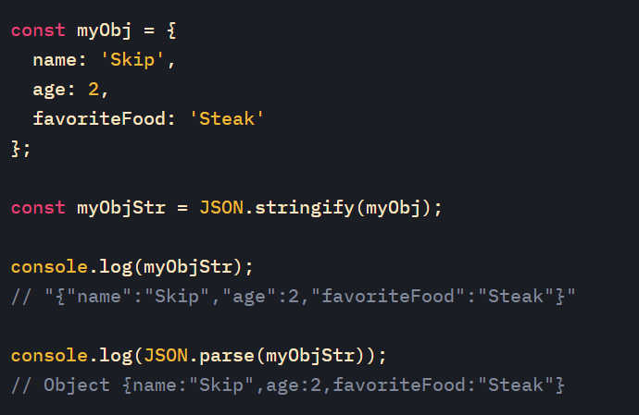

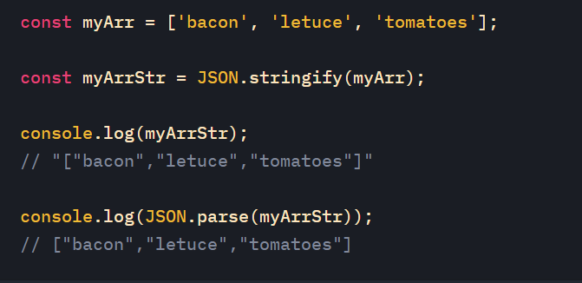

## Not Allowed in Strict Mode

Using a variable, without declaring it, is not allowed:

"use strict";  
x = 3.14;                // This will cause an error

[Try it Yourself »](https://www.w3schools.com/js/tryit.asp?filename=tryjs_strict_variable)

Objects are variables too.

Using an object, without declaring it, is not allowed:

"use strict";  
x = {p1:10, p2:20};      // This will cause an error

[Try it Yourself »](https://www.w3schools.com/js/tryit.asp?filename=tryjs_strict_object)

Deleting a variable (or object) is not allowed.

"use strict";  
var x = 3.14;  
delete x;                // This will cause an error

[Try it Yourself »](https://www.w3schools.com/js/tryit.asp?filename=tryjs_strict_delete)

Deleting a function is not allowed.

"use strict";  
function x(p1, p2) {};  
delete x;                // This will cause an error

## Future Proof!

Keywords reserved for future JavaScript versions can NOT be used as variable names in strict mode.

These are:

* implements
* interface
* let
* package
* private
* protected
* public
* static
* yield

## Why Strict Mode?

Strict mode makes it easier to write "secure" JavaScript.

Strict mode changes previously accepted "bad syntax" into real errors.

As an example, in normal JavaScript, mistyping a variable name creates a new global variable. In strict mode, this will throw an error, making it impossible to accidentally create a global variable.

In normal JavaScript, a developer will not receive any error feedback assigning values to non-writable properties.

In strict mode, any assignment to a non-writable property, a getter-only property, a non-existing property, a non-existing variable, or a non-existing object, will throw an error.

 quote some interesting parts:

Strict Mode is a new feature in ECMAScript 5 that allows you to place a program, or a function, in a "strict" operating context. This strict context prevents certain actions from being taken and throws more exceptions.

And:

Strict mode helps out in a couple ways:

* It catches some common coding bloopers, throwing exceptions.
* It prevents, or throws errors, when relatively "unsafe" actions are taken (such as gaining access to the global object).
* It disables features that are confusing or poorly thought out.

Also note you can apply "strict mode" to the whole file... Or you can use it only for a specific function *(still quoting from John Resig's article)*:

// Non-strict code...

(function(){

"use strict";

// Define your library strictly...

})();

// Non-strict code...

Just add "use strict"; at the top of your code, before anything else.

For example, blah = 33; is valid JavaScript. It means you create a completely global variable blah.

But in strict mode its an error because you did not use the keyword "var" to declare the variable.

Most of the time you don't mean to create global variables in the middle of some arbitrary scope, so most of the time that blah = 33 is written it is an error and the programmer didn't actually want it to be a global variable, they meant to write var blah = 33.

It similarly disallows a lot of things that are technically valid to do. NaN = "lol" does not produce an error. It also doesn't change the value of NaN. using strict this (and similar weird statements) produce errors. Most people appreciate this because there is no reason to ever write NaN = "lol", so there was most likely a typo.

Partial pages are [www.cricbuzz.com](http://www.cricbuzz.com)

Like Menu will be remains same But

Content, whether report, this will be keep on updated.

<https://www.studentprojectguide.com/php/online-shopping-system/>

web packs;

[https://webpack.js.org](https://webpack.js.org/)

<https://webpack.js.org/concepts/>

what is express

routing

router mentods

how to chwck url works

tokenigation

afectedrows>=1, insertedrows>=1

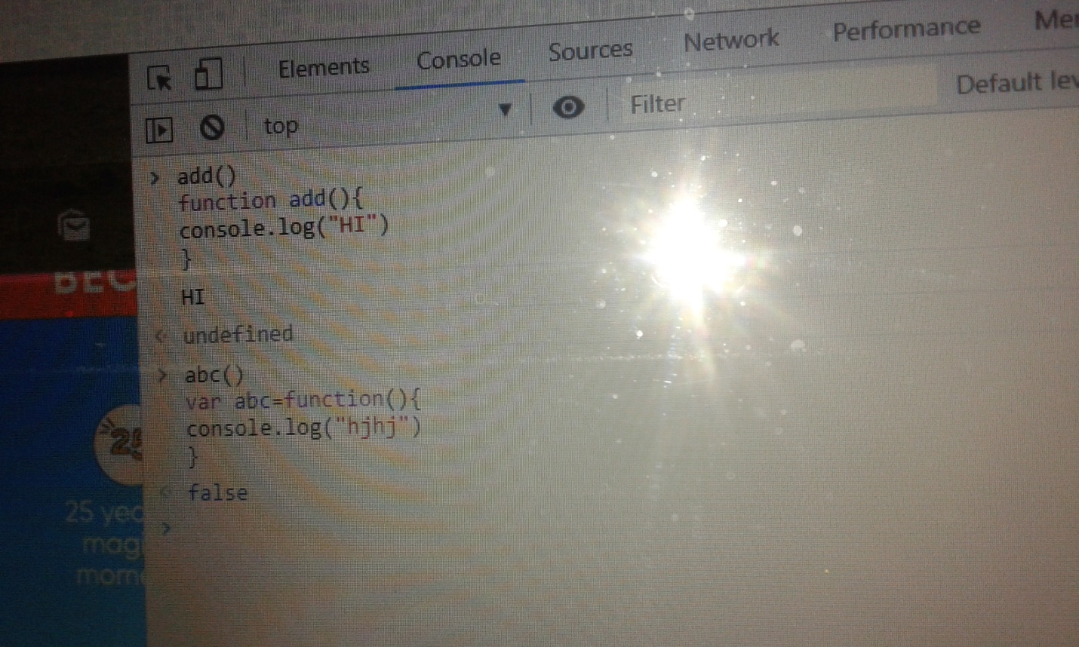

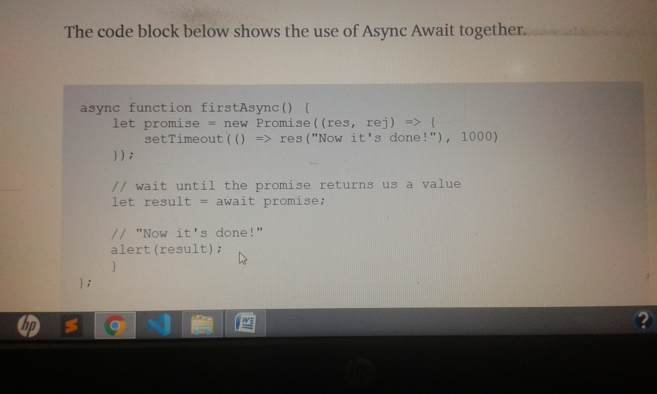

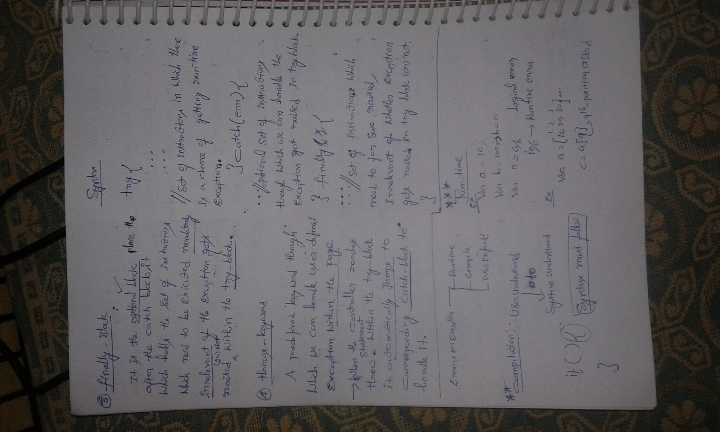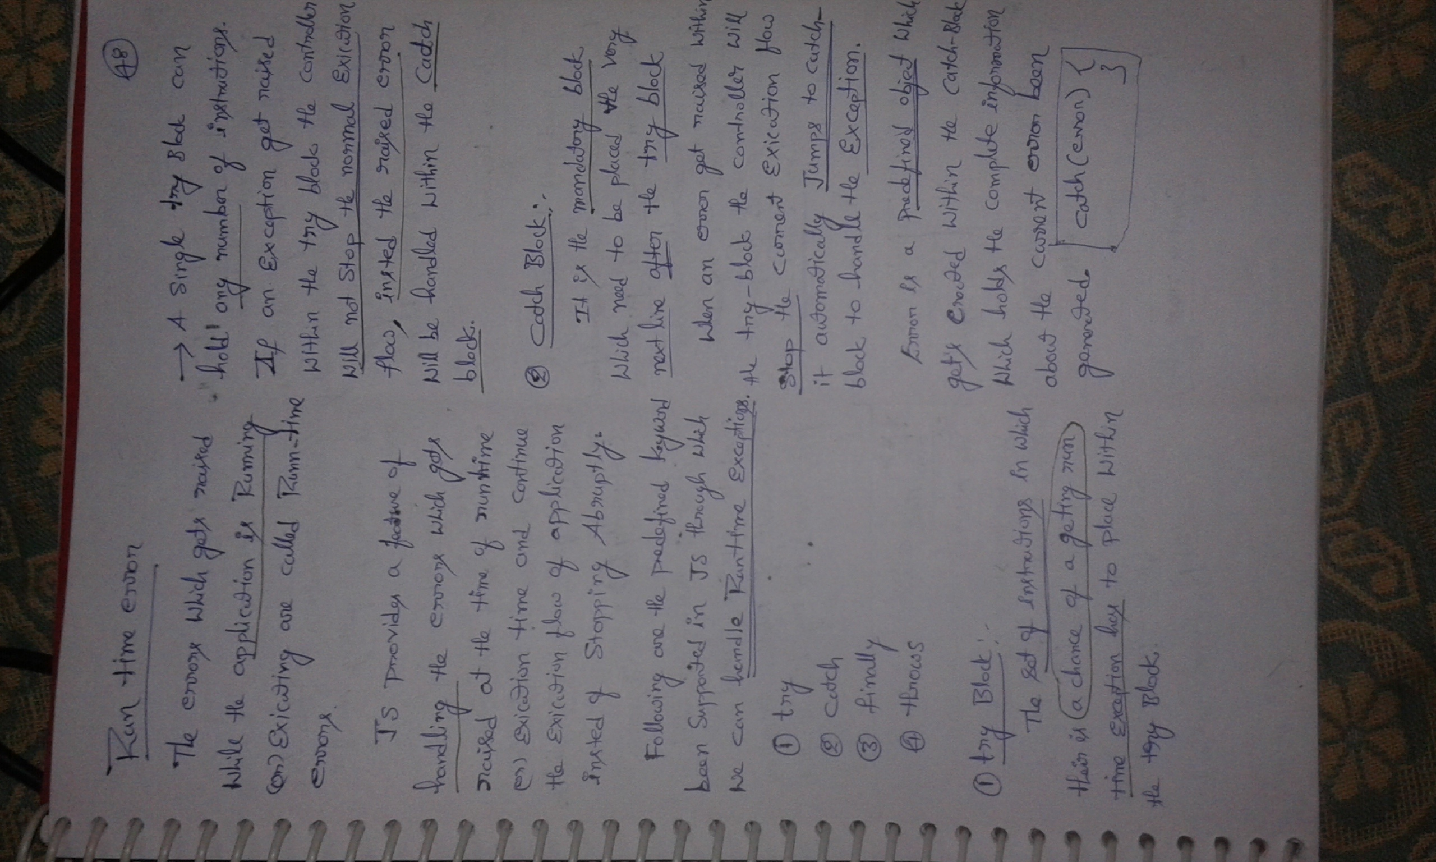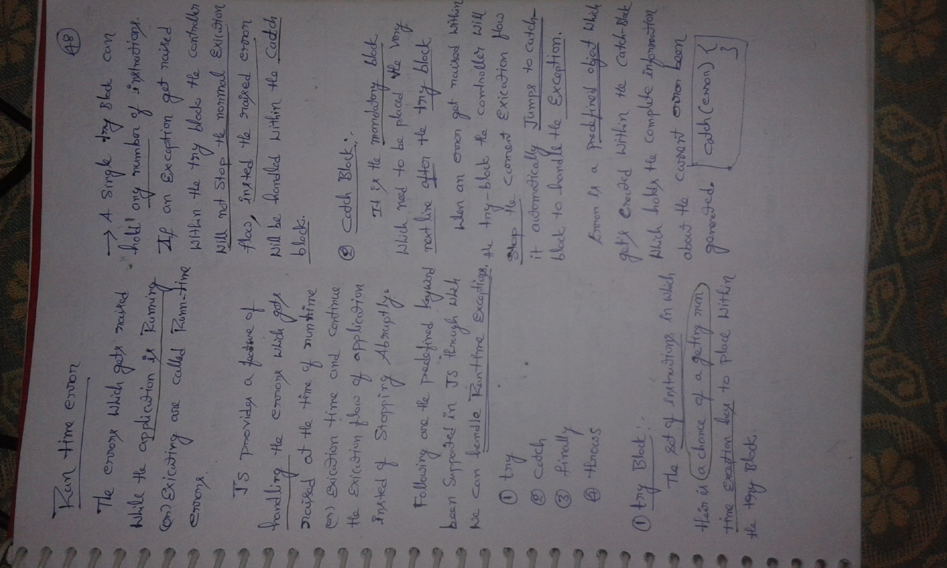 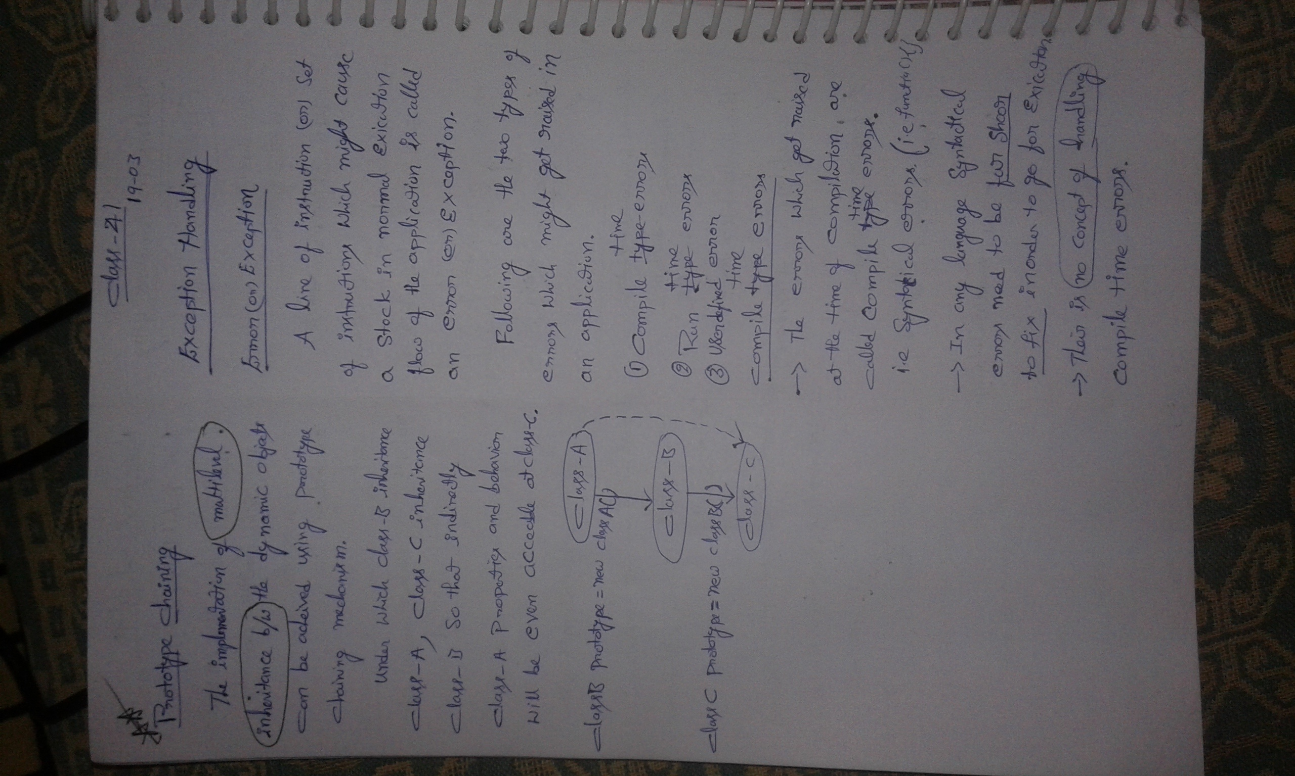

**Exception handlings**

1.**Compile time** error

I.e Syntatical Errors

2.**Run time** errors

These occurs while application is running.

We can handle run time errors are **1.try,2.catch,3.finally,4.throw**

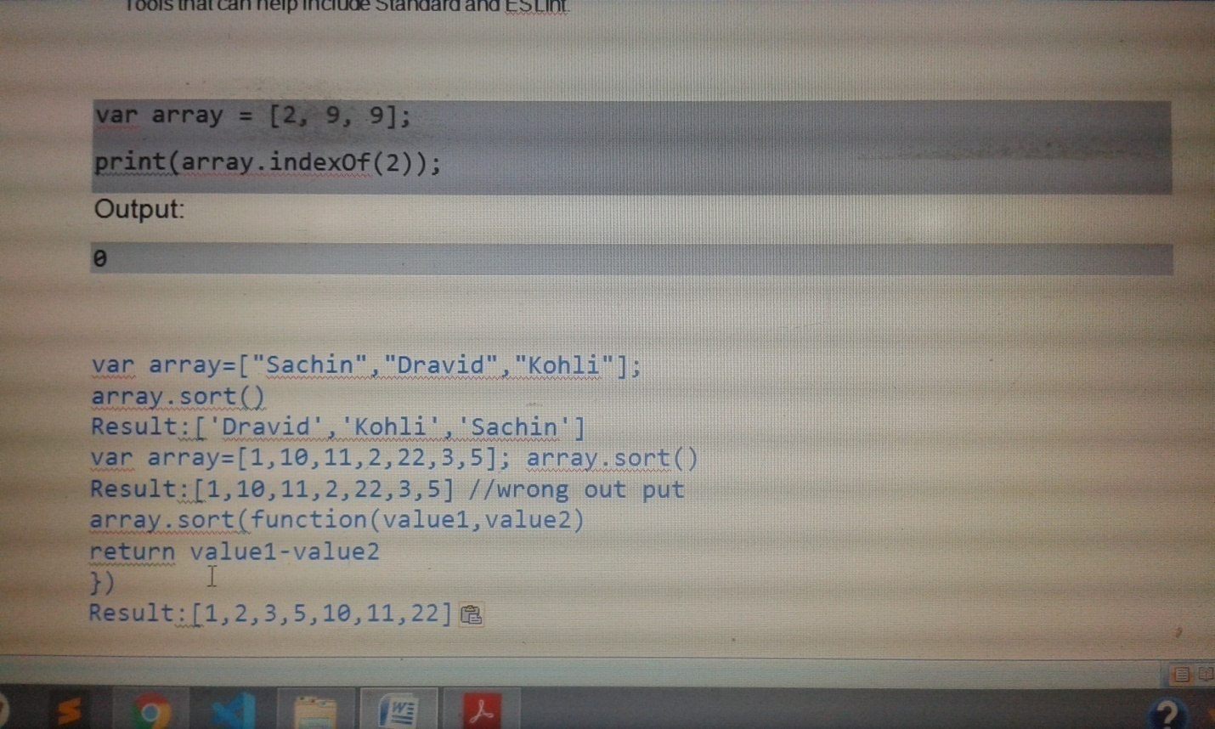

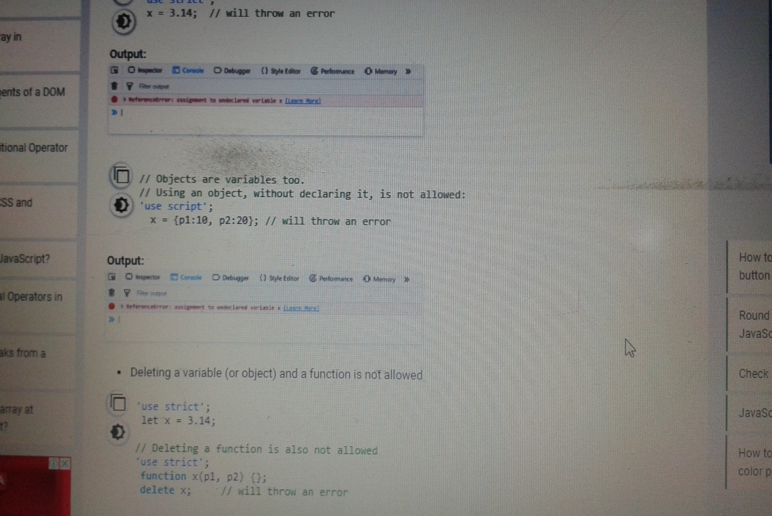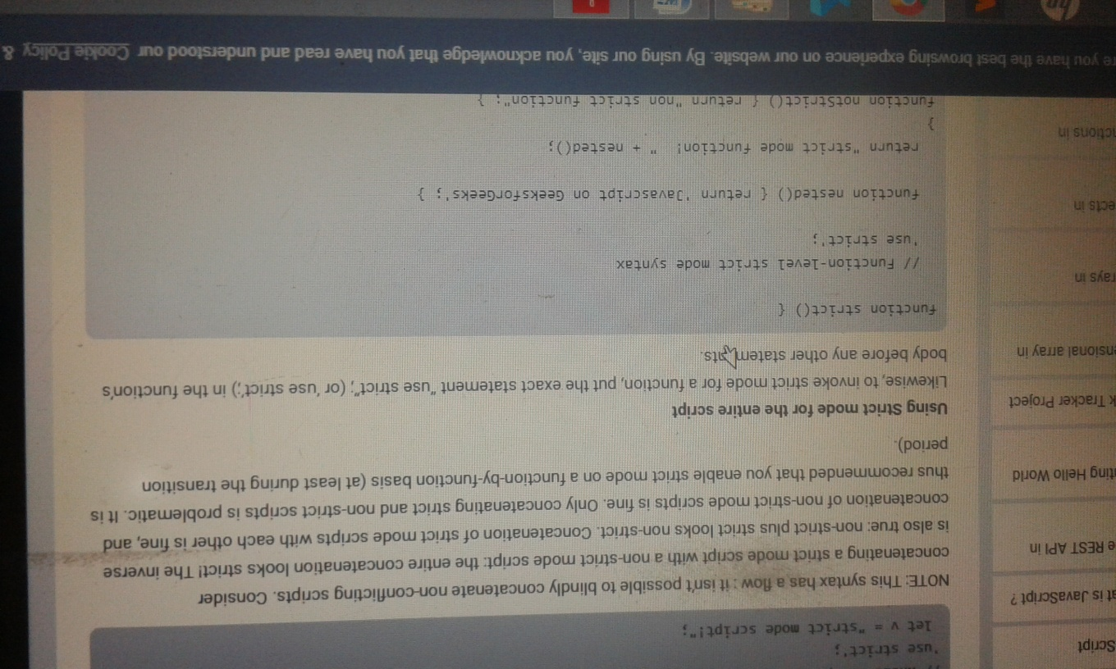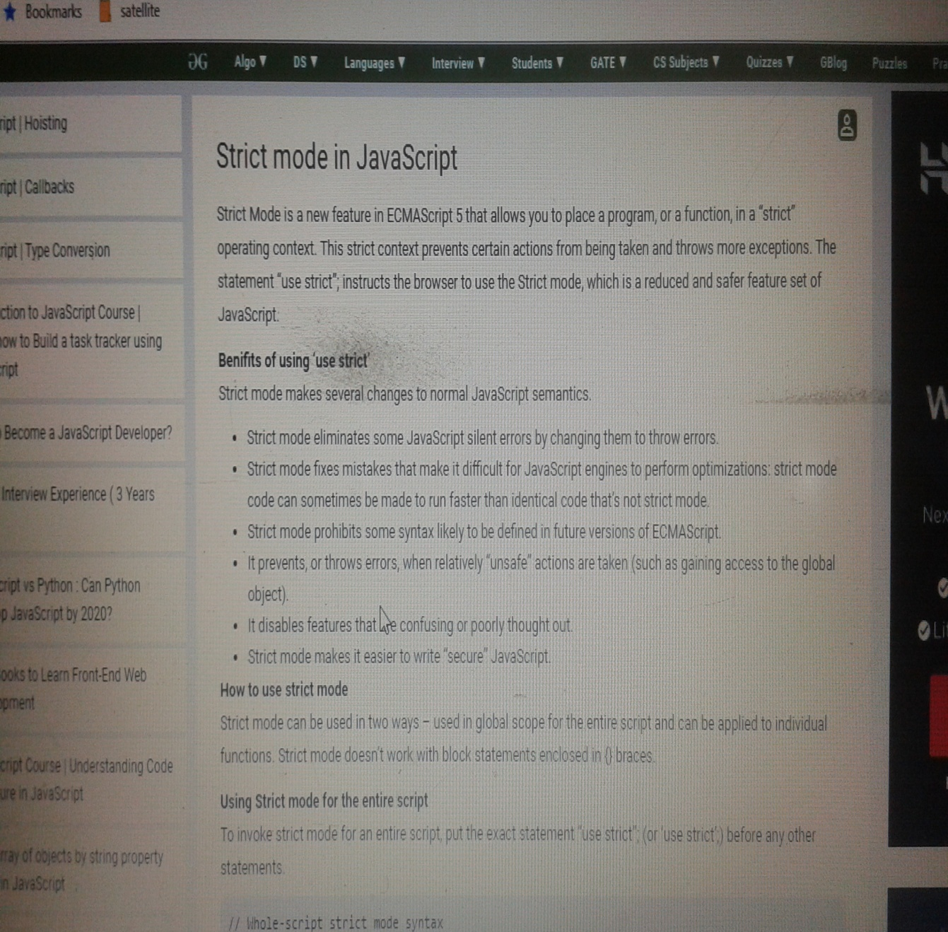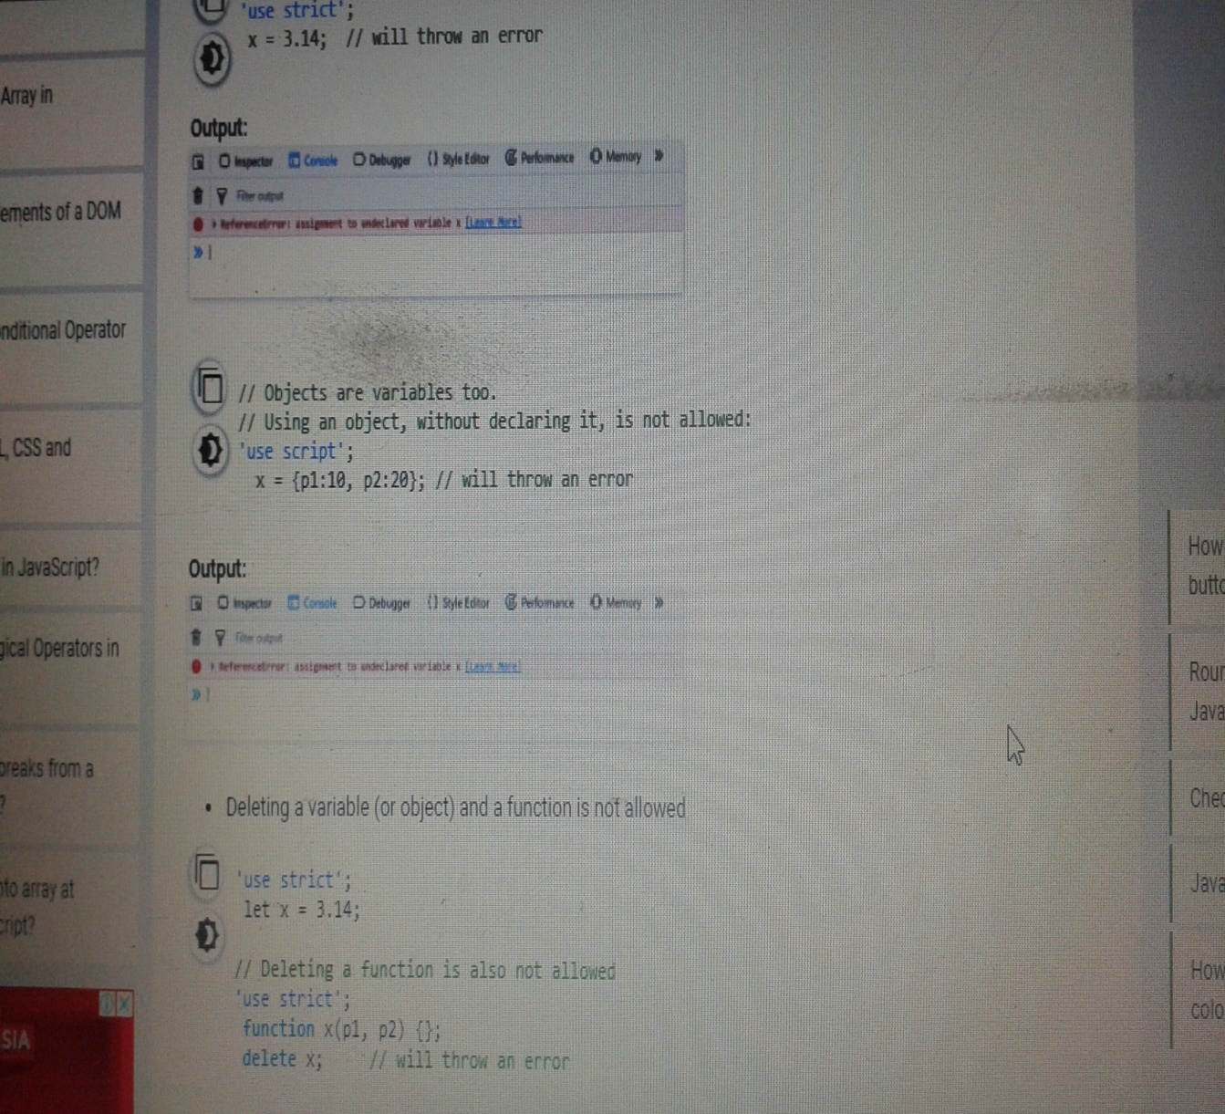

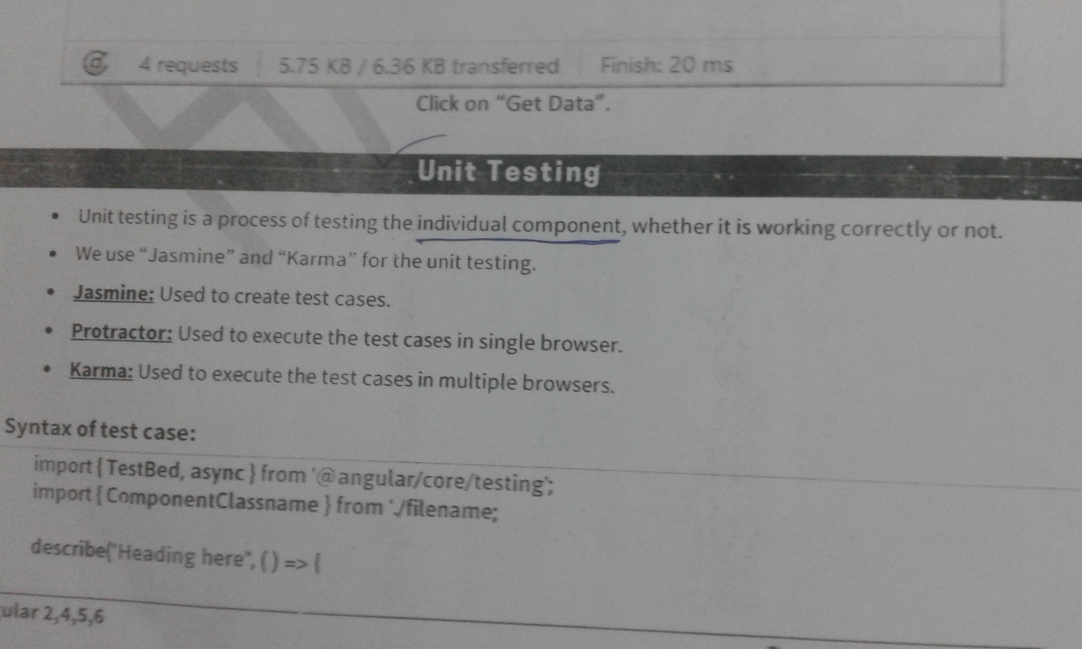We

substring(0,1) We have to print names strat with only ‘r’ 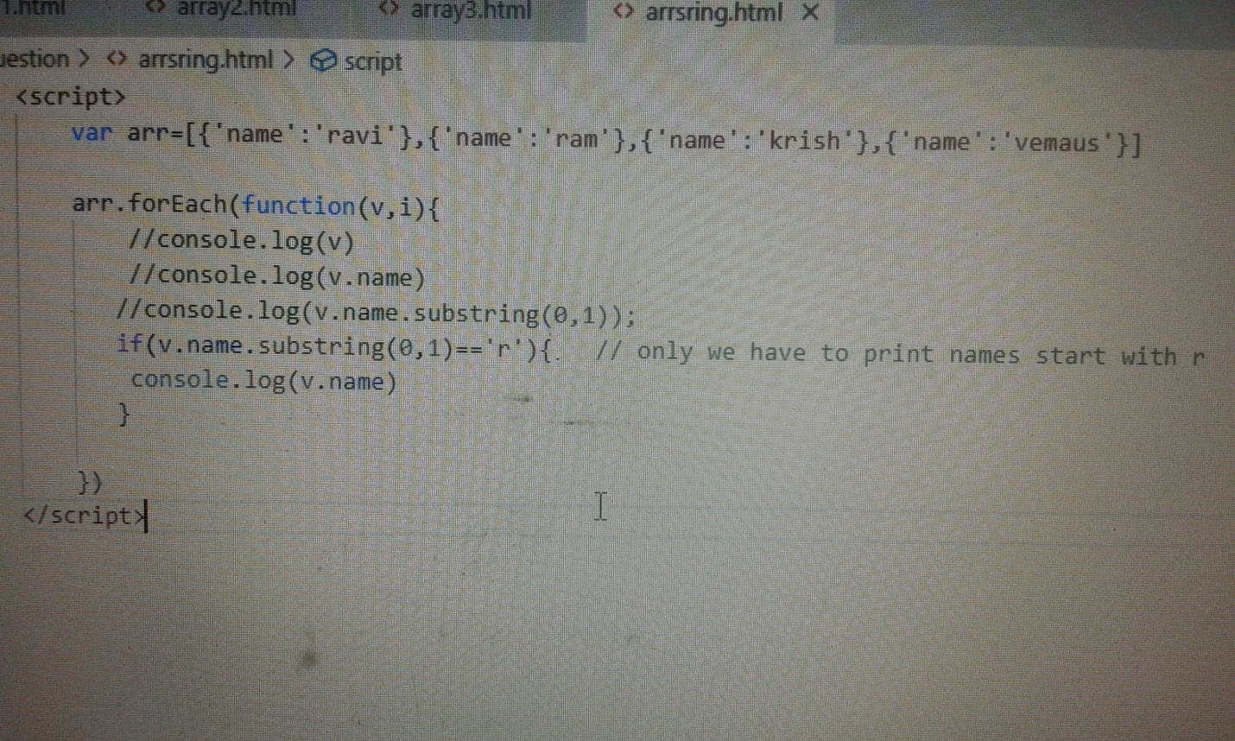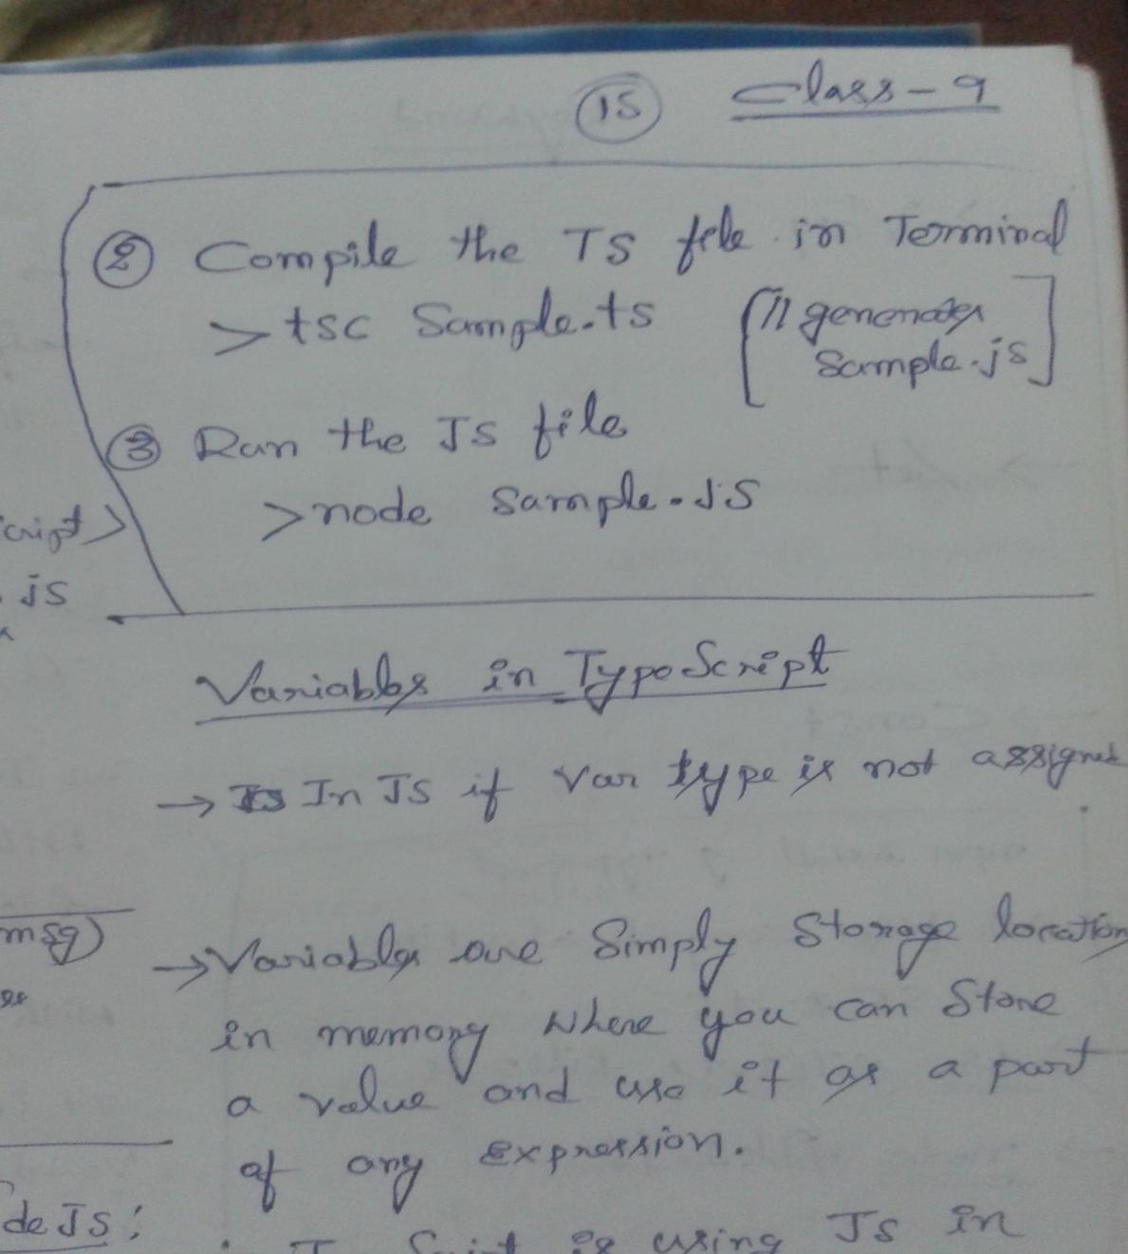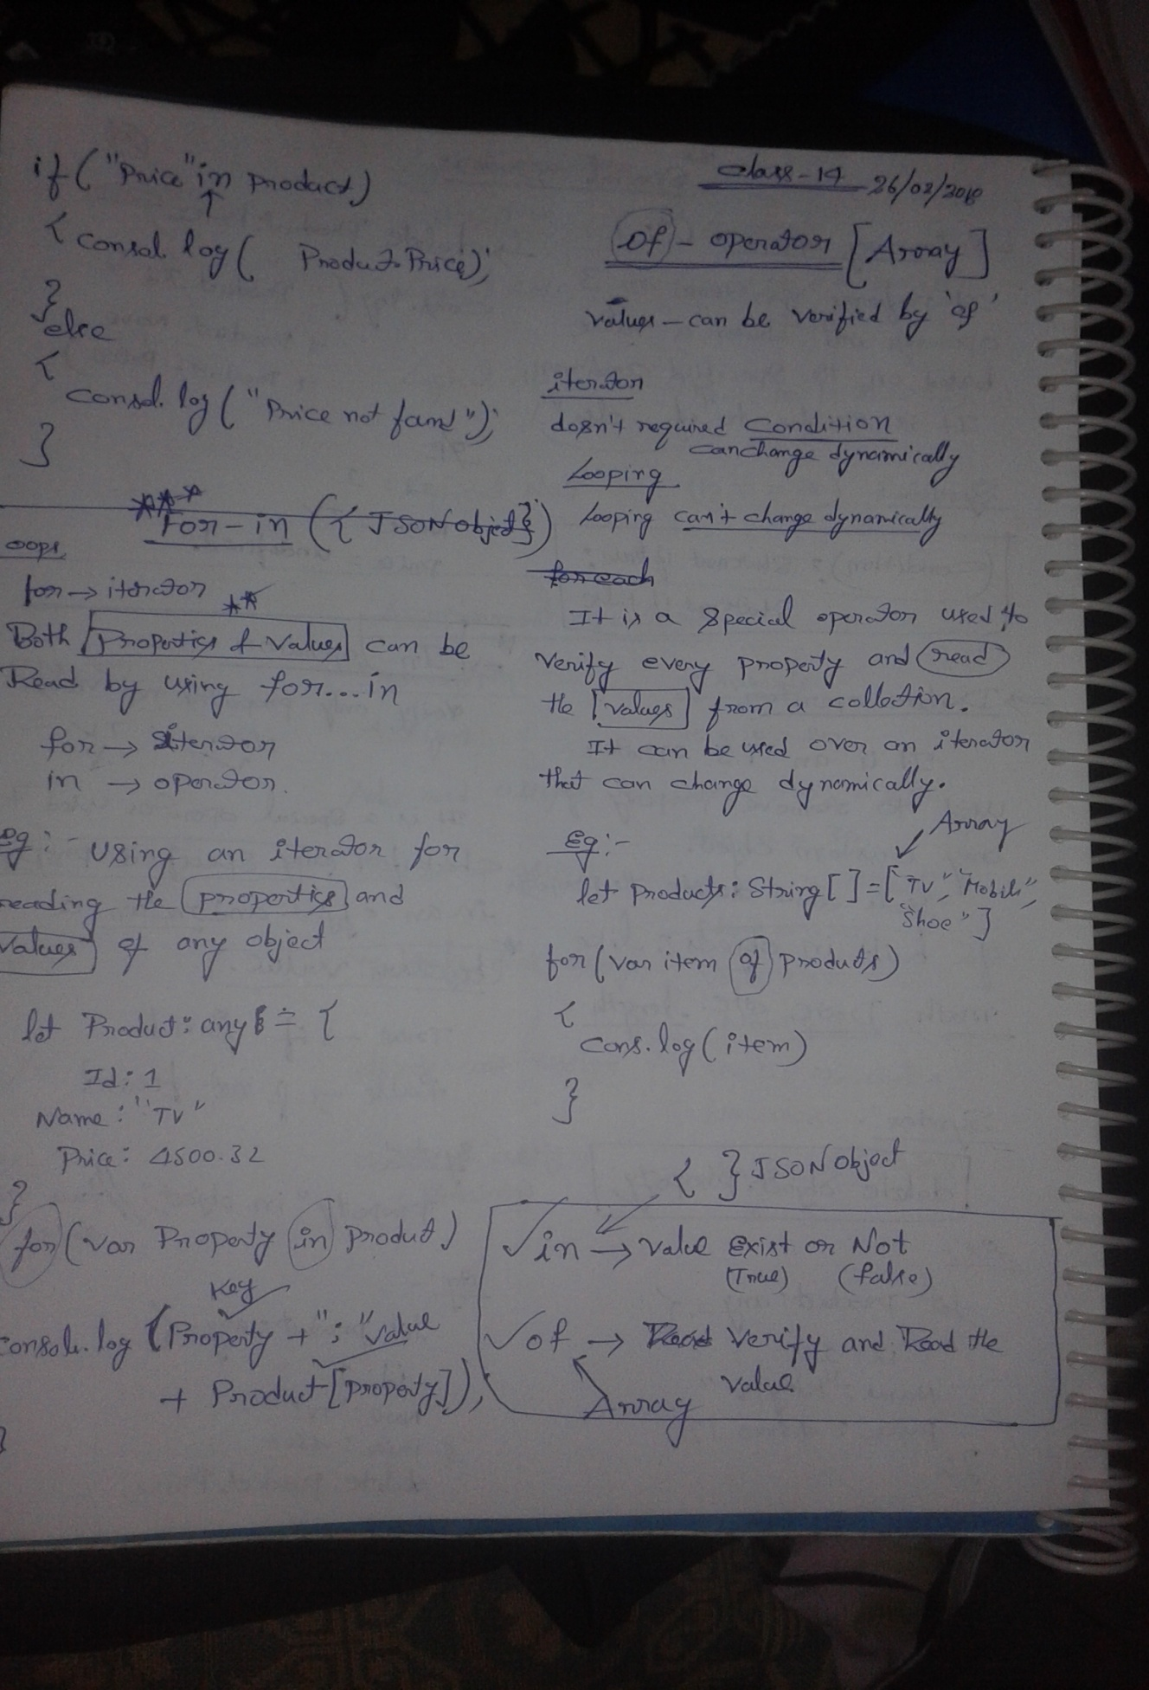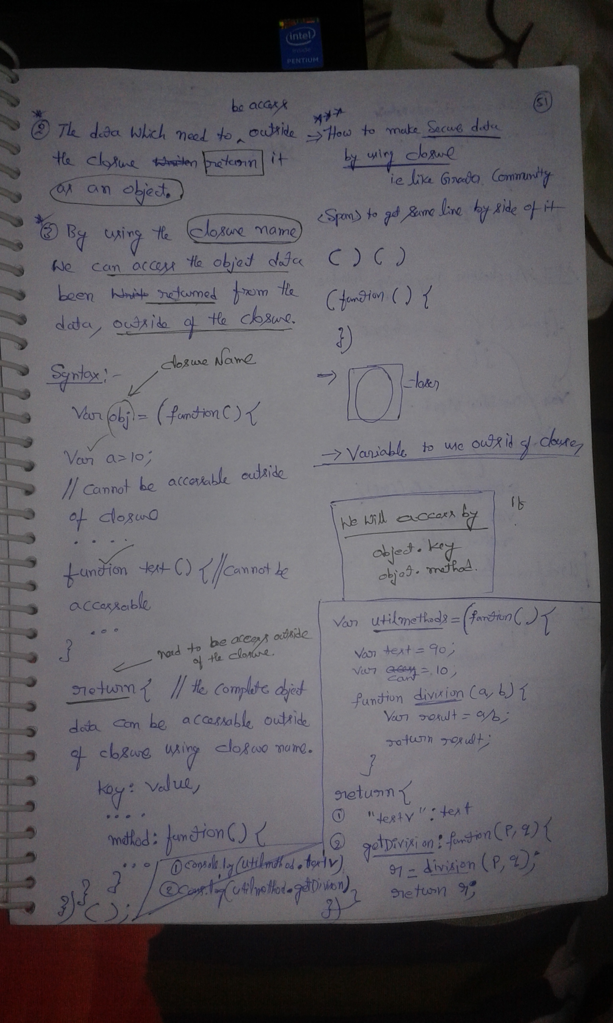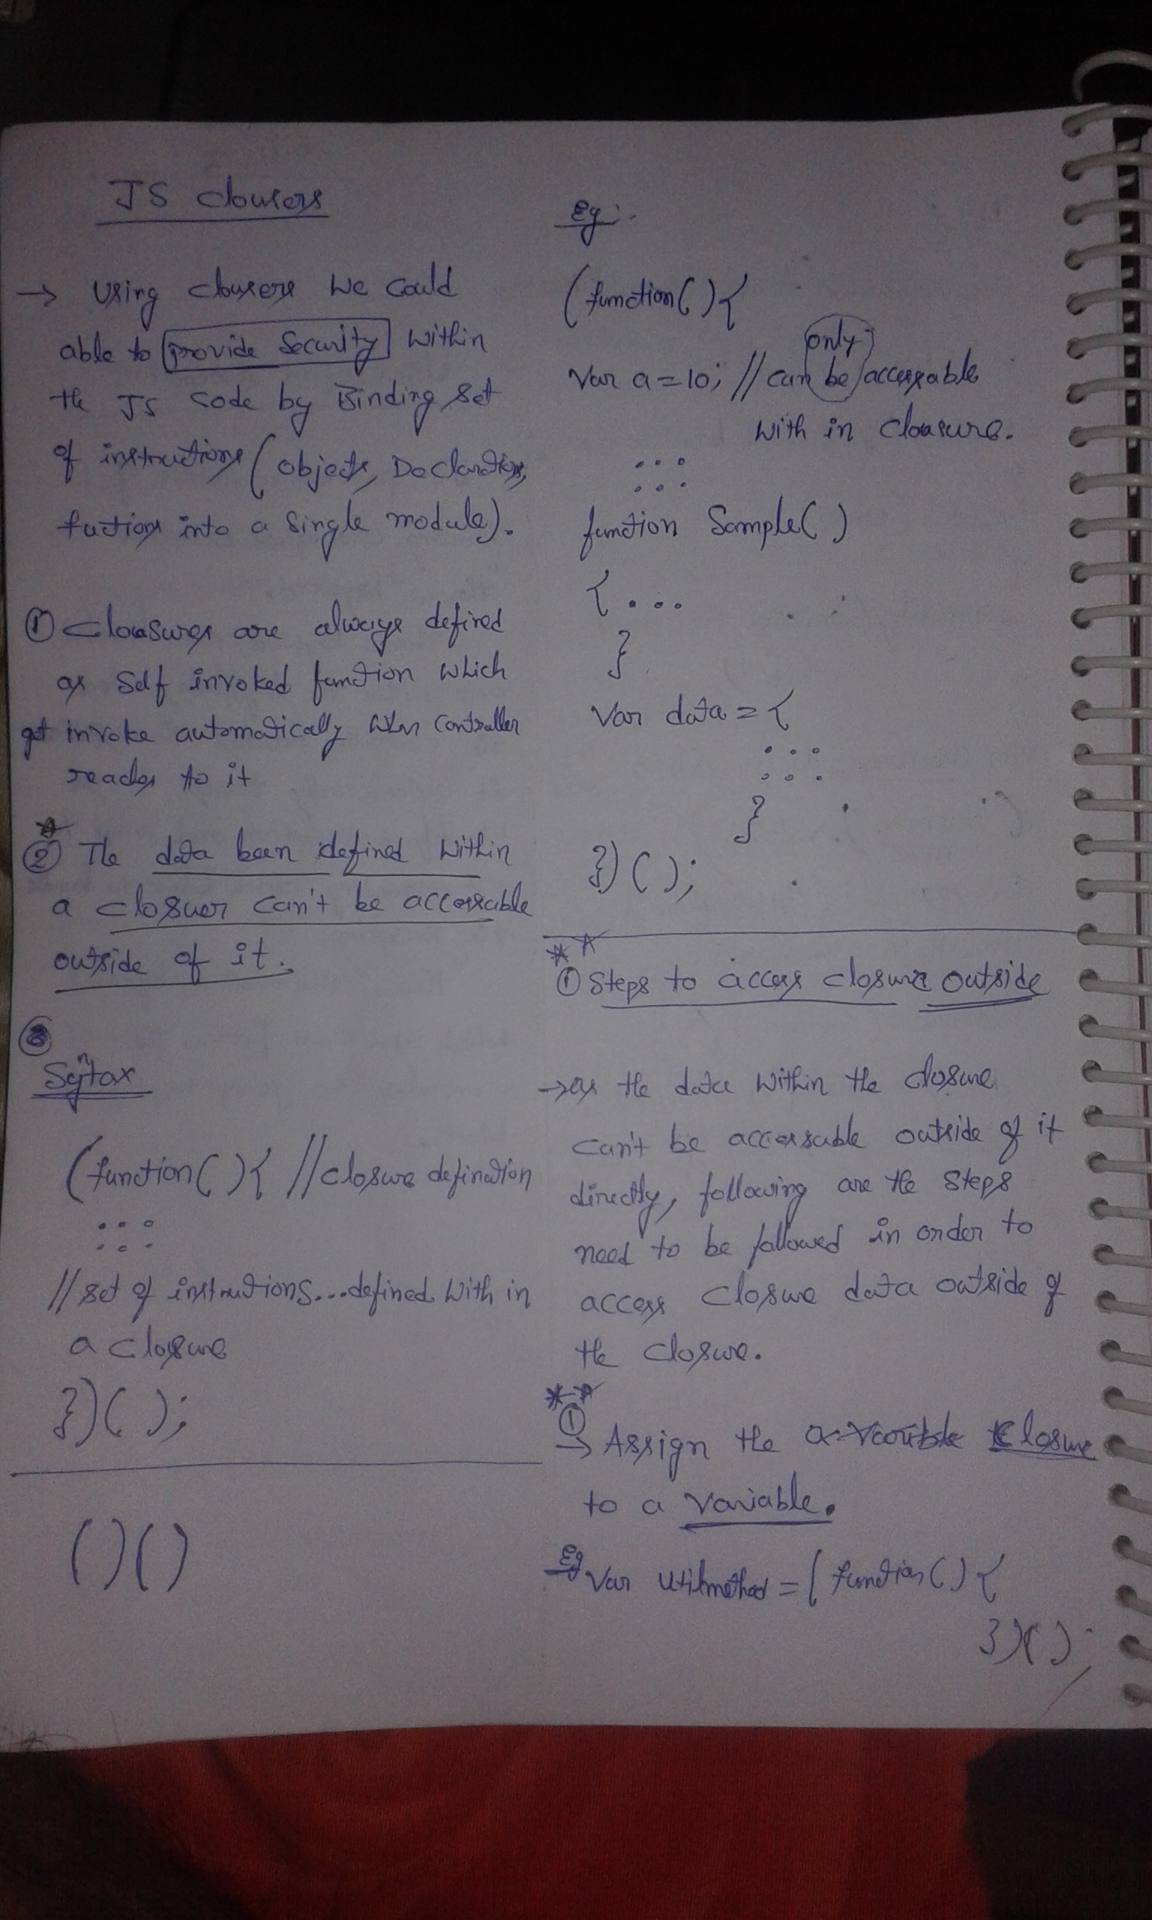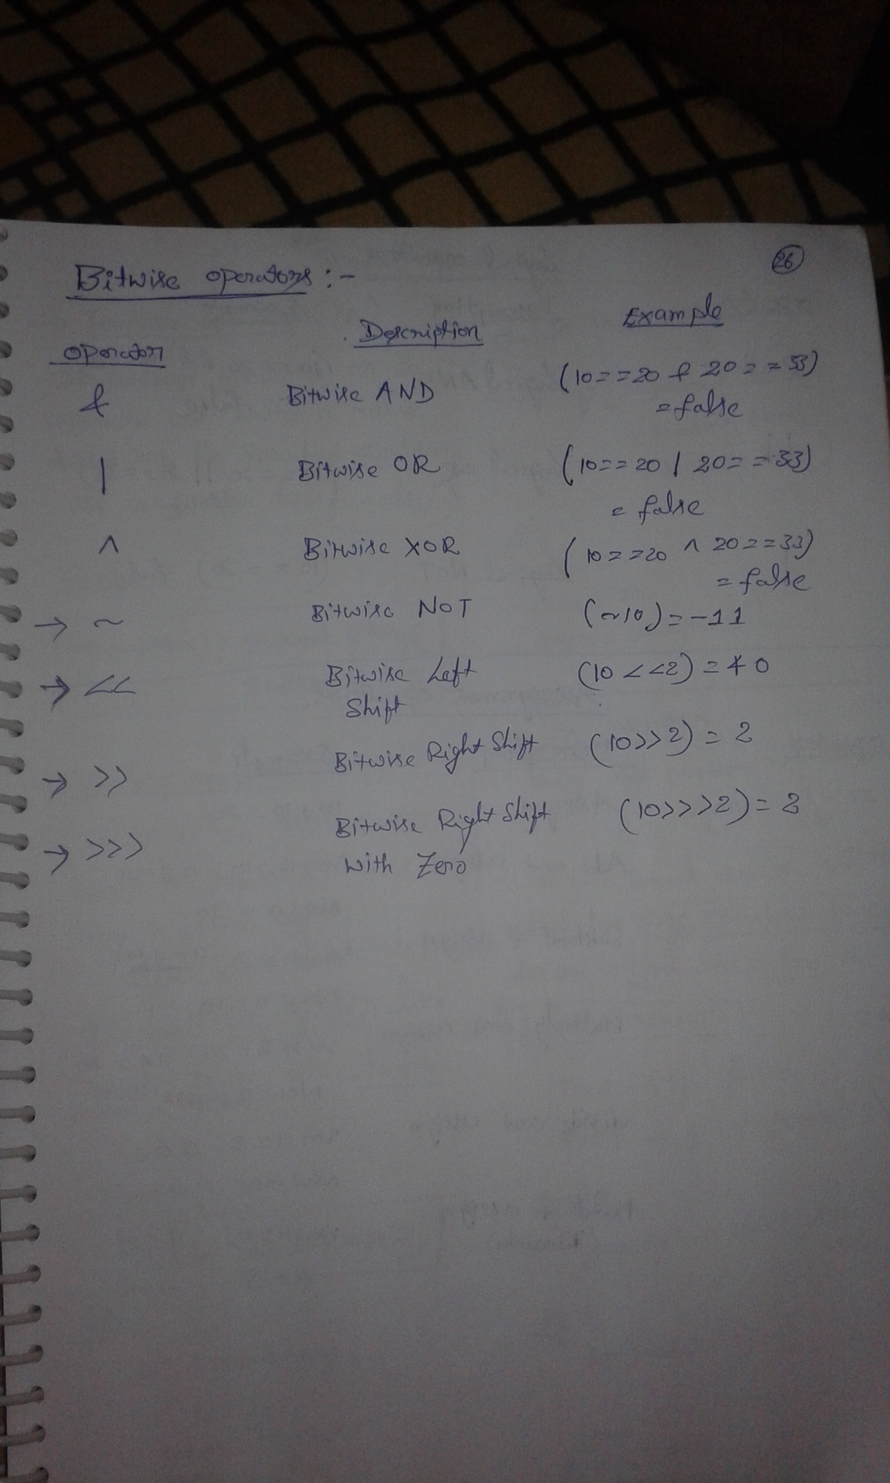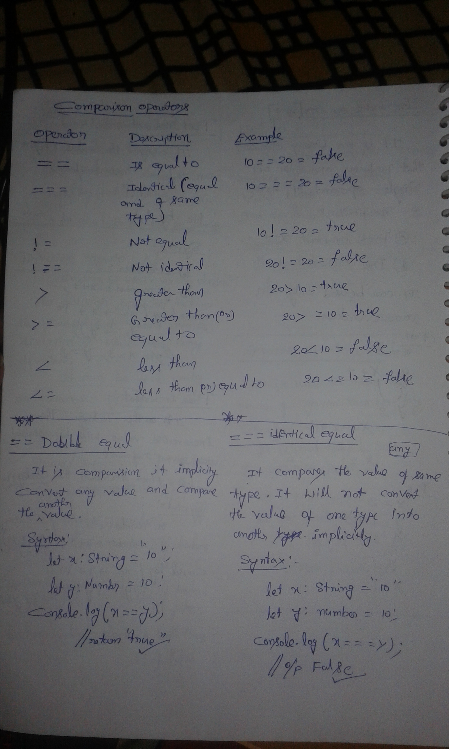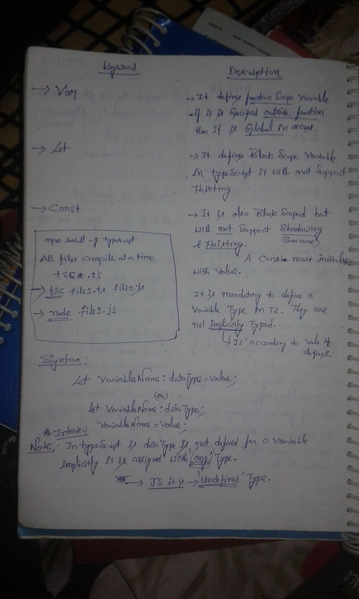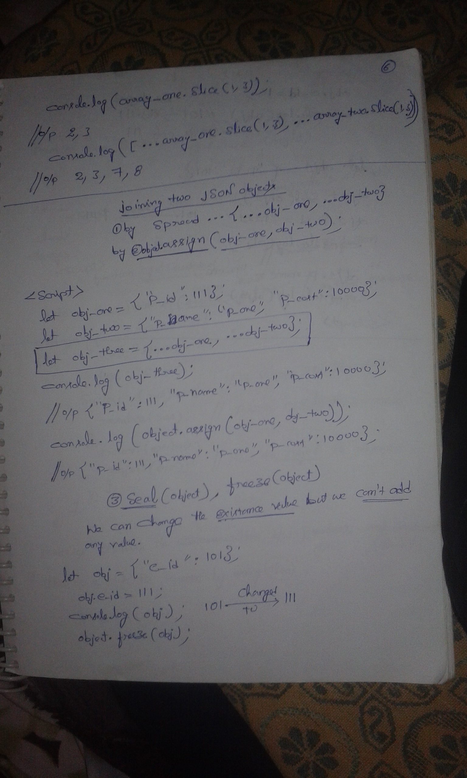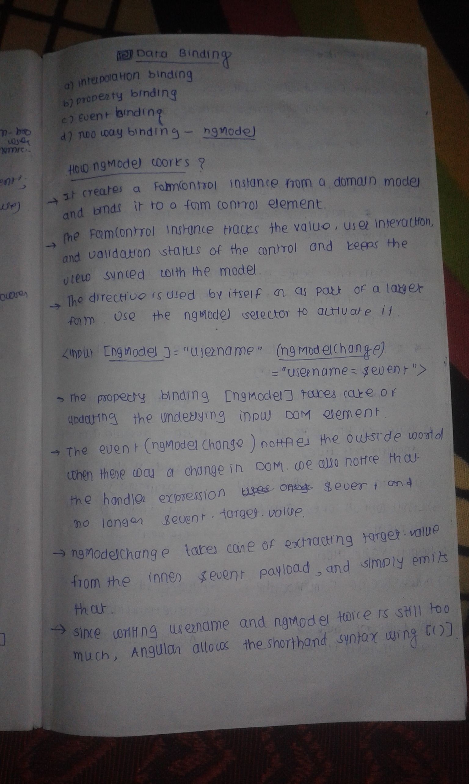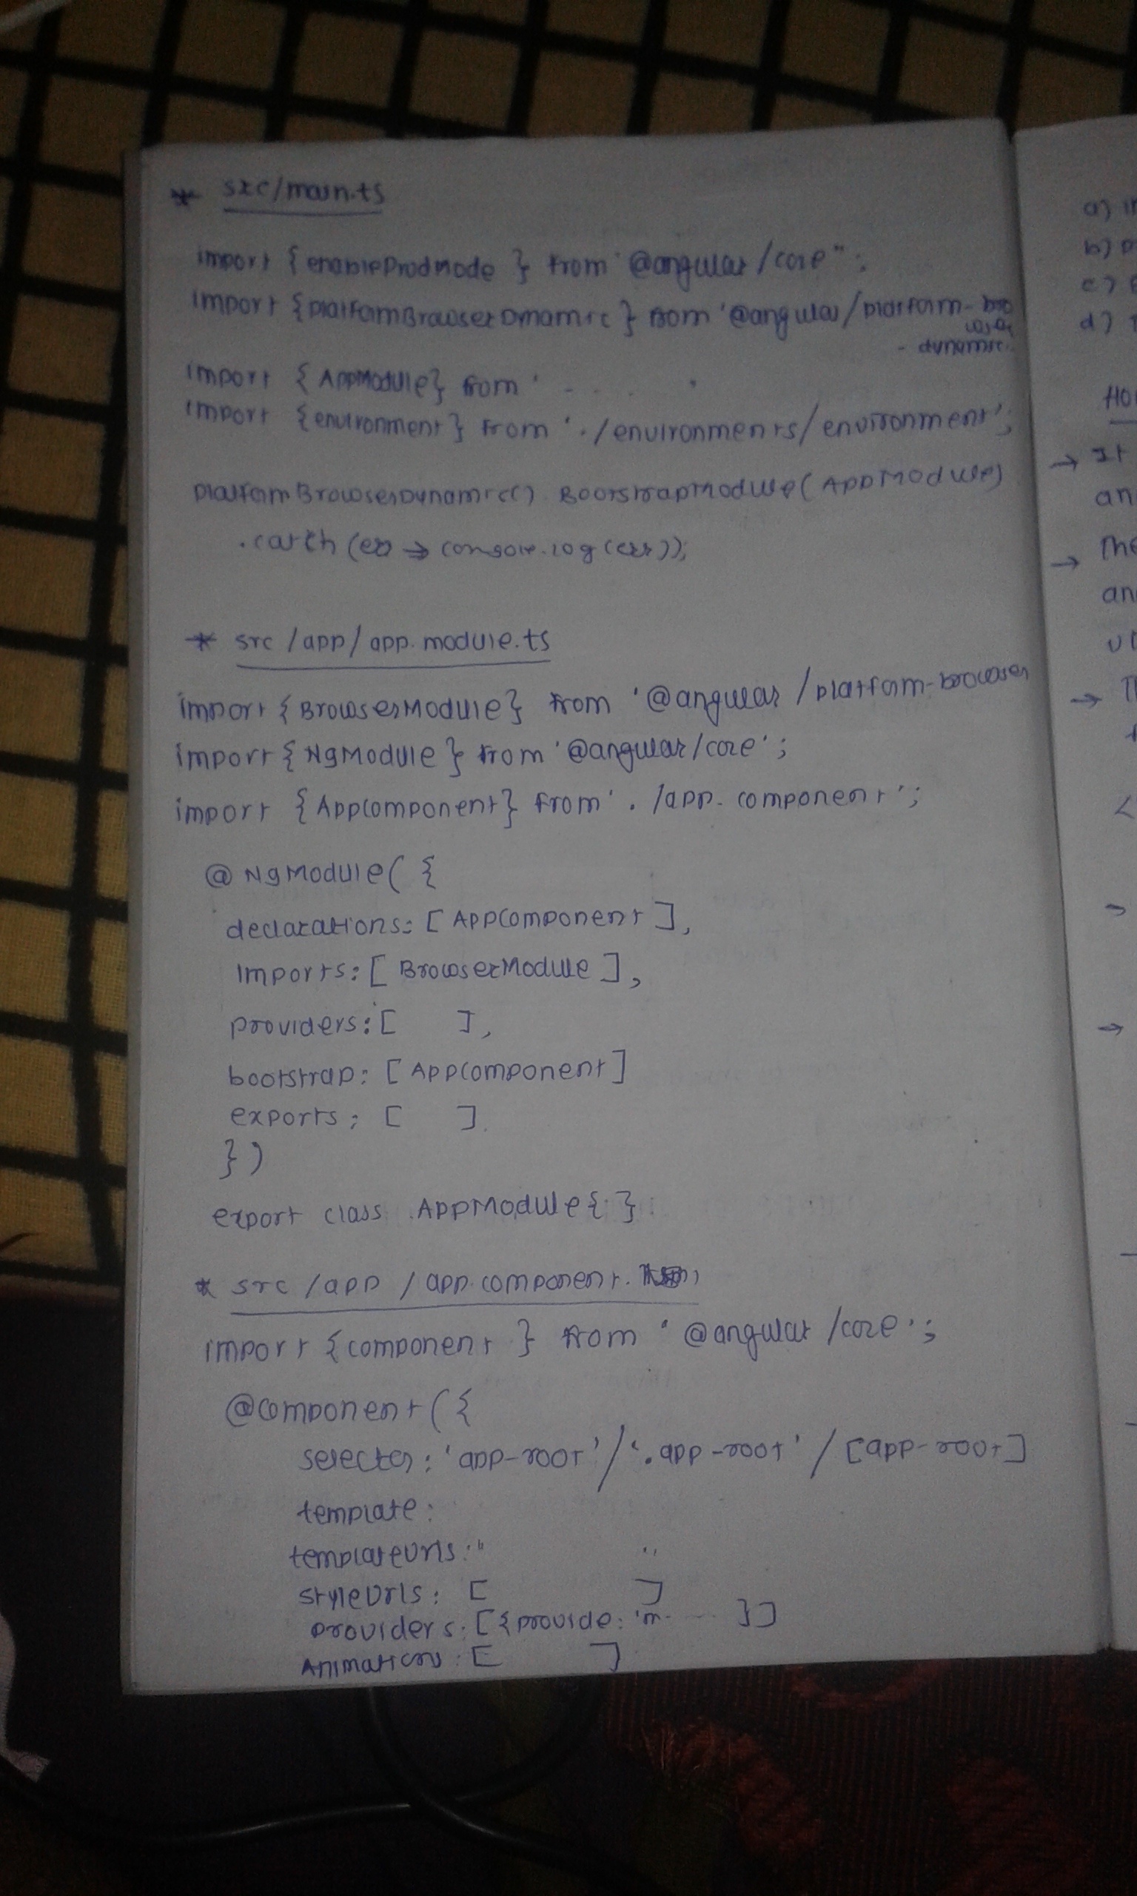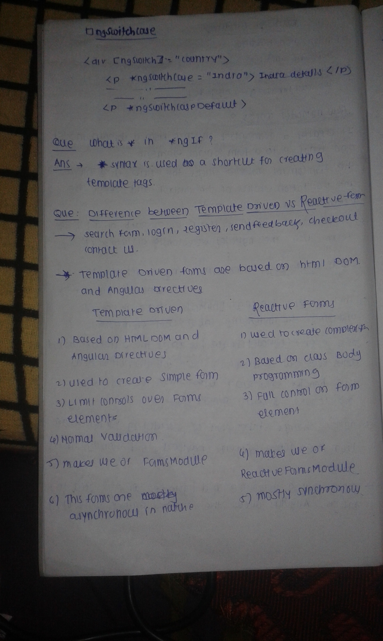

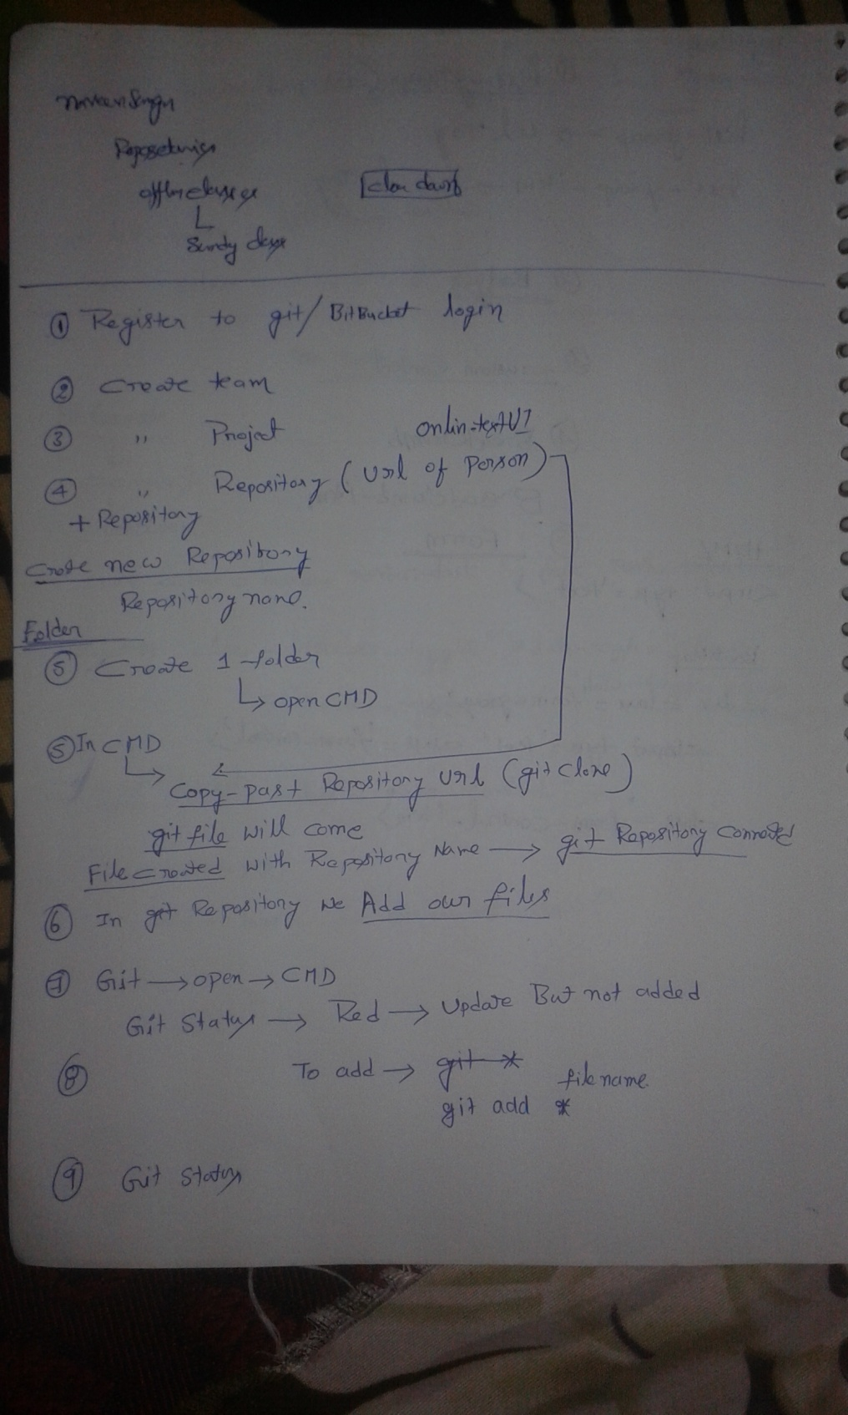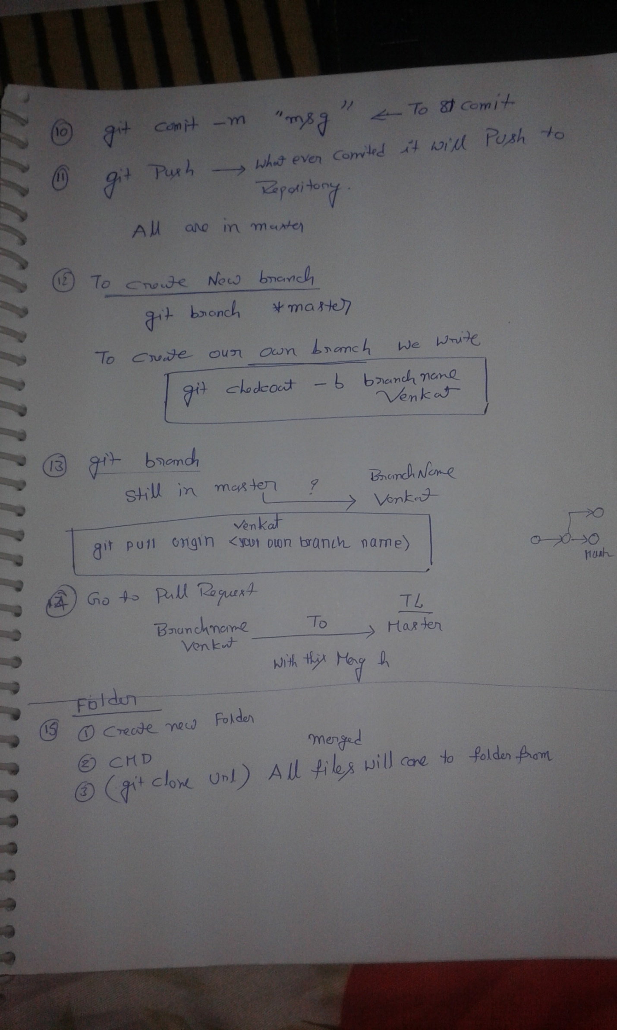

 <script>

        // calling x after definition

        var x = 5;

        document.write(x, "\n");

        // calling y after definition

        let y = 10;

        document.write(y, "\n");

        // calling var z before definition will return undefined

        document.write(z, "\n");

        var z = 2;

        // calling let a before definition will give error

        document.write(a);

        let a = 3;

    </script>

<https://programmingwithmosh.com/javascript/javascript-var-let-and-const/>

var name = 'Adhithi';

In this example, I have declared a variable name using ***var***, outside a function. **Now, JavaScript treats this as a global variable, and attaches it to the window object**. Since there is only one instance of the window object, attaching our global variables to the window object is a bad practice. If you were to use a third-party library that has variables with the same name as your global variables, then you run into the risk of your variables being overridden.

***var*** variables have a function-scope, if they are not declared within a function, they have a global-scope.

Since var does not offer a block-scope, and also attaches itself to the window object, incase of global scope, it leads to several problems and unexpected behaviour of your application.

function begin () {

for (var i=0; i<5; i++) {

console.log(i)

}

// i is accessible outside the for loop

console.log(i)

}

function begin () {

for (let i=0; i<5; i++) {

console.log(i)

}

// i is not defined and will return an error

console.log(i)

}

## const

***const***is another addition in the ES6 JavaScript standards. It is similar to ***let,***where it also adheres to the block-scope. The difference between ***const***and ***let***can be understood with a simple example below.

const name = 'Adhithi';

let age = 25;

// can reassign age

age = 27;

In the example above, I have assigned a name using ***const***and an age using ***let***. You can notice here that I can assign another value to age and it will work just fine.

In the same example, I cannot assign another value to the ***const***name.

const name = 'Adhithi';

let age = 25;

age = 27;

// cannot re-assign name. will throw error

name = 'Adhithi Ravichandran';

This example above will throw an error when ***name***is :TypeError: Assignment to constant variable.

The takeaway here is that, ***const*** does not allow you to re-assign values to a constant variable. Whereas, ***let***allows you to re-assign values to variables that already have a value (example above: age).

Let’s take a look at how ***const***objects work in JavaScript.

const user = {"name": "Adhithi", "age": 10}

//Can manipulate object properties

user.name = "Josh";

//Cannot re-assign the entire object

user = {"name": "Josh", "age": "12"} //Uncaught TypeError: Assignment to constant variable

In this example, we can manipulate the properties of an Object. We can change the name and age properties of the user Object although the user Object is a ***const***.

But, we cannot re-assign the entire Object. The idea is that in case of ***const***Objects, the individual properties of the Object can be modified/re-assigned but the Object itself cannot be changed entirely.

1. ***var*** – Can be re-assigned, re-defined and has a function-scope. When declared outside the function, it has a global scope and attaches itself to the window object.
2. ***let***– Can be re-assigned. It’s scope is within a block of code.
3. ***const****–*Cannot be re-assigned or re-defined. It’s scope is within a block of code.

<https://www.youth4work.com/Talent/Javascript/Forum/129252-what-is-difference-between-undefined-and-not-defined-in-js#:~:text=If%20a%20variable%20is%20accessed,before%20accessing%2C%20then%20its%20undefined.&text=Null%20means%20an%20empty%20or,assigned%2C%20and%20explicitly%20means%20nothing.>

Undefined and Not defined

A not defined is a variable which is not declared at a given point of time with declaration keyword like var,   
let or const.  
  
  console.log(a);  
  var a = 5;  
  
While if we don’t use var keyword above the output will be:-  
  
  console.log(b);  
  b = 5;  
  //Output:- "ReferenceError: b is not defined  
    
The reason why the variable a was printed with undefined value above but b was declared as not defined was   
because of the way variable hoisting works in javascript i.e.   
the variable declarations are processed before code execution takes place in javascript.  
  
Internally the execution for the variable a above was as follows:-  
  
  var a;  
  console.log(a); //undefined  
  a = 5;  
    
While for variable b above it was as follows:-  
  
  console.log(b); // b is not defined  
  window.b = 5;

<https://medium.com/technoetics/difference-between-null-undefined-and-not-defined-in-javascript-3a52a62894b>

**Not defined:-**

A not defined is a variable which is not declared at a given point of time with declaration keyword like var, let or const.

console.log(a);  
var a = 5;  
//Output:- undefined

While if we don’t use var keyword above the output will be:-

console.log(b);  
b = 5;  
//Output:- "ReferenceError: b is not defined

The reason why the variable a was printed with undefined value above but b was declared as not defined was because of the way variable hoisting works in javascript i.e. the variable declarations are processed before code execution takes place in javascript.

Internally the execution for the variable a above was as follows:-

var a;  
console.log(a); //undefined  
a = 5;

While for variable b above it was as follows:-

console.log(b); // b is not defined  
window.b = 5;

Differences:-

The type of null and undefined are different as follows:

console.log(typeof(undefined)); //"undefined"  
console.log(typeof(null)); //"object"

null is an object with a valid non-existent value and it is non-mutable while object type of an undefined value is in itself undefined.

Also any arithmetic operation with null value will result in integer value while any arithmetic operation with undefined with result in value of variable being changed to NaN.

let a = 7 + null;  
console.log(a); // 7let b = 7 * null;  
console.log(b); // 0let c = 8 + undefined;  
console.log(c); //NaNlet d = 8 * undefined;  
console.log(d); //NaN

Hope your concepts of the three got a bit more clear today. Stay tuned for more such posts in near future.

JavaScript Functions vs Methods (and other helpful tips)

<https://medium.com/predict/javascript-functions-vs-methods-and-other-helpful-tips-e58a621b1d27>

Also, this definition may not technically be true in JavaScript — and I’ll show you why — but it’s probably the easiest way to think of it. If you are unaware of what a “**receiver**” is, look at the code snippet below:

someObject.someMethod()----------🡪 is a method as it has receiver

In this context, the someObject is the receiver, while the someMethod is the method. Compare that with a function invocation:

someFunction(arg)--------🡪 is a function

first method initiating later function calling

var object = {  
 method: function() {  
 console.log("Am I still a method?");  
 }  
};object.method(); // method call  
var func = object.method;   
func(); // now it is a function invocation

sum of ‘55555’

function repeatFun(stringArg) {

        var newArray = [];

        var secarray = [];

        var secValue = 0;

        var thrValue = 0;

        for (var i = 0; i < stringArg.length; i++) {

            newArray.push(stringArg.charAt(i))

        }

        newArray.forEach((strValue) => {

            secValue = secValue + parseInt(strValue)

        })

        secValue = secValue.toString()

        if (secValue.length > 1) {

            for (var k = 0; k < secValue.length; k++) {

                secarray.push(secValue.charAt(k))

            }

            secarray.forEach((strValue) => {

                thrValue = thrValue + parseInt(strValue)

            })

            console.log(thrValue)

        } else {

            console.log(secValue)

        }

    }

    repeatFun('55555')

or

 var n = 55514;

 console.log(n % 9)

 sum = n % 9 || 9;

console.log(sum)

or

var arr = n.toString(10).replace(/\D/g, '0').split('').map(Number);

const numToSeparate = 12345;

const arrayOfDigits = Array.from(String(numToSeparate), Number);

console.log(arrayOfDigits); //[1,2,3,4,5]

tried

 valueRED = valueRED.toString()

        if (valueRED.length >= 1) {

            for (var i = 0; i < valueRED.length; i++) {

                const secArrayOfDigits = Array.from(String(valueRED), Number);

                console.log(secArrayOfDigits)

                var secRED = secArrayOfDigits.reduce((valOne, valTwo) => {

                    valOne = valOne + valTwo

                        // valueRED = valOne

                    valueRED = valOne.toString()

                    return valOne

                })

                console.log(valueRED)

            }

        }

        console.log(valueRED)

reduceRight()

findIndex()

find()

fill()

flat()

flatMap()

copyWithIn()

Array.from()

Repeat()

toString()

replace()

trim()

trimStart()

trimEnd()

padStart()

padEnd()

subStar()

subString()

for……of()

for……in()

globalThis.

For promiss has 3 states

Fulfilled

Rejected

Pending

How to check whether it is number or not?

isNaN(48) // false

isNaN(“char string”) // true

of typeof 48 // number

string to number

parseInt(“2.555”) // 2

parseFloat(“2.555”) // 2.555

while and do while in javascript

***1. //this works***

**let sheepSay = "baa";**

**sheepSay = "moo"**

***2.//this won't work, thankfully:***

**let sheepSay = "baa";**

**let sheepSay = "moo";**

***1.//this doesn't***

**const sheepSay = "baa";**

**sheepSay = "moo";**

***2.//...syntax error will be thrown and sheep will still say "baa".***

**const sheepSay = "baa";**

**const sheepSay = "moo"; *//will also throw an error giving the same reason as let: variable with this name already exists.***

**1.**

**var sheepSay = "baa";**

**var sheepSay = "moo"; *//unfortunately, this works. Sheep now say "moo".***

**Array.isArray()----is to check is array or not**

**Explain default function parameters?**

**function addTogether(x , y = 1) {**

**return x + y**

**}**

**addTogether(10 , 20) // 30**

**addTogether(10 ) // 11**

function addTogether(x, y) {

        console.log(x)

        console.log(y)   // undefined

        console.log(x + y); // Nan

        return x + y

    }

    addTogether(10)

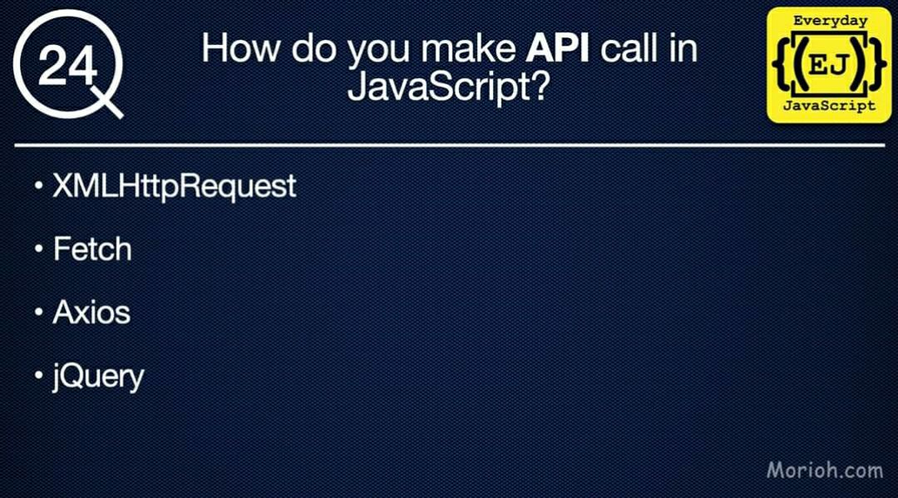 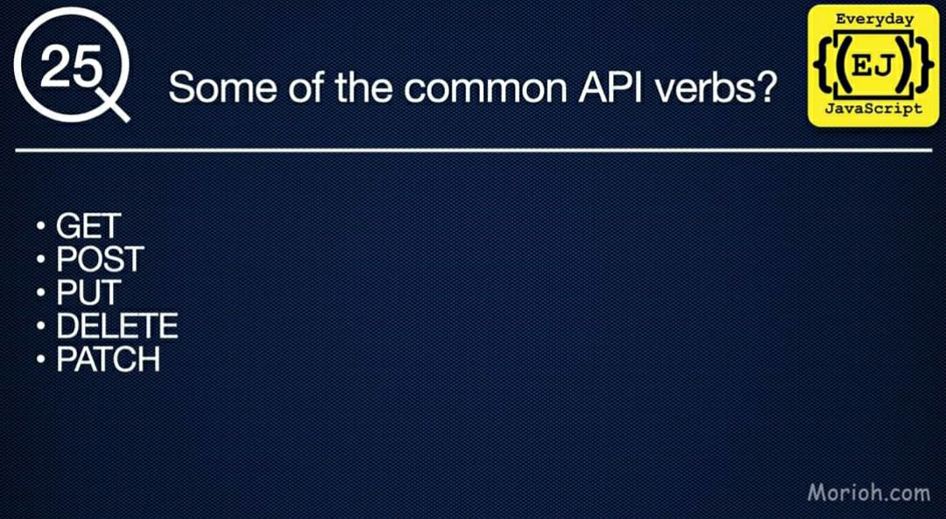

**Set**

<https://developer.mozilla.org/en-US/docs/Web/JavaScript/Reference/Global_Objects/Set>

<https://www.geeksforgeeks.org/sets-in-javascript/>

*************************************************************************

How to convert object into Array { } ----------🡪 [] --🡪

Object.entries() {} 🡪 [] ; object.assign( [] ) -🡪 [] to {};

… three dots called spreed operator

[] merging or {} merging …spreed operator is best

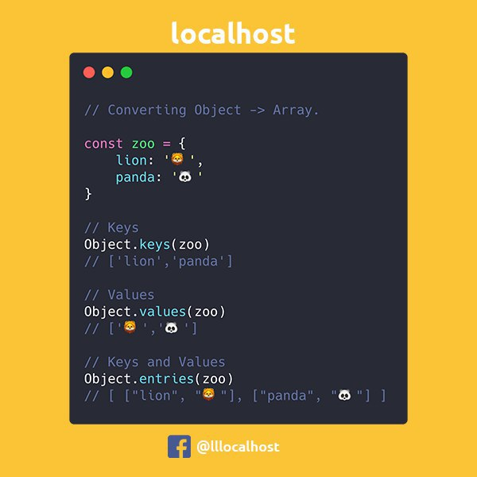

Array to object converter

Object.assign({}, ['a','b','c']); // {0:"a", 1:"b", 2:"c"}

Or

{ ...['a', 'b', 'c' ] }



To repeat strings || string + number

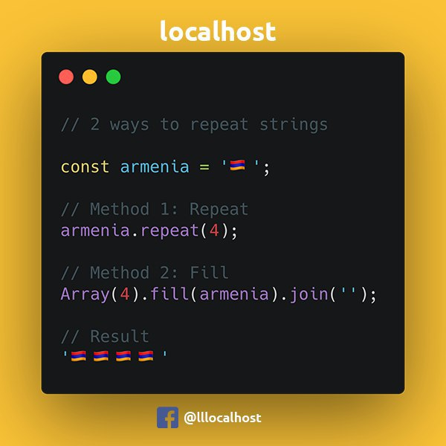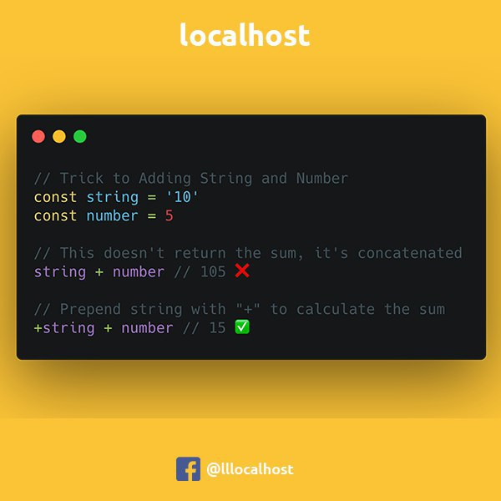

Set timeout || sort number

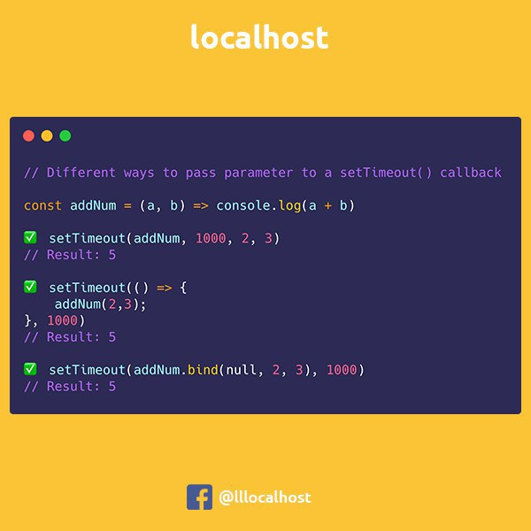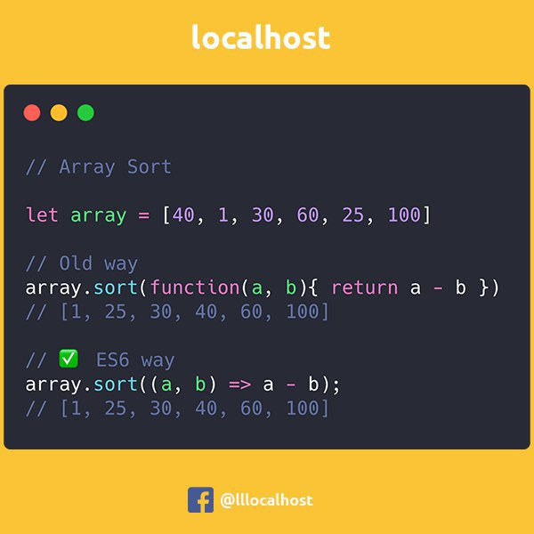

Swap variables || Math.sign(num)

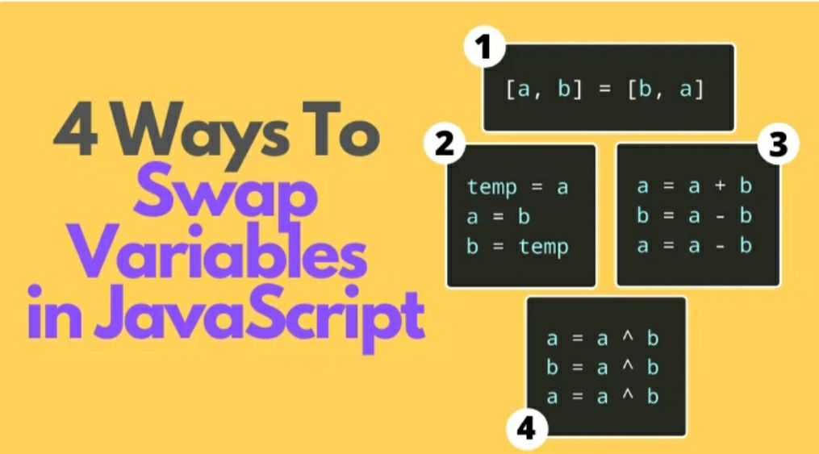 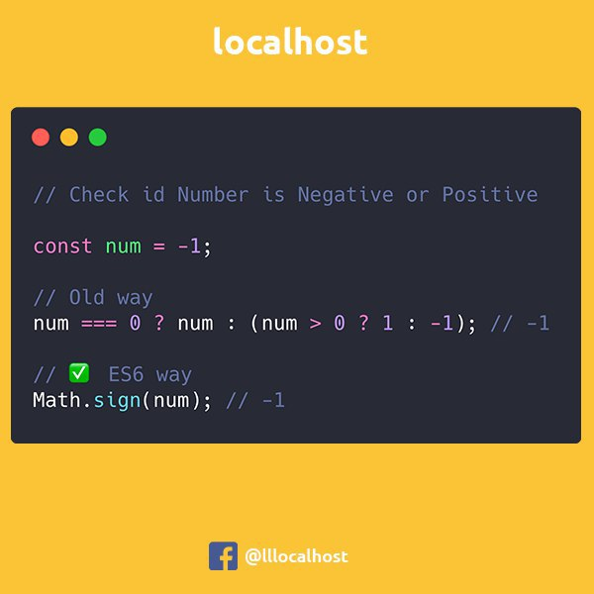

Change colors in console %c || float to integer

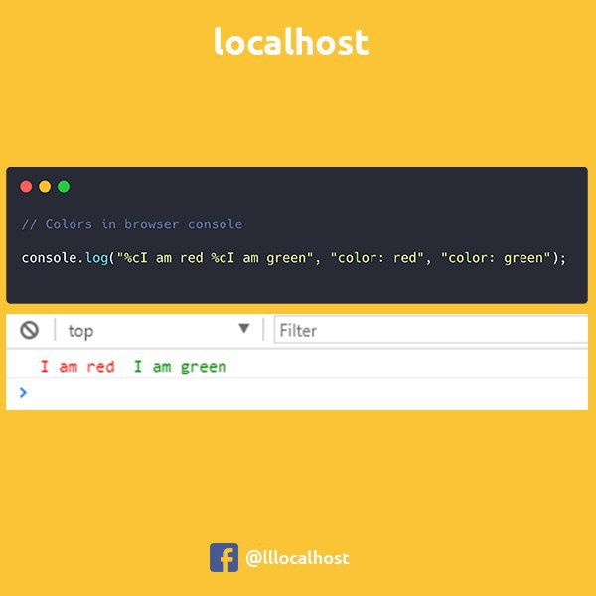 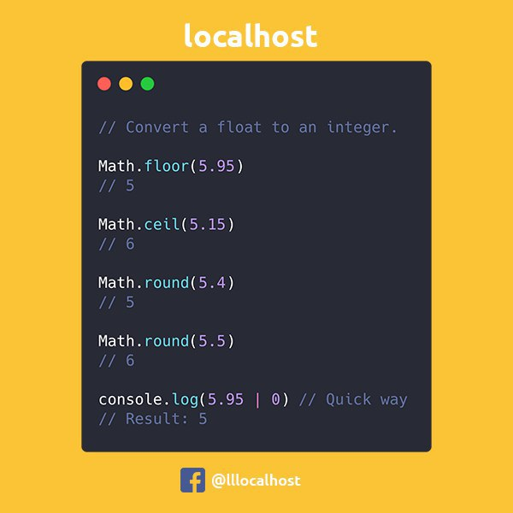

Merge two objects

let merge = Object.assign({}, obj1, obj2);;

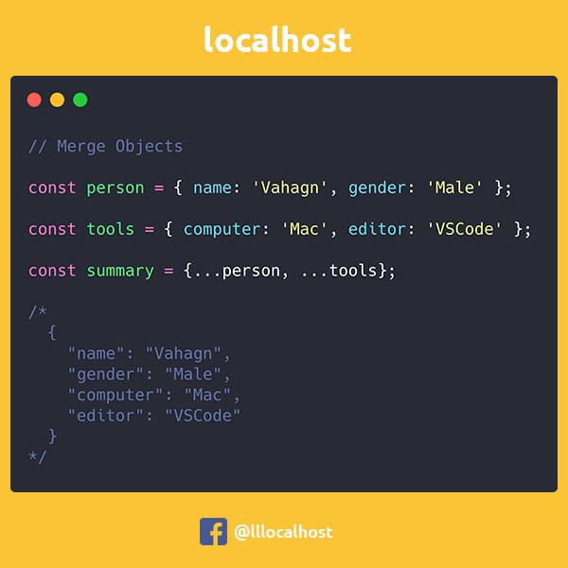

How to check is it a NaN ||split()-🡪 […splitValue]

Number.isNaN(NaN) //true  
Number.isNaN(0 / 0) //true

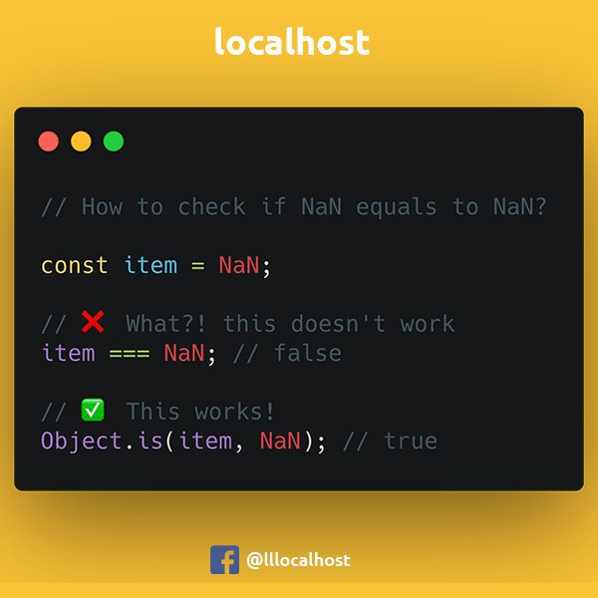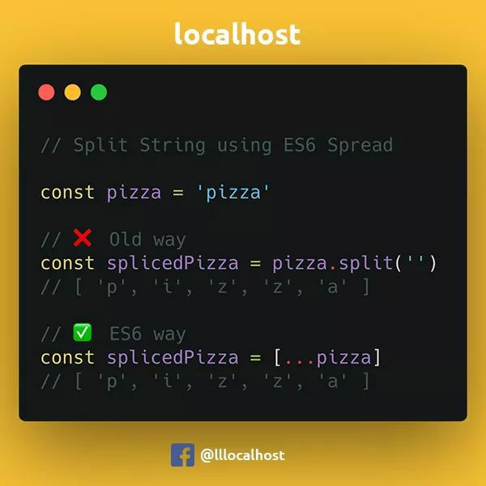

How to flat an Array

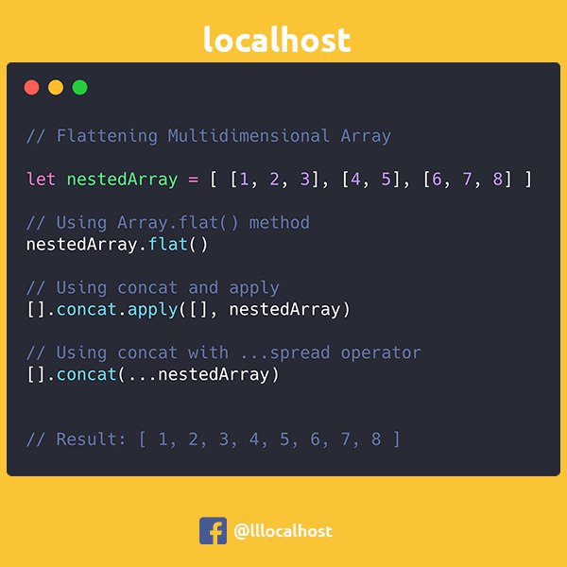

let arrOne = [2, 4, 5, 2, 4, 5, 5, 6, 3];

    let arrTwo = [...new Set(arrOne)];

    console.log(arrTwo); // [2,4,5,6,3+]

    let arrThree = arrTwo.reduce((a, b) => a + b); //20

    console.log(arrThree);

[Aga Khan Education Services](https://www.agakhanschools.org/)

St. George's Grammar School

<https://www.naics.com/six-digit-naics/?code=61>

NAICS [**Educational Services**](https://www.naics.com/naics-code-description/?code=61)

**NAICS**

Generate evc – 3 steps

e- verify returns-- 5 steps

manage itdren --- ncdl spdl --- form V and form CC

refund failure communication

fradulant pan tan

user profile management

CA user, itdrein user, individual user, HUF user, Eri user, Eri sub user, Help Desk users, Otherthan Individual, Tan users

Authorized person details, e-vault options, refund demand status, representative assess, links.

Bank account

Response to outstanding

Action management

Pre processing

Intimation 245

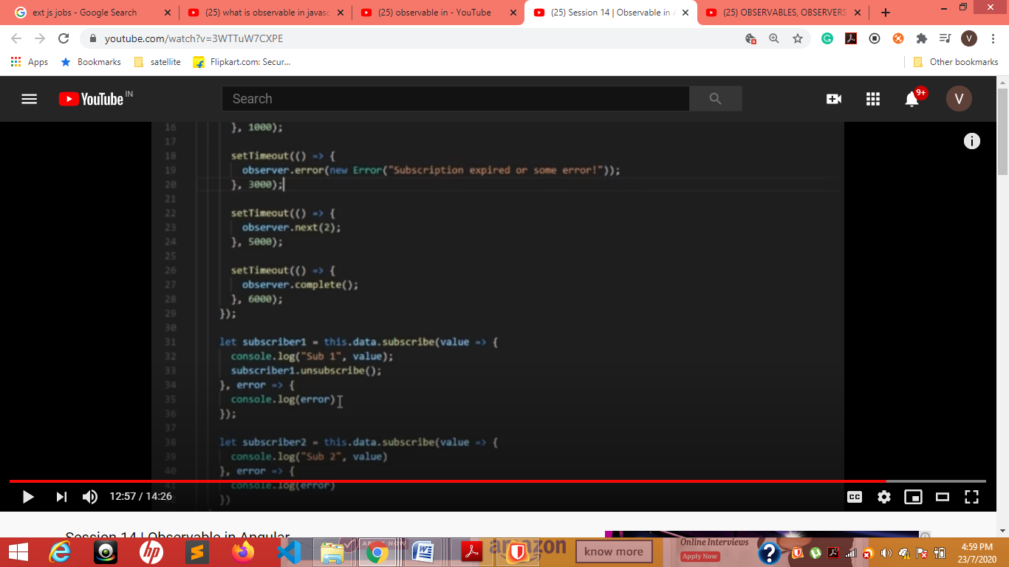

After first we got value we can un subscribe

How to convert xml file to json

<https://www.cssscript.com/convert-xml-json/>

<script src="xmlToJson.js"></script>

var json = xmlToJson.parse( xmldata );

Multipple Inheritance XXXXXXX

A--------

--🡪----C

B---------

1. class A{
2. int a;
3. ....
4. public :
5. ....
6. };
8. class B{
9. int b;
10. ...
11. public :
12. ....
13. };
15. class C: public A, public B{
16. int c;
17. .....
18. };

Multi level A-------🡪 B---------🡪 C

1. class A{
2. ...
4. };
6. class B: public A{
7. ....
9. };
11. class C: public B{
12. ....
14. };

Array largest of right

const inputArray = [1, 2, 25, 3, 42, 6];

 var newArry = []

 function maxnumber() {

        inputArray.forEach((el, startIndex) => {

            let nextNumber = -1;

            for (let i = startIndex; i < inputArray.length; i++) {

                if (inputArray[i] > el) {

                    return newArry.push({

                        [el]: inputArray[i]

                    })

                }

            }

            // no element comes in loop

            return newArry.push({

                [el]: nextNumber

            });

        })

    }

    console.log(maxnumber());

    console.log(newArry)

Before each

var ipArr = [4, 7, 6, 8, 5]

    var nwArr = [];

    var currAns = -1;

    //  function findMaxBefore() {

    //     for (var i = 0; i < ipArr.length; i++) {

    //         for (var j = i - 1; j >= 0; j--) {

    //             if (ipArr[j] > currAns && ipArr[j] < ipArr[i]) {

    //                 currAns = ipArr[j];

    //             }

    //         }

    //         nwArr.push(currAns) // observe

    //     }

    // }

    // console.log(findMaxBefore())

    // console.log(currAns)

newArry=[];

secArray=[]

  getRandomArbitrary(min, max) {

    this.newArry.push( Math.ceil (Math.random() * (max - min) + min ) )

}

otherFun(){

  for (var i = 1; i < 500; i++){

this.getRandomArbitrary(1,i)

  }

for( var j=0; j < this.newArry.length; j++){

            if(this.secArray.indexOf(this.newArry[j]) === -1) {

                this.secArray.push(this.newArry[j]);

           }

       }

console.log(this.secArray.slice(0,50))

}

secFun(){

  this.otherFun();

// this.secArray= this.newArry.slice(0,500)

for( var j=0; j < this.newArry.length; j++){

            if(this.secArray.indexOf(this.newArry[j]) === -1) {

                this.secArray.push(this.newArry[j]);

           }

       }

console.log(this.secArray.slice(0,50))

}

<https://www.tutorialspoint.com/javascript/javascript_interview_questions.htm>

How can you get the type of arguments passed to a function?

How can you get the total number of arguments passed to a function?

function func(x){

console.log(typeof x, arguments.length);

}

func(); //==> "undefined", 0

func(1); //==> "number", 1

func("1", "2", "3"); //==> "string", 3

How can you get the reference of a caller function inside a function?

function func() {

return arguments.callee;

}

func(); // ==> func

What is closure?

Closures are created whenever a variable that is defined outside the current scope is accessed from within some inner scope.

Give an example of closure?

function create() {

var counter = 0;

return {

increment: function() {

counter++;

},

print: function() {

console.log(counter);

}

}

}

var c = create();

c.increment();

c.print(); // ==> 1

check---------------------------------

Var Arr =[1,2,3,4,12,1,2,3,4]

newArr = [ ]

count = 0;

// Obj={1:2,2:2,3:2,4:2,12:1}

Function reperEleFun(Arr){

Arr.forEach((val, ind)=>{

For( var I = ind ; i< Arr.length; i++){

If(Arr[ind]== Arr[i]){

Count++;

newArr.push({[ Arr[ind] ]: Count})

}

}

})

}

reperEleFun(Arr);

var a = [1,2,3,4]

var b = a;

b[0] = "test"

console.log(a)

console.log(b)

https://medium.com/@amirdanish126/how-to-count-duplicate-value-in-an-array-in-javascript-e942b59af8f2

myArray = [‘a’,’b’,’c’,’a’,’c’,’a’];

output:{ a: 3, b: 1, c: 2 }

— — — — — — —here how we should do it — — — — — — —

var result = {};  
myArray.forEach(function(x) {

result[x] = (result[x] || 0) + 1;

});

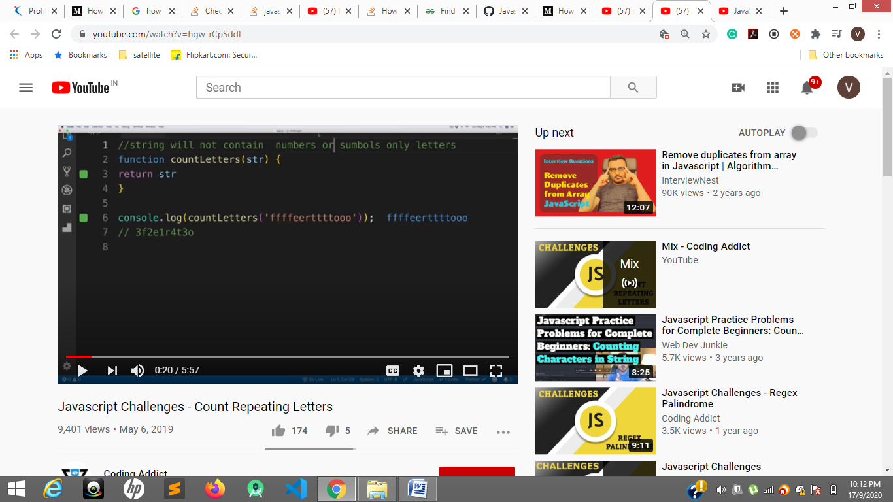

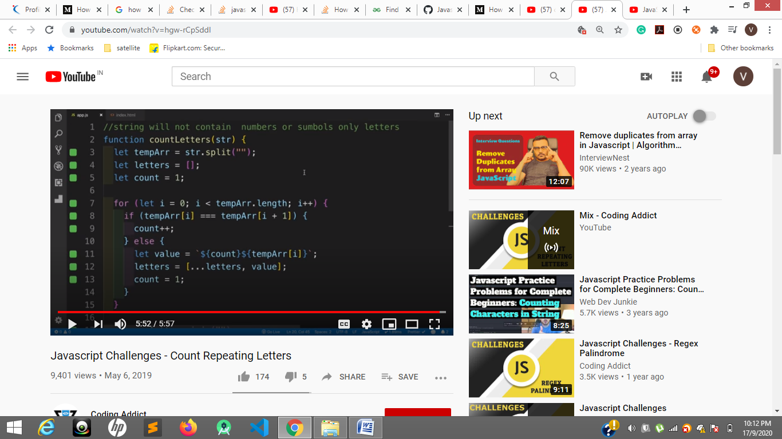

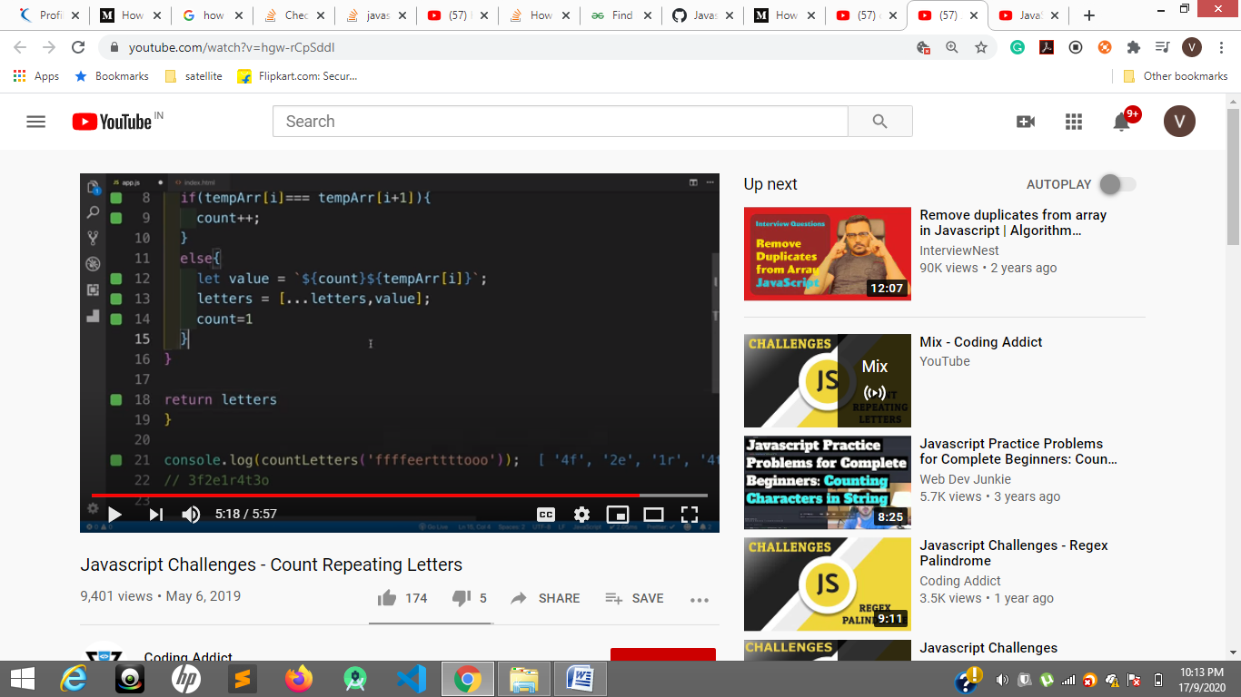

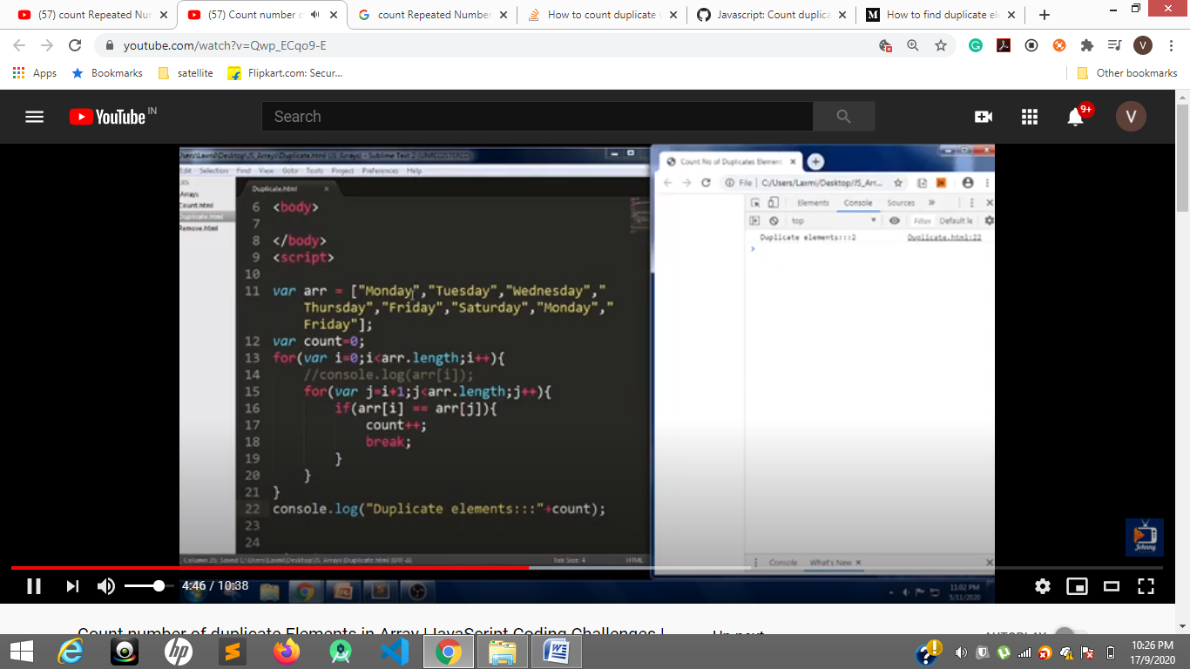

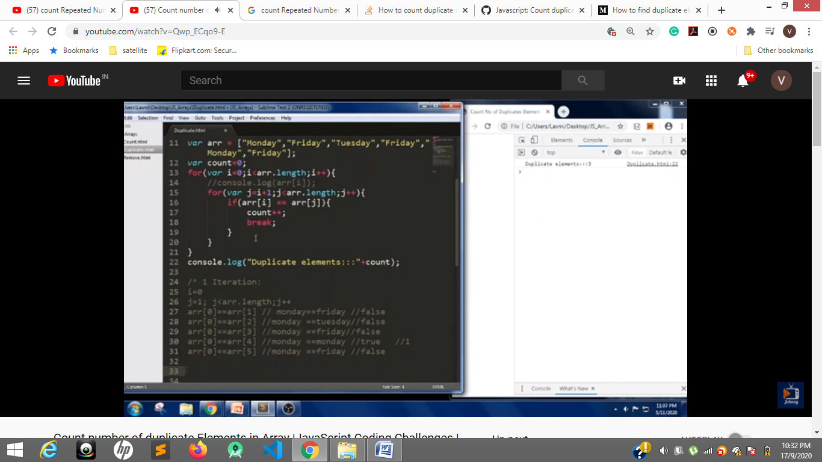

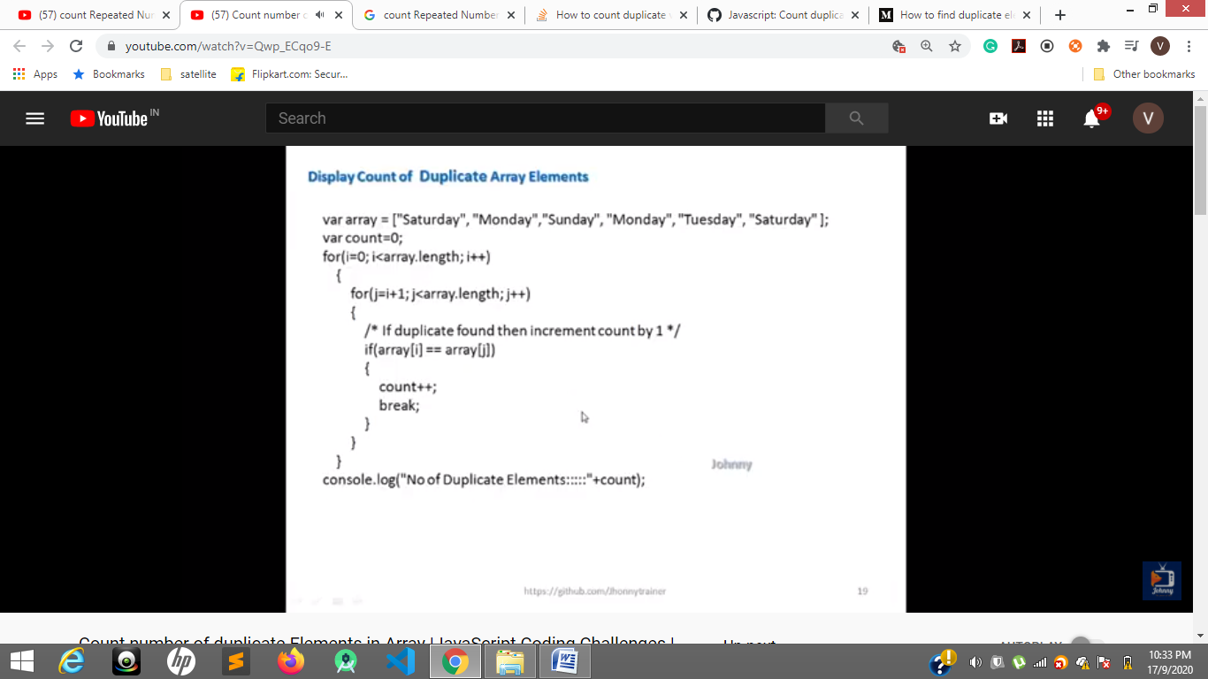

To write a code in console press SHIFT + Enter to get into next step

|  |
| --- |
| function compressArray(original) { |
|  |  |
|  | var compressed = []; |
|  | // make a copy of the input array |
|  | var copy = original.slice(0); |
|  |  |
|  | // first loop goes over every element |
|  | for (var i = 0; i < original.length; i++) { |
|  |  |
|  | var myCount = 0; |
|  | // loop over every element in the copy and see if it's the same |
|  | for (var w = 0; w < copy.length; w++) { |
|  | if (original[i] == copy[w]) { |
|  | // increase amount of times duplicate is found |
|  | myCount++; |
|  | // sets item to undefined |
|  | delete copy[w]; |
|  | } |
|  | } |
|  |  |
|  | if (myCount > 0) { |
|  | var a = new Object(); |
|  | a.value = original[i]; |
|  | a.count = myCount; |
|  | compressed.push(a); |
|  | } |
|  | } |
|  |  |
|  | return compressed; |
|  | }; |
|  |  |
|  | // It should go something like this: |
|  |  |
|  | var testArray = new Array("dog", "dog", "cat", "buffalo", "wolf", "cat", "tiger", "cat"); |
|  | var newArray = compressArray(testArray); |
|  |  |
|  | /* |
|  | console: [ |
|  | Object { value="dog", count=2}, |
|  | Object { value="cat", count=3}, |
|  | Object { value="buffalo", count=1}, |
|  | Object { value="wolf", count=1}, |
|  | Object { value="tiger", count=1} |
|  | ] |
|  | */ |

Callback(),promise(), async await

<https://www.youtube.com/watch?v=cjrOxszo6No>

function myFunction() {

console.log("a")

setTimeout(function(){ console.log("b"); }, 0);

console.log("c")

}

 <body>

    <div>one div</div>

    <script>

        var a = 20;

        console.log(a)

    </script>

    <p>para</p>

</body>

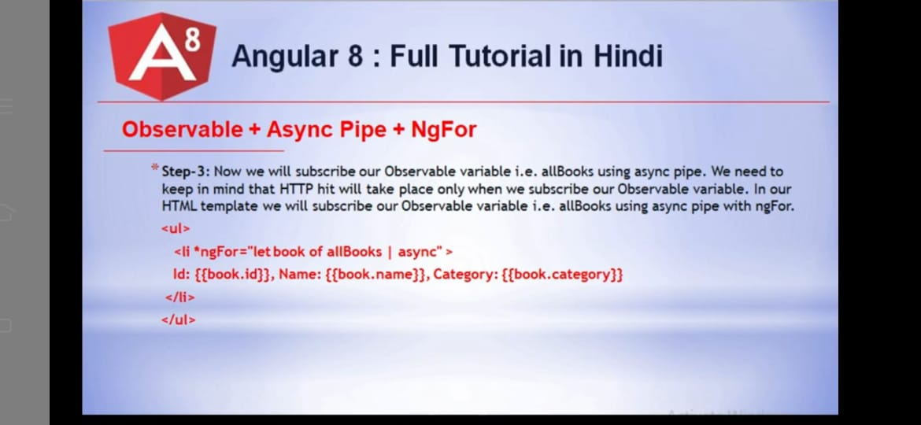

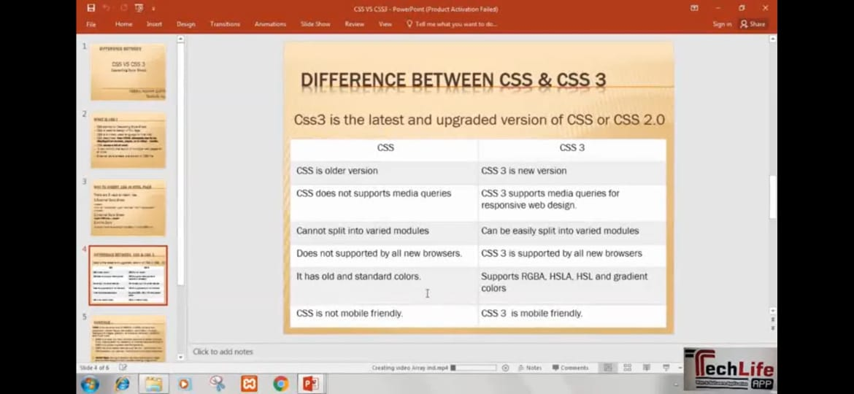

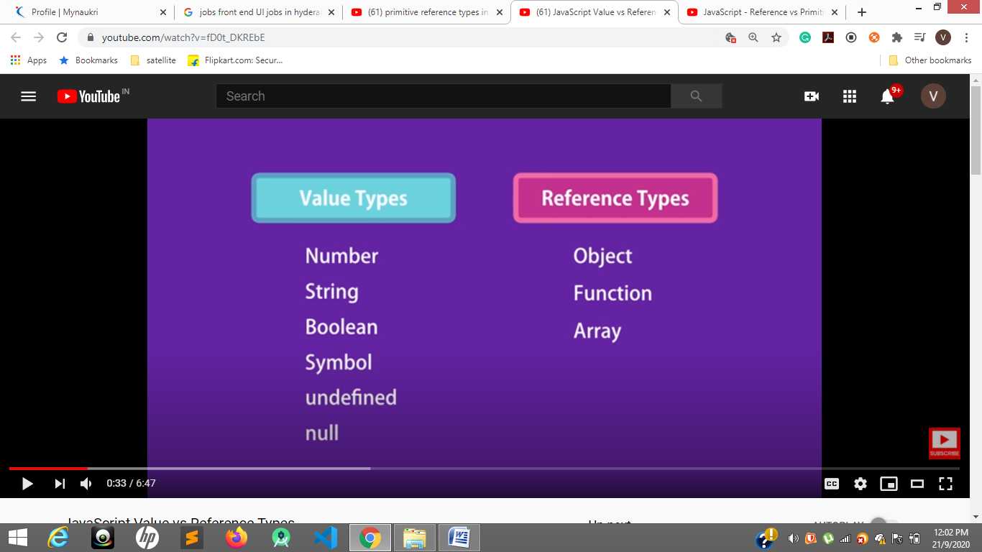

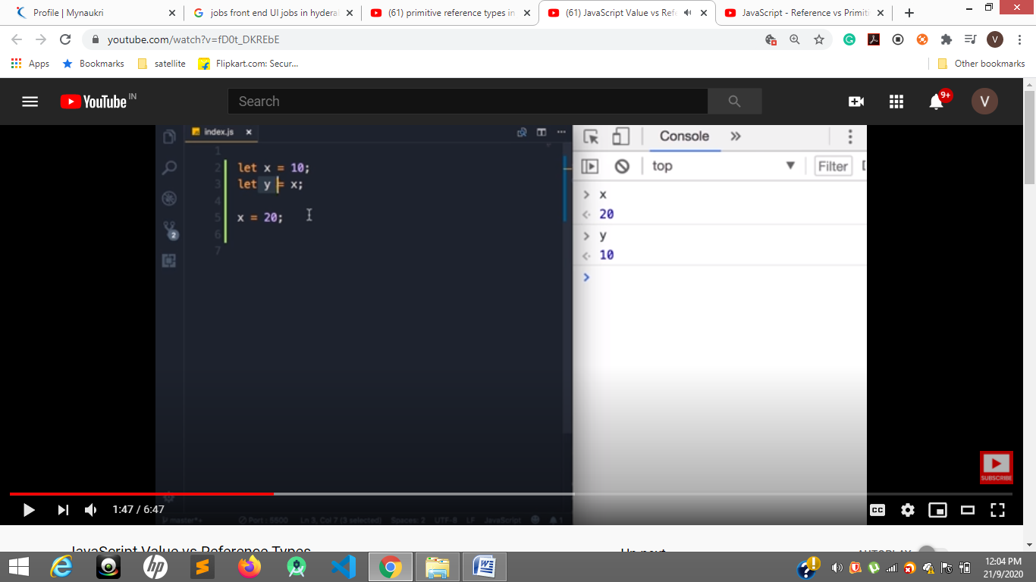

Both x and y are independent

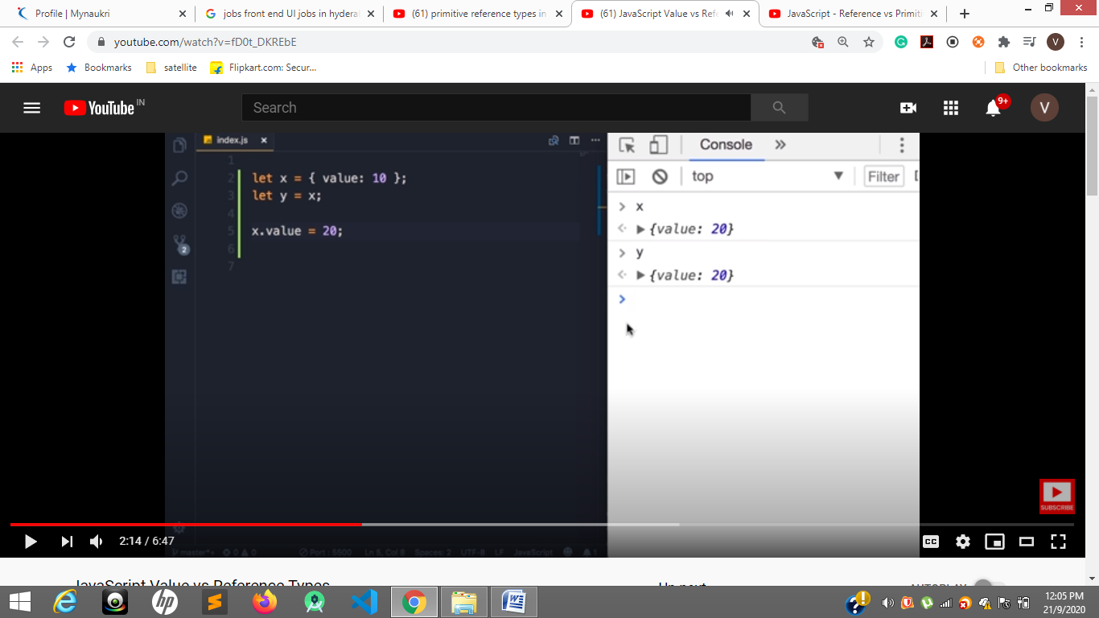

Now they are reference with object so x and y both same and stored in memory

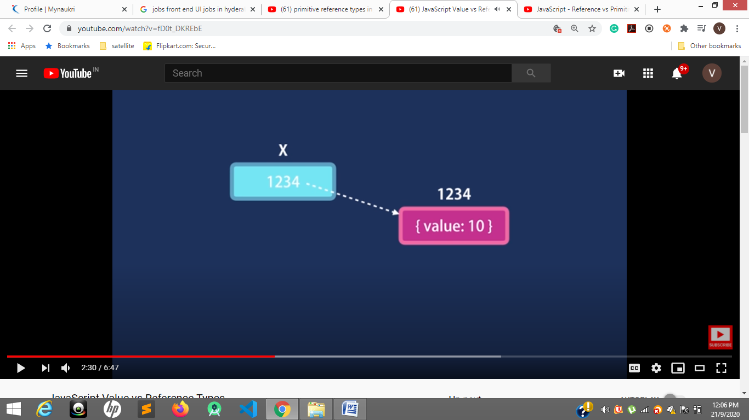

In y= x the address of x is copied so x and y has same memory of that object

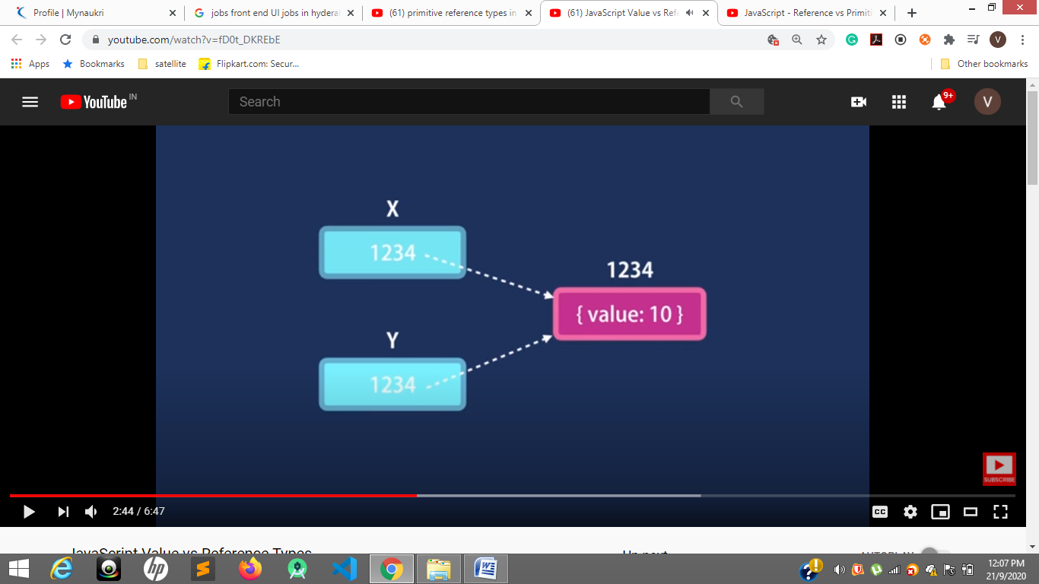

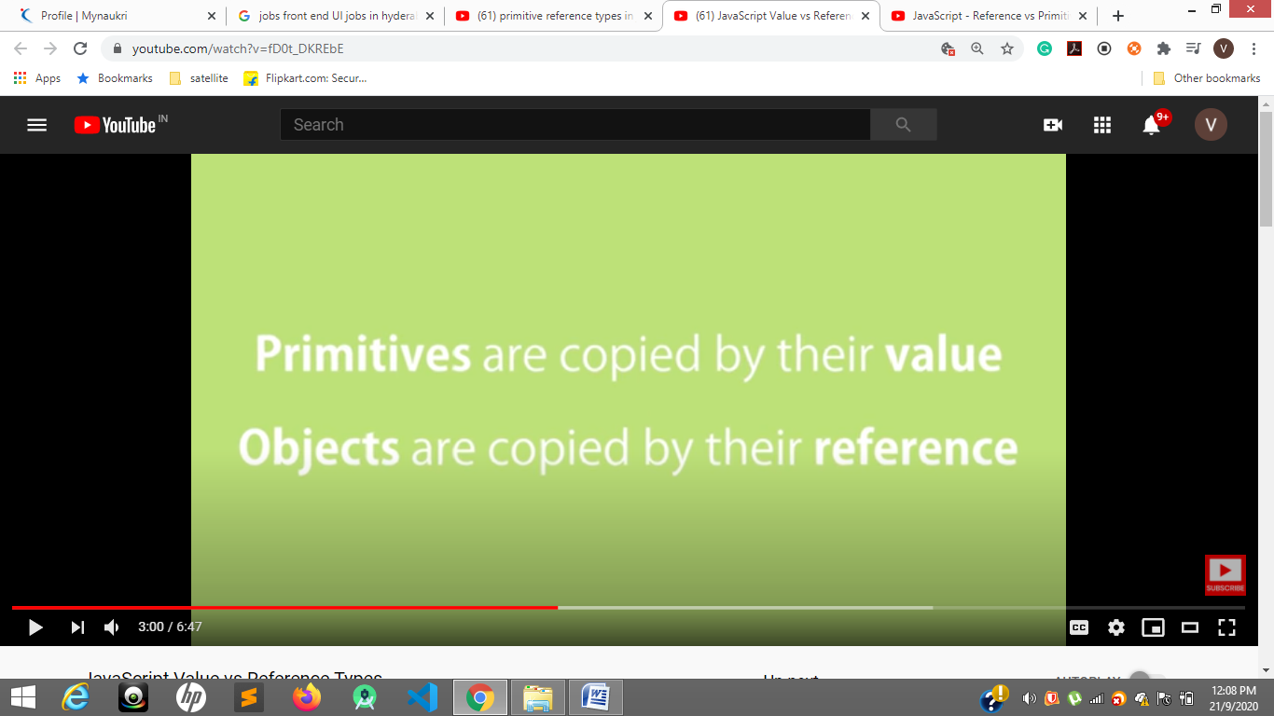

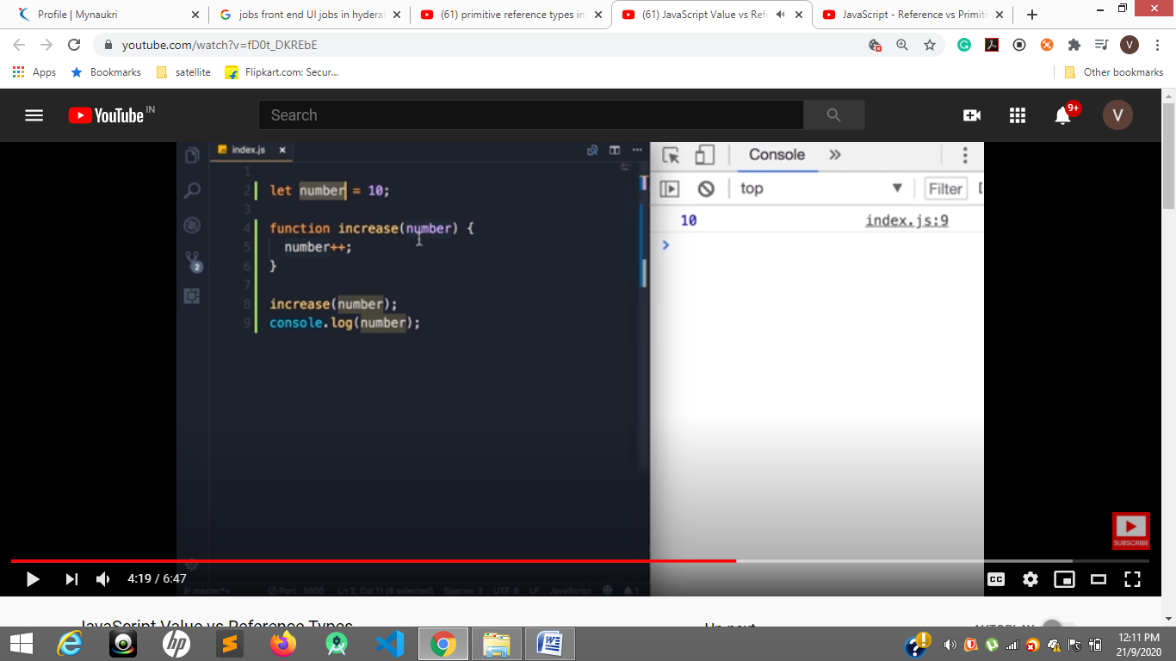

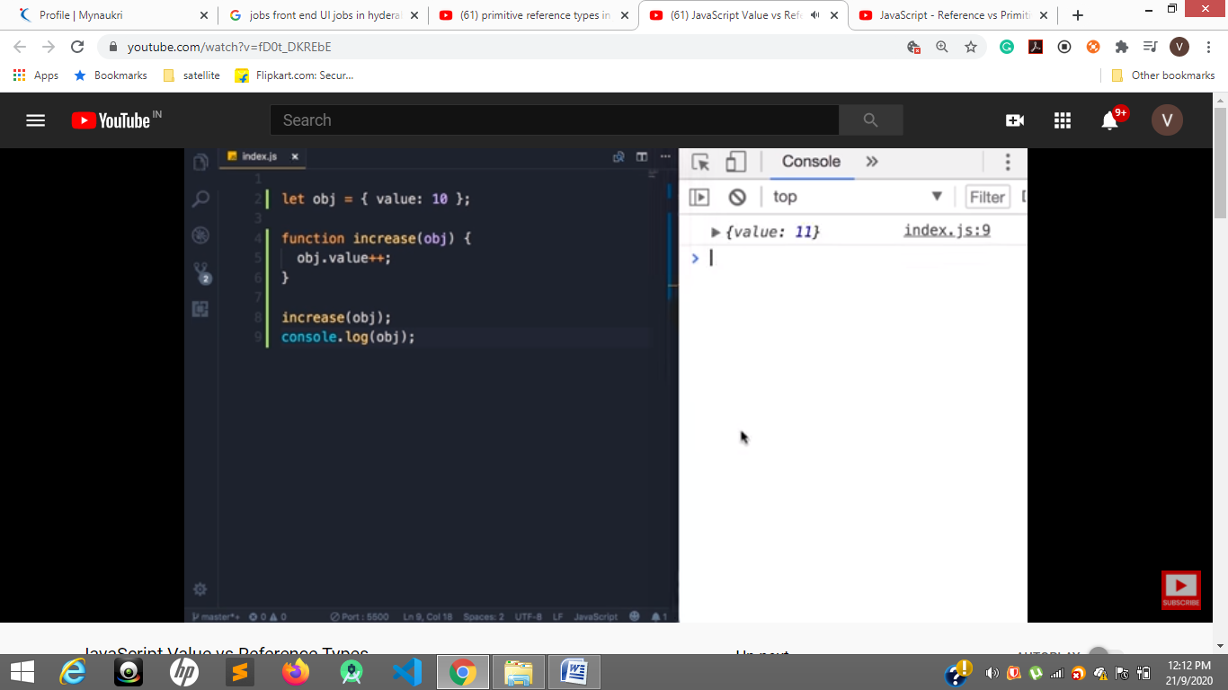

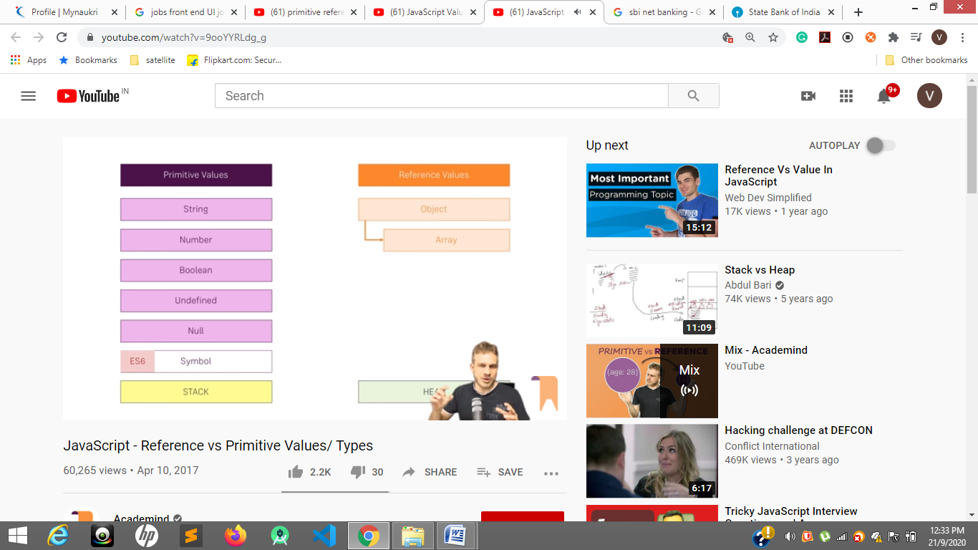

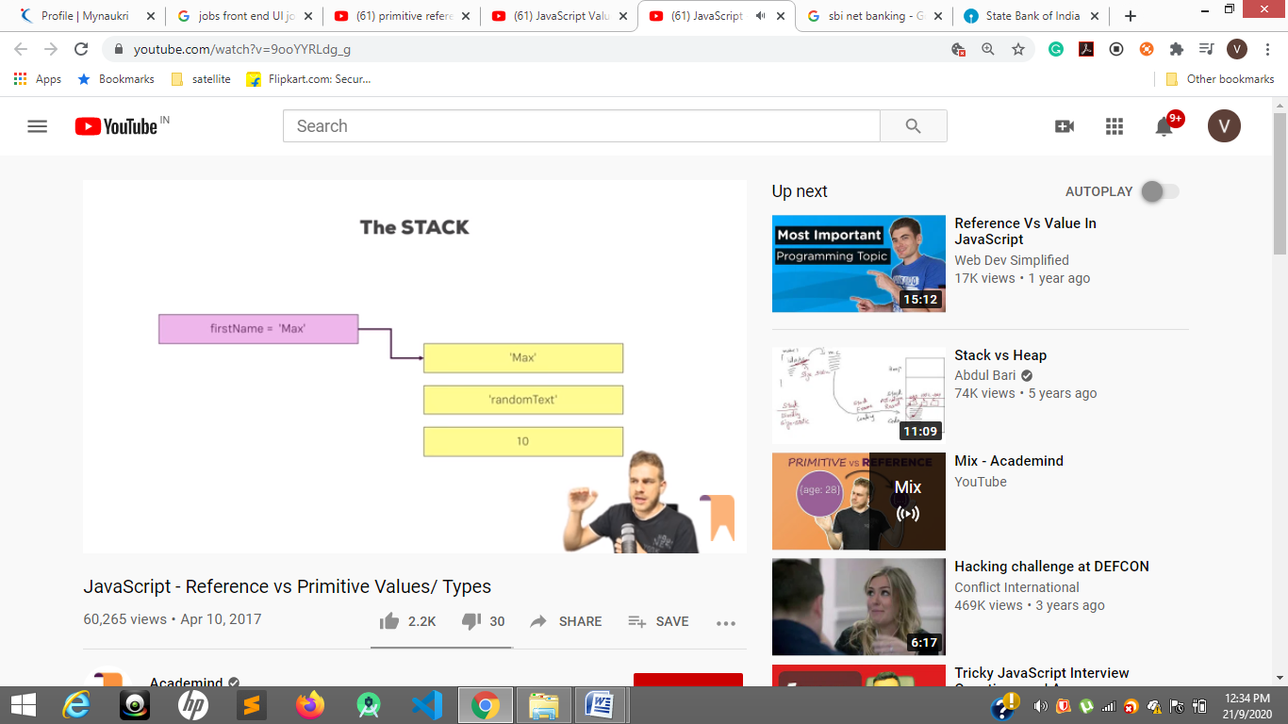

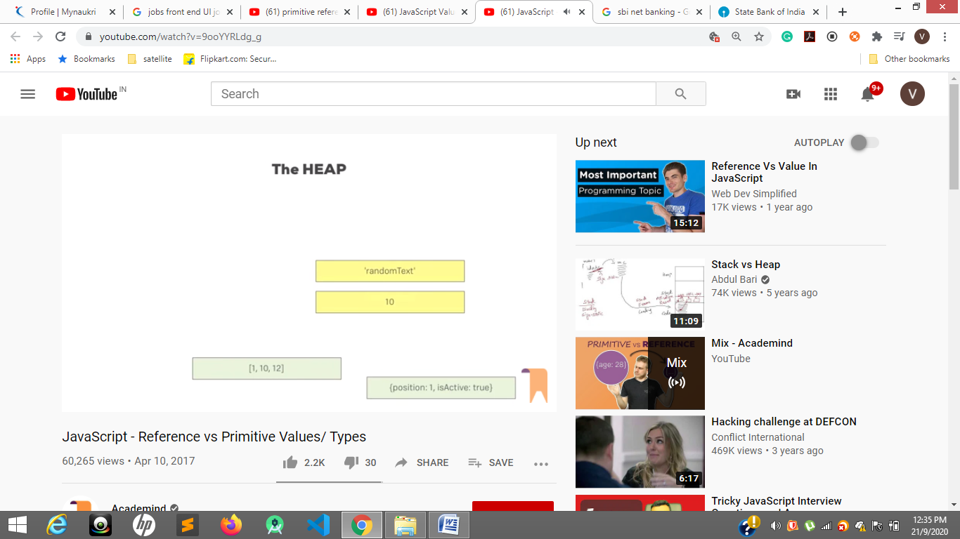

Object.freeze

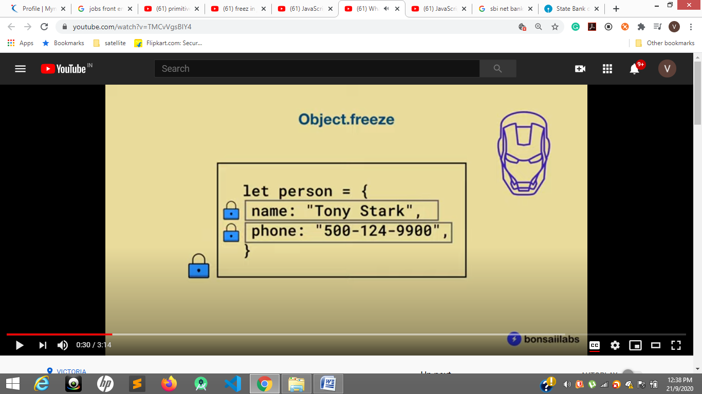

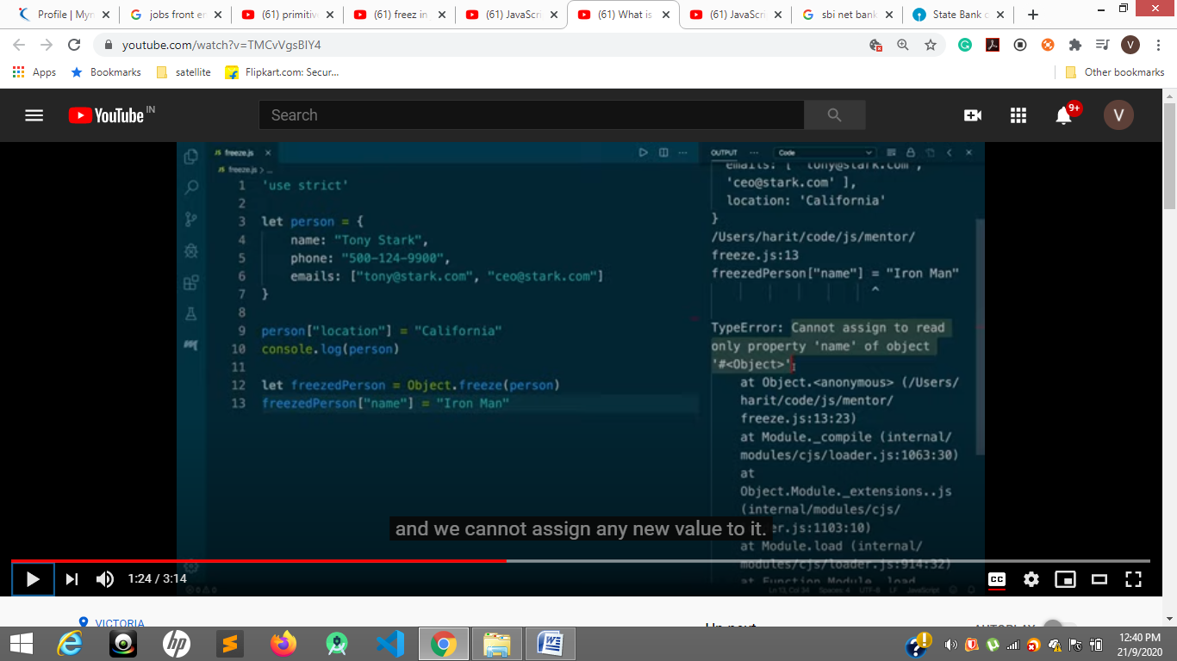

<https://developer.mozilla.org/en-US/docs/Web/JavaScript/Reference/Global_Objects/Object/seal>

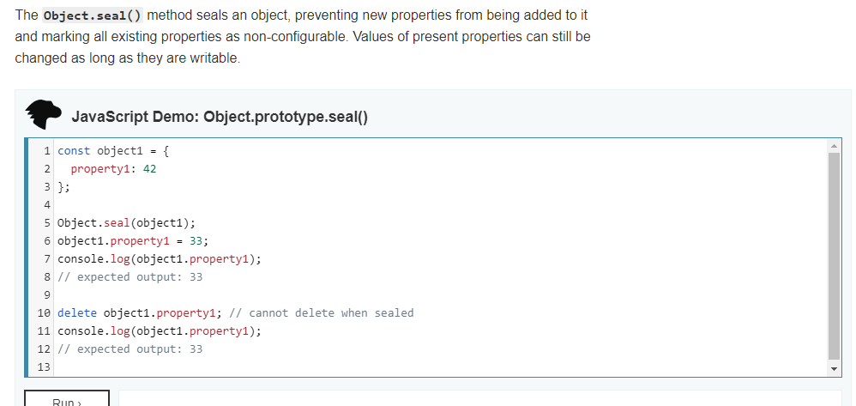

Object.freeze(obj)----even values we cannot update or change

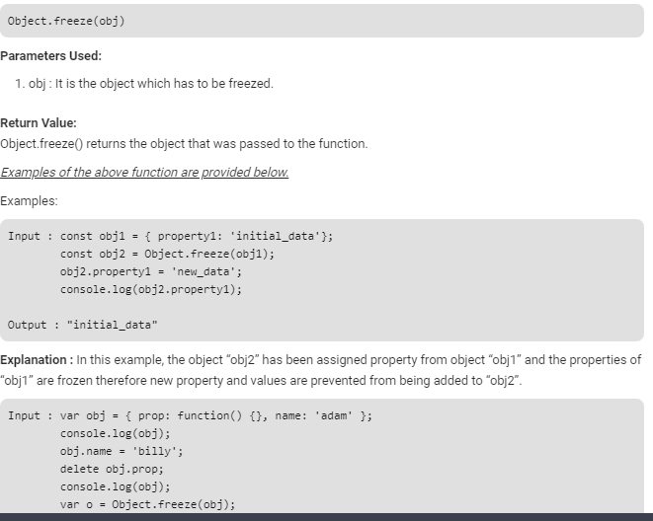

<https://developer.mozilla.org/en-US/docs/Web/JavaScript/Reference/Functions/Arrow_functions>

An **arrow function expression** is a compact alternative to a traditional [function expression](https://developer.mozilla.org/en-US/docs/Web/JavaScript/Reference/Operators/function), but is limited and can't be used in all situations.

**Differences & Limitations:**

* Does not have its own bindings to [this](https://developer.mozilla.org/en-US/docs/Web/JavaScript/Reference/Operators/this) or [super](https://developer.mozilla.org/en-US/docs/Web/JavaScript/Reference/Operators/super), and should not be used as [methods](https://developer.mozilla.org/en-US/docs/Glossary/Method).
* Does not have [arguments](https://developer.mozilla.org/en-US/docs/Web/JavaScript/Reference/Functions/arguments), or [new.target](https://developer.mozilla.org/en-US/docs/Web/JavaScript/Reference/Operators/new.target) keywords.
* Not suitable for [call](https://developer.mozilla.org/en-US/docs/Web/JavaScript/Reference/Global_Objects/Function/call), [apply](https://developer.mozilla.org/en-US/docs/Web/JavaScript/Reference/Global_Objects/Function/apply) and [bind](https://developer.mozilla.org/en-US/docs/Web/JavaScript/Reference/Global_Objects/Function/bind) methods, which generally rely on establishing a [scope.](https://developer.mozilla.org/en-US/docs/Glossary/Scope)
* Can not be used as [constructors](https://developer.mozilla.org/en-US/docs/Glossary/constructor).
* Can not use [yield](https://developer.mozilla.org/en-US/docs/Web/JavaScript/Reference/Operators/yield), within its body.

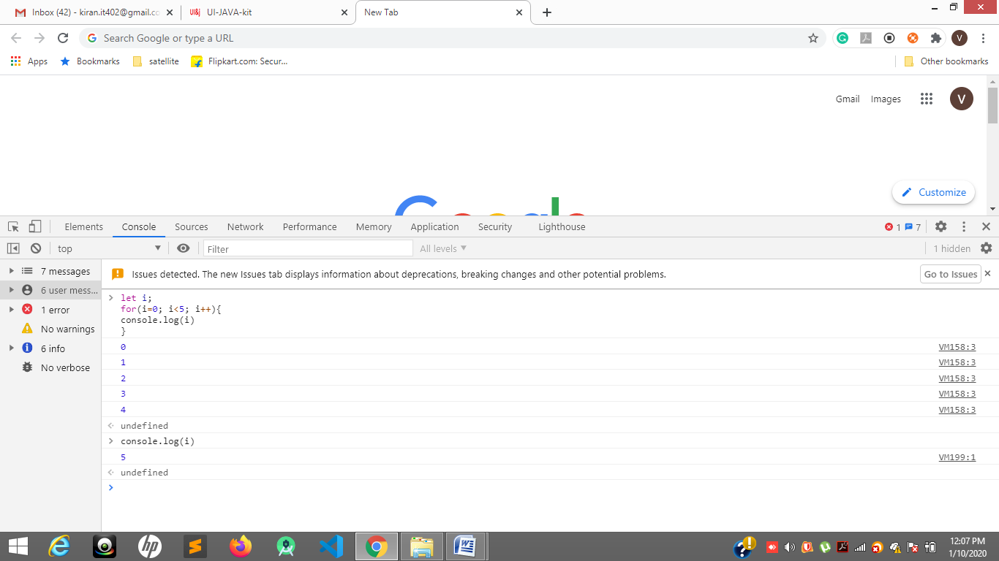

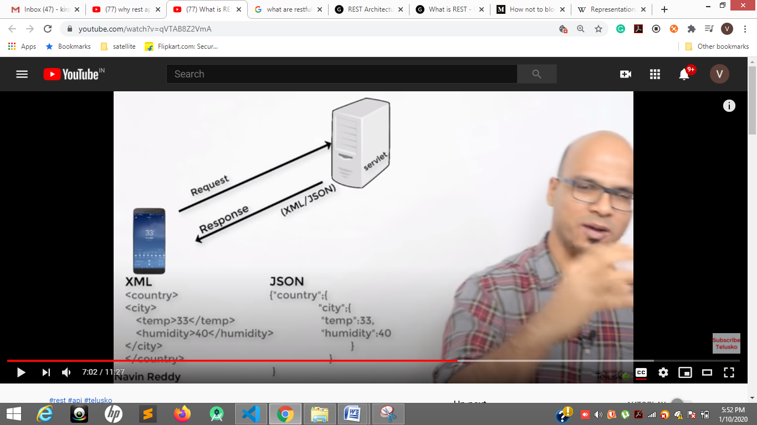

The object we are sending state of an object i.e representational state

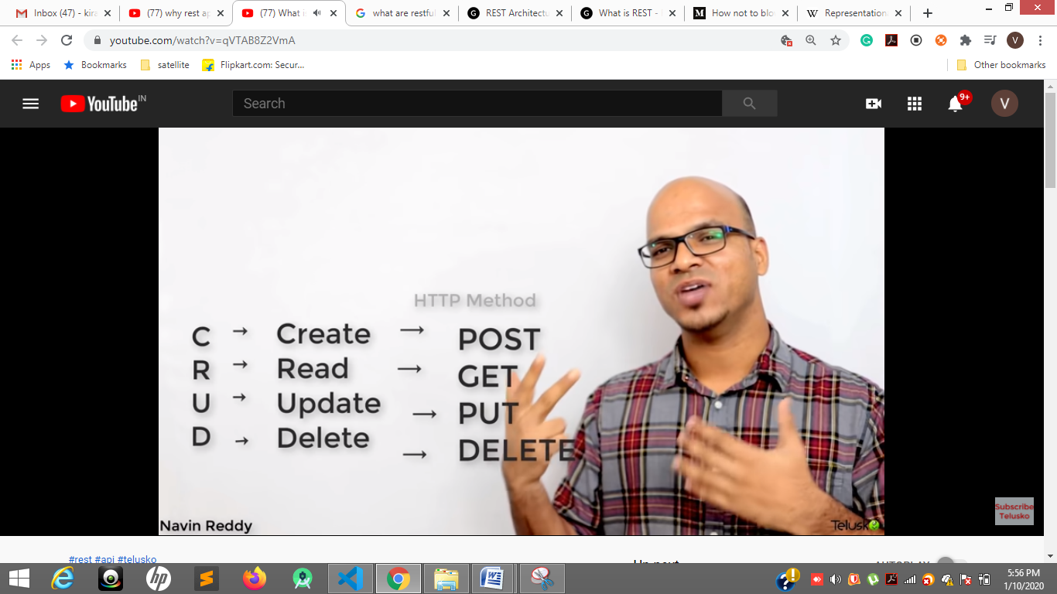

Soap

REST was created to address the problems of SOAP. Therefore it has a more flexible architecture. It consists of only loose guidelines and lets developers implement the recommendations in their own way. It allows different messaging **formats, such as HTML, JSON, XML, and plain text, while SOAP only allows XML.** REST is also a more lightweight architecture, so RESTful web services have a better performance. Because of that, it has become incredibly popular in the mobile era where even a few seconds matter a lot (both in page load time and revenue).

Ivy new rendering engine

<https://www.youtube.com/watch?v=Lexyv6up-ww>



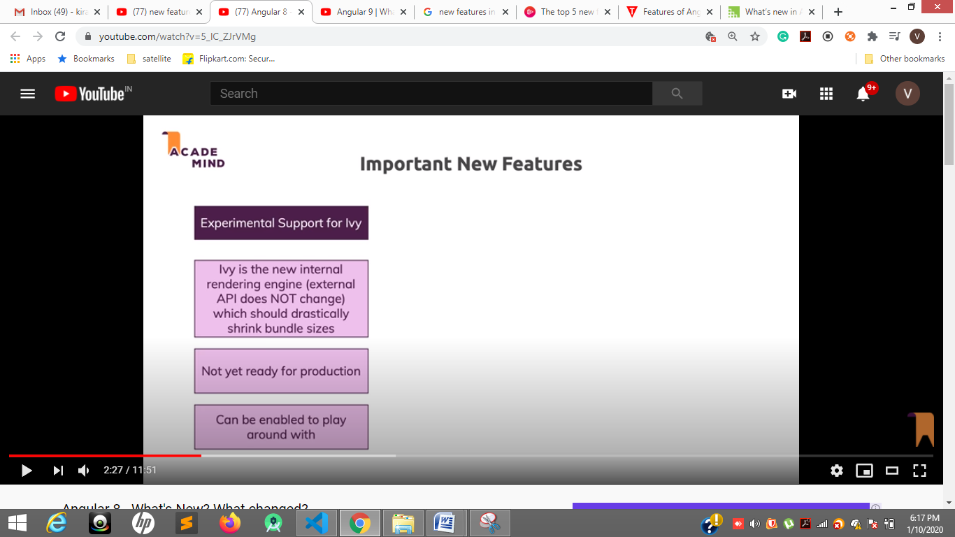

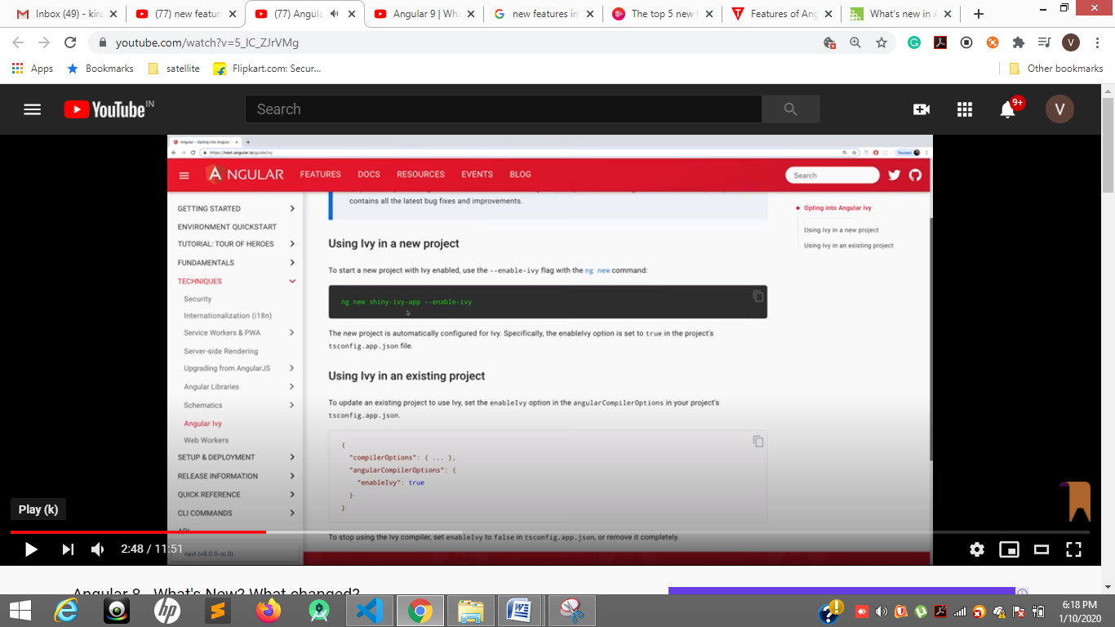

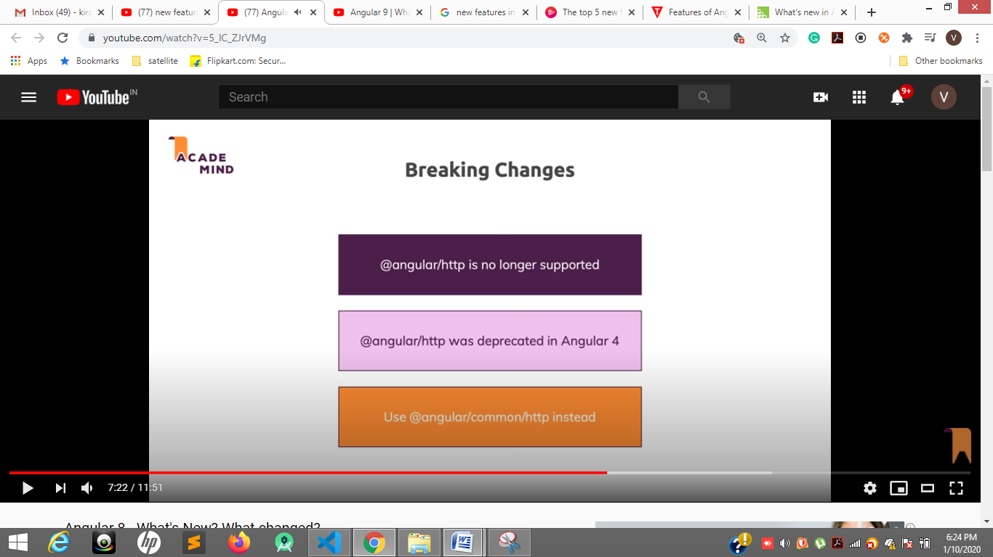

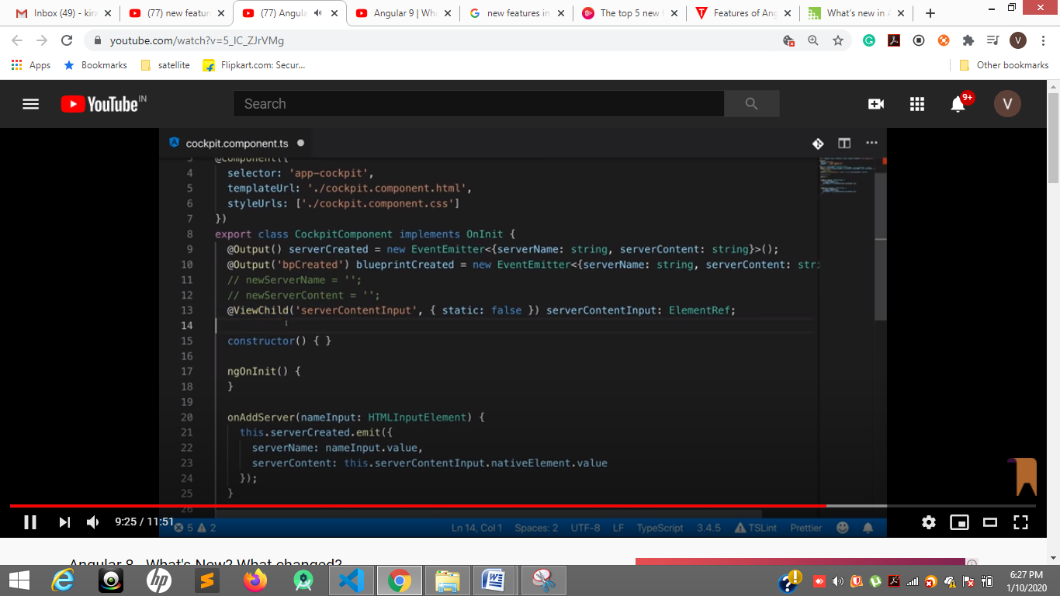

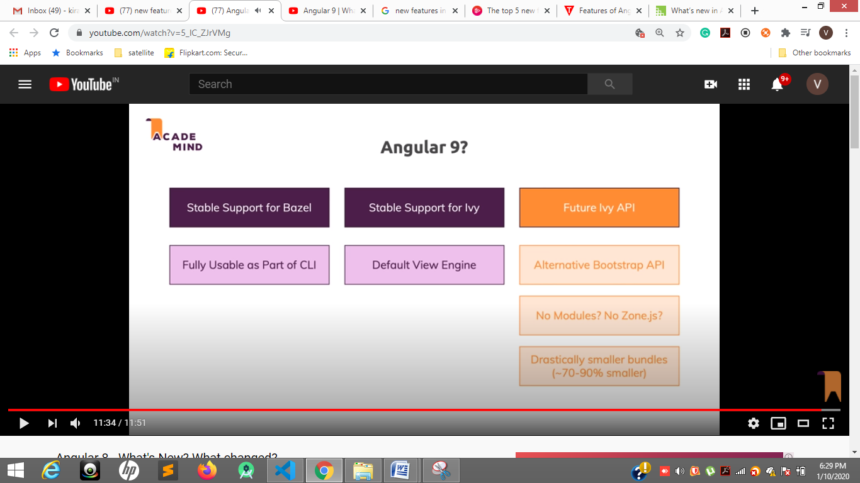

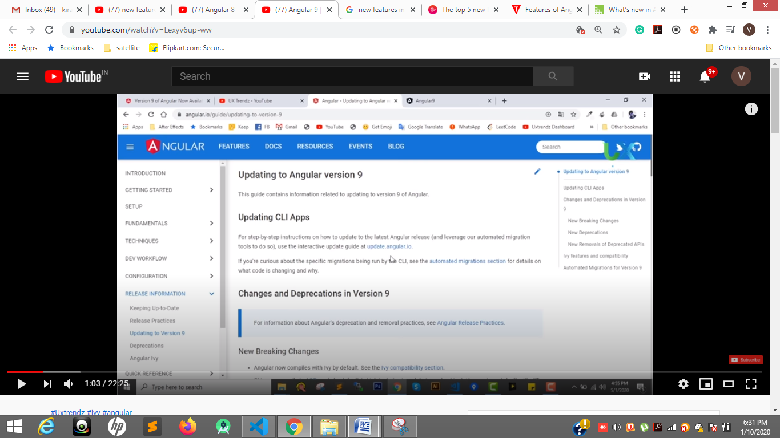

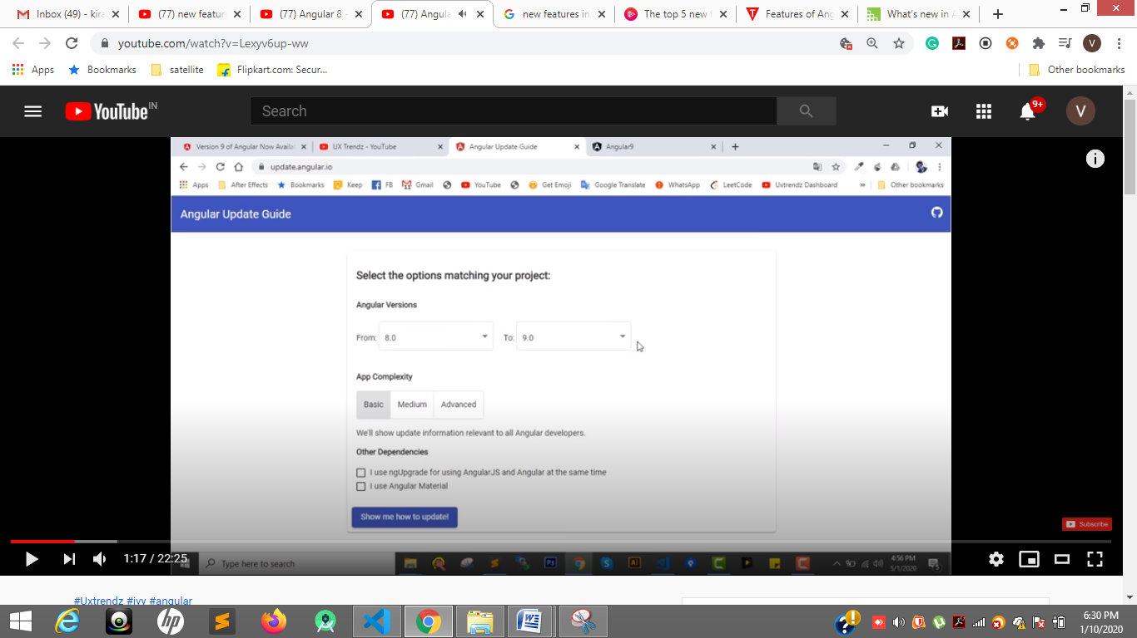

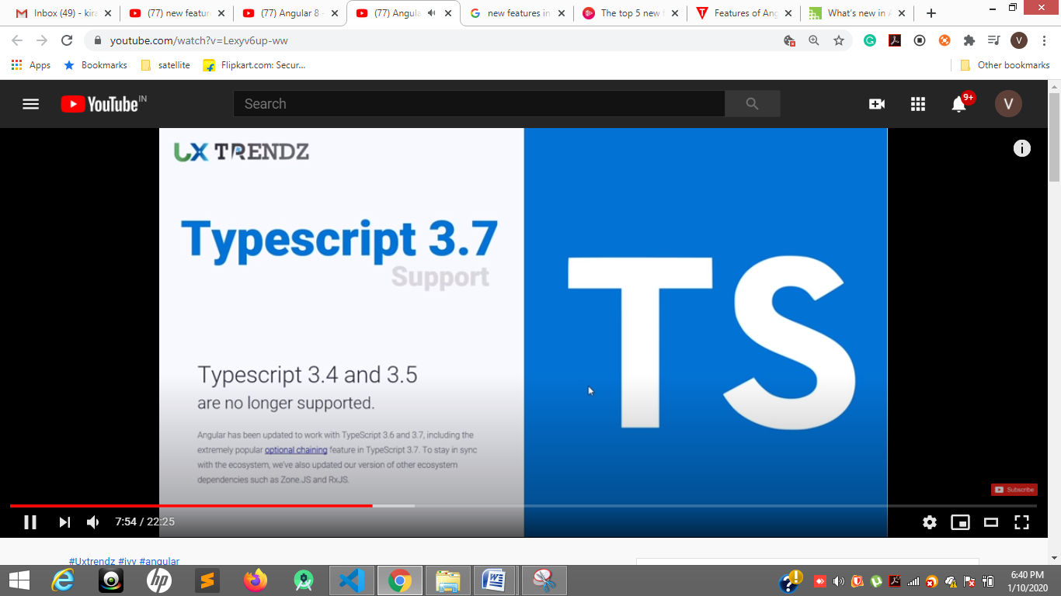

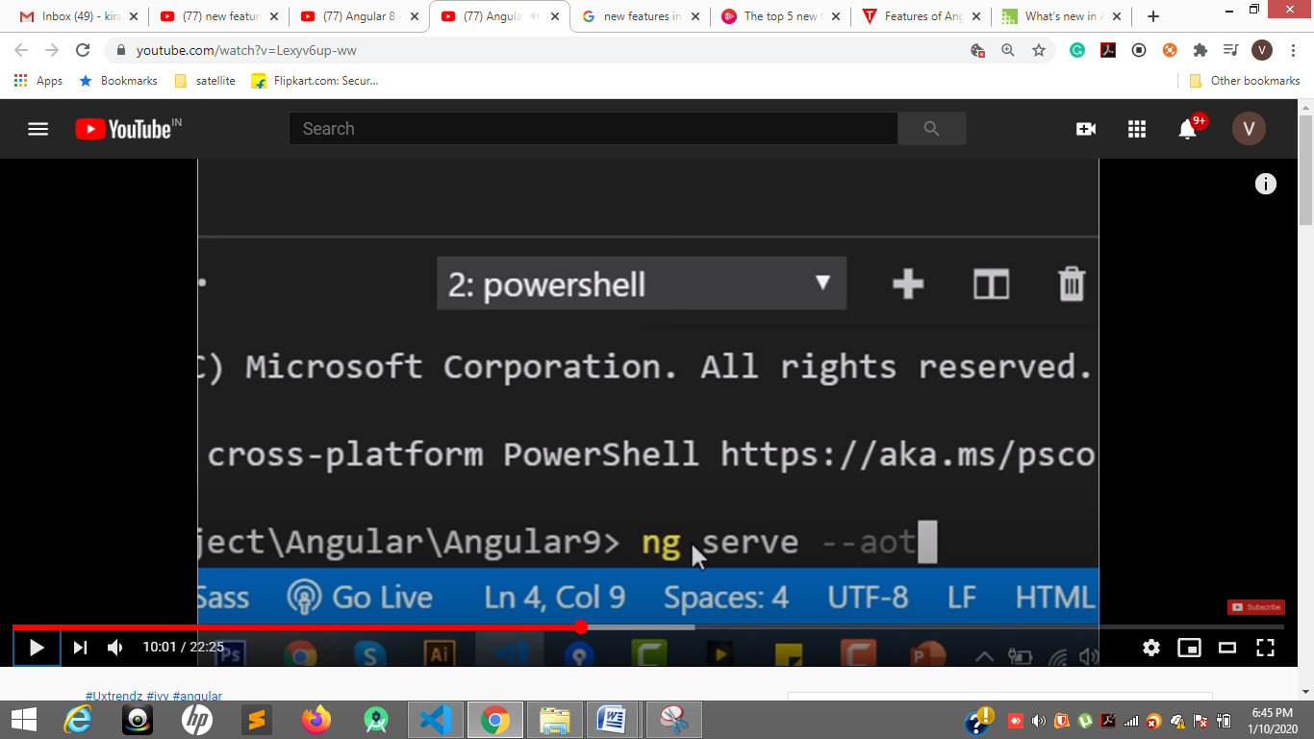

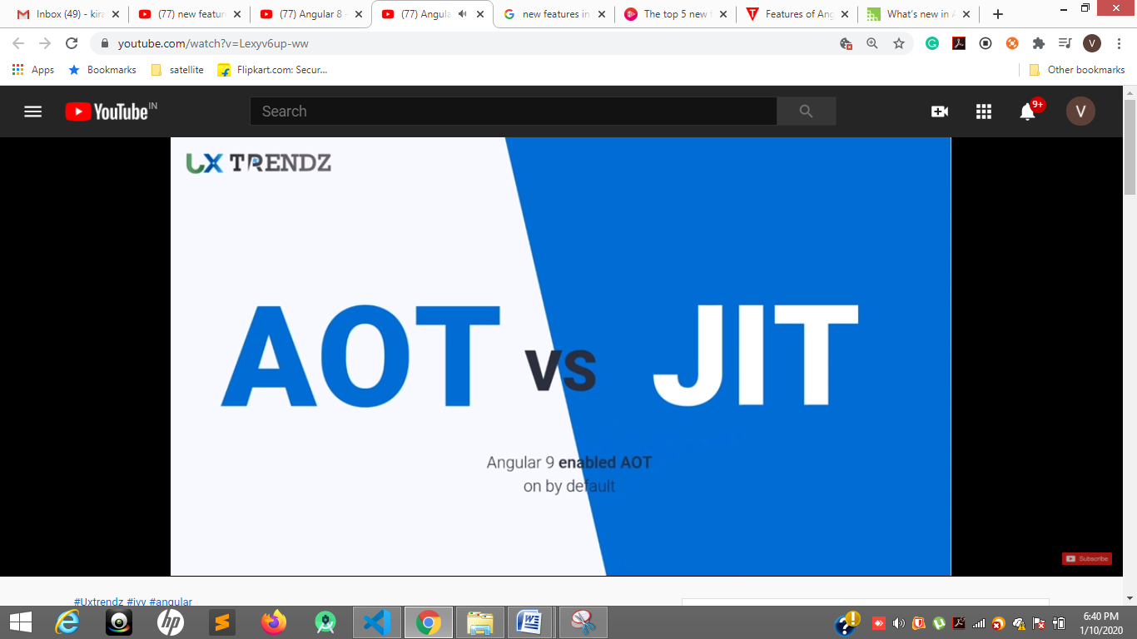

JIT if we run ng s if error other component after reacing to that component it give error But by defaul AOT while compilation itself it will through error.

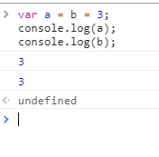

 var empName = 'ravi'

    var length = 10;

    var width = 10;

    let user = {

        empName: "GFG",

        gfg1: () => {

            var length = 2;

            var width = 4;

            console.log(this == window) // true

                // console.log(this.empName); // ravi // Unlike regular functions, arrow functions do not have their own this.

                // console.log("hello 1" + this.name); // no 'this' binding here

            console.log(this.length * this.width);

        },

        gfg2() {

            // var length = 5;

            // var width = 4;

            console.log(this == window) // false

            console.log(length * width);

            // console.log(this.empName); // GFG

            // console.log("Welcome to 2" + this.name); // 'this' binding works here

        }

    };

    user.gfg1();

    user.gfg2();

arrow functions

<https://levelup.gitconnected.com/arrow-function-vs-regular-function-in-javascript-b6337fb87032>

Pros:

1. It reduces a lot of code and makes it more readable.
2. The greatest advantage of having contextual “this”, no longer need to “bind” functions any more.
3. Most modern browsers support Arrow Functions out of the box. Although I will still advice using a transpiler like Bable to polyfill for backward compatibility.

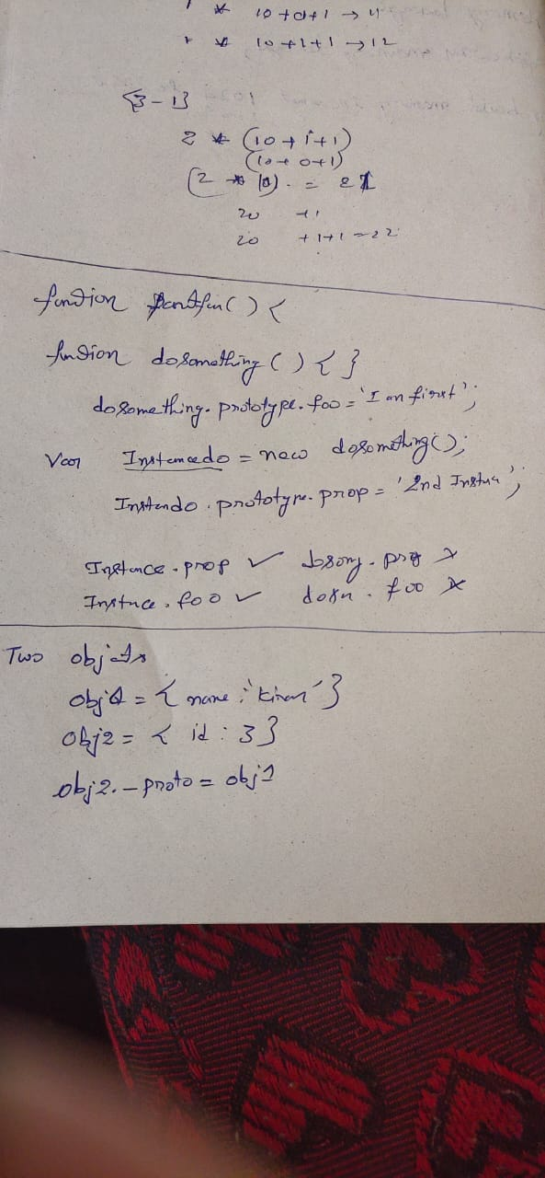

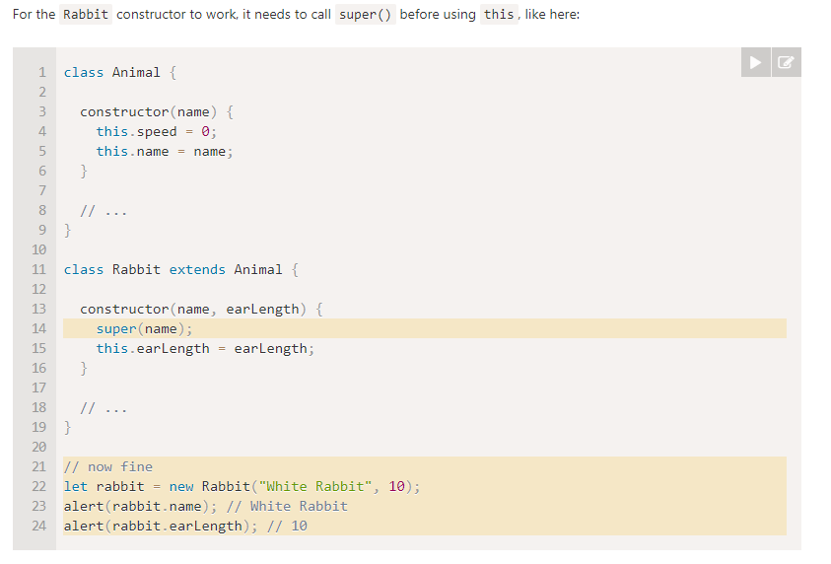

<https://javascript.info/prototype-inheritance>

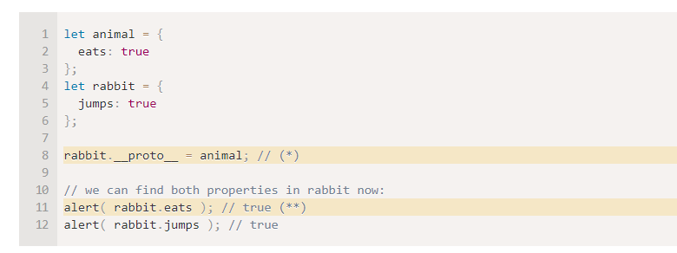

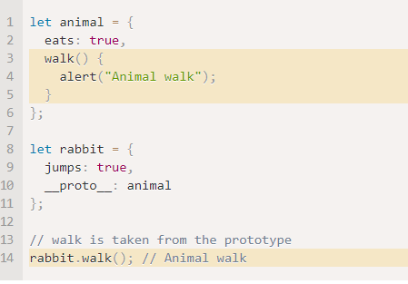

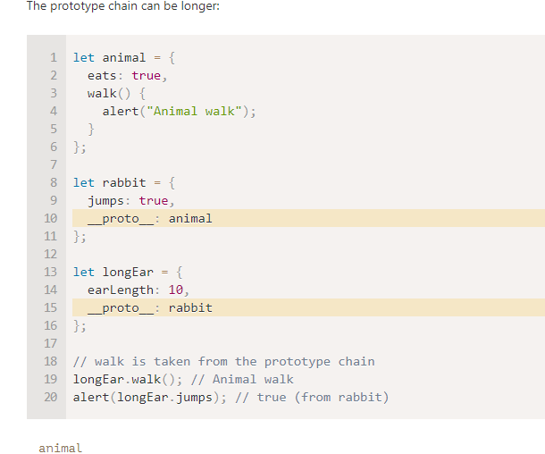

Observe 19 line

<https://www.geeksforgeeks.org/explain-the-differences-between-for-in-and-for-of-statement-in-javascript/>

For in----object , for of is for array, string,

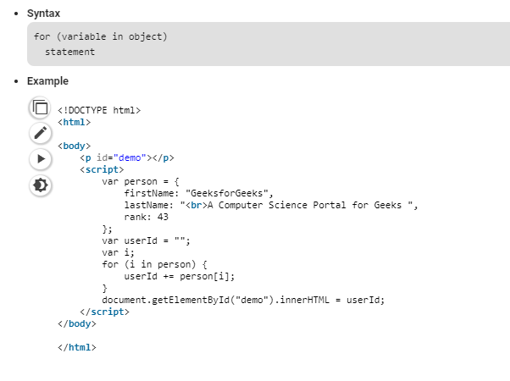

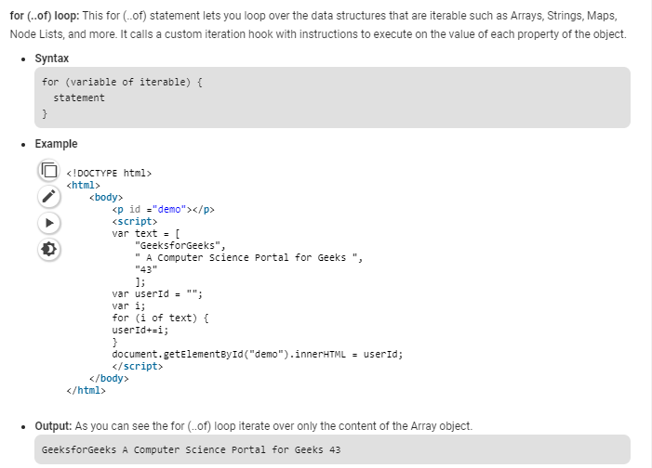

Difference btwn function and method

<https://medium.com/predict/javascript-functions-vs-methods-and-other-helpful-tips-e58a621b1d27>

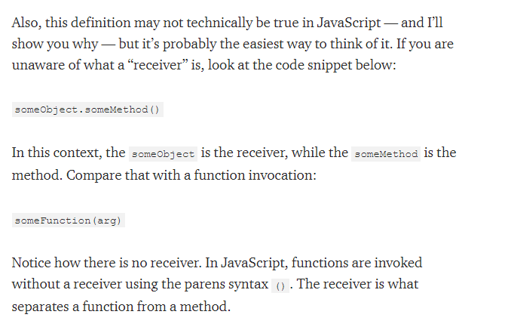

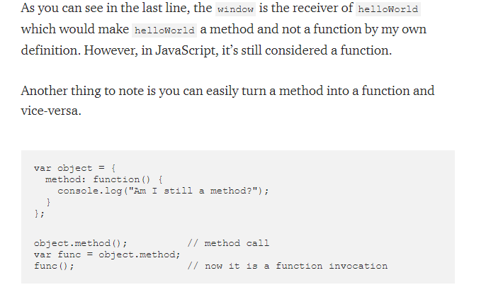

**Javaseript de structuring**

[**https://www.youtube.com/watch?v=NIq3qLaHCIs**](https://www.youtube.com/watch?v=NIq3qLaHCIs)

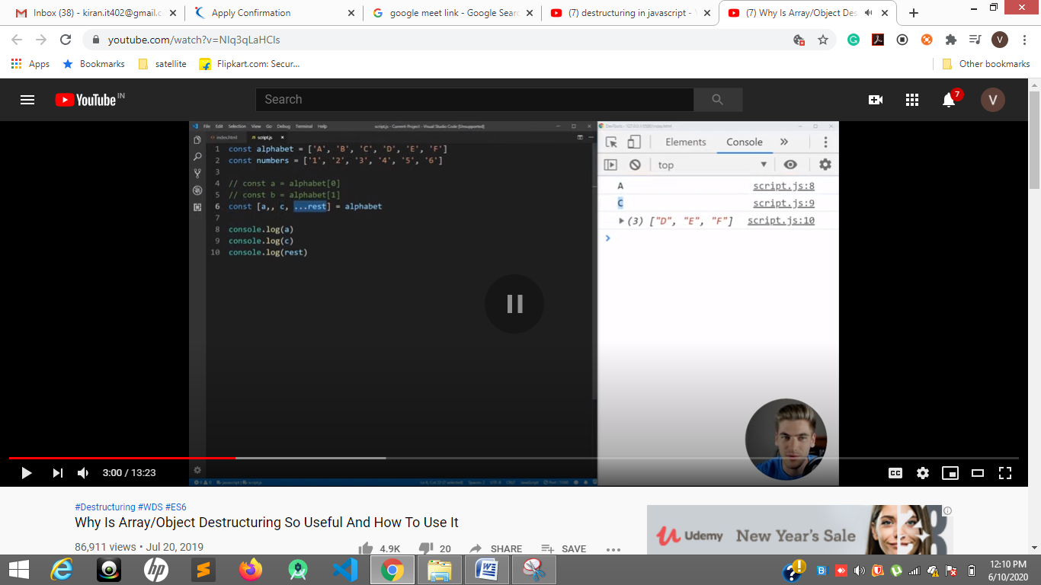

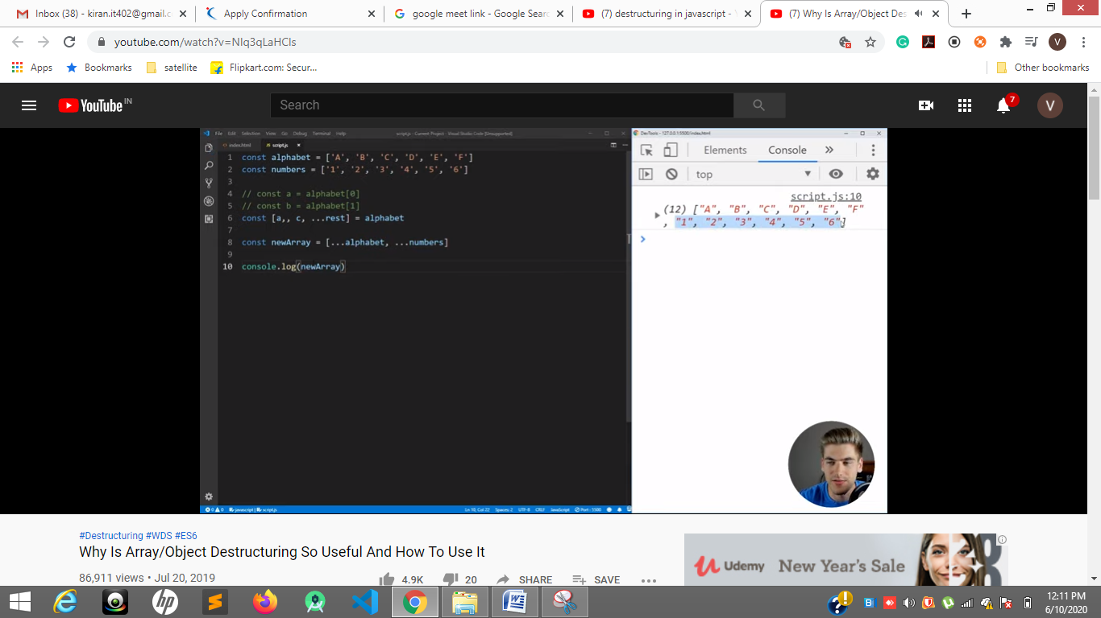

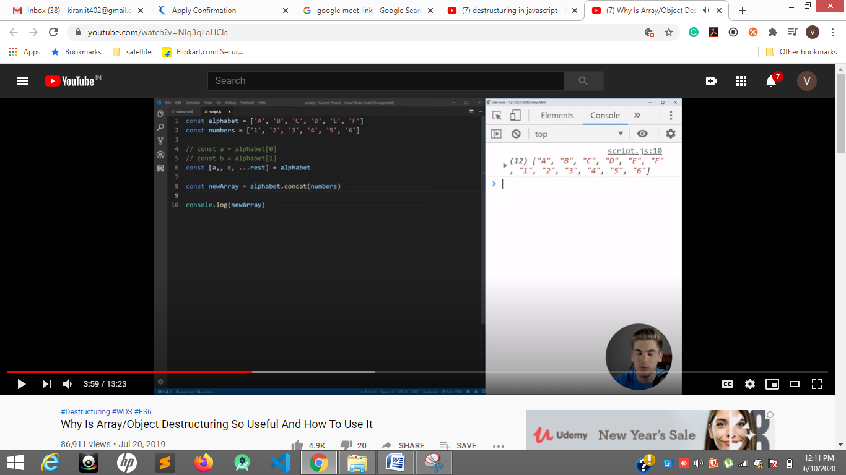

**…rest**

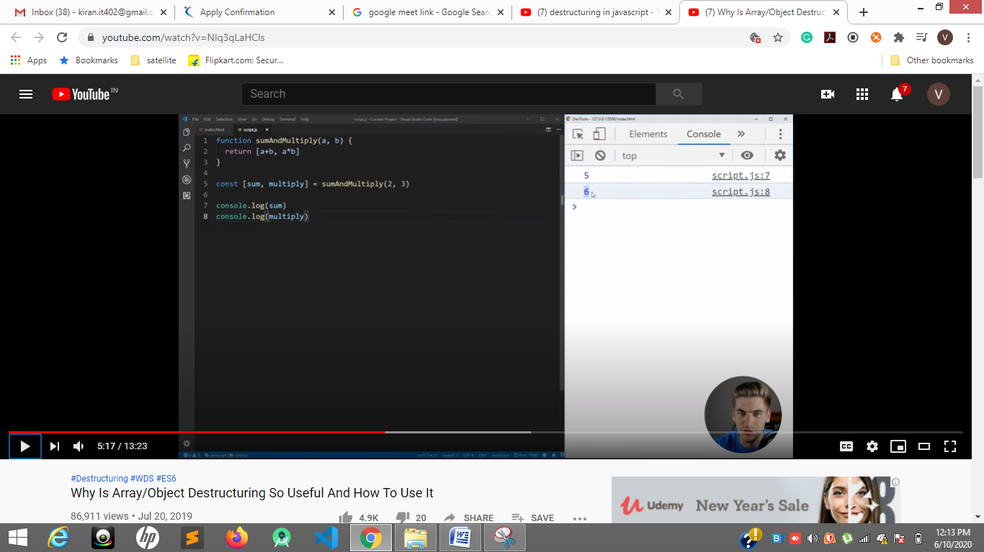

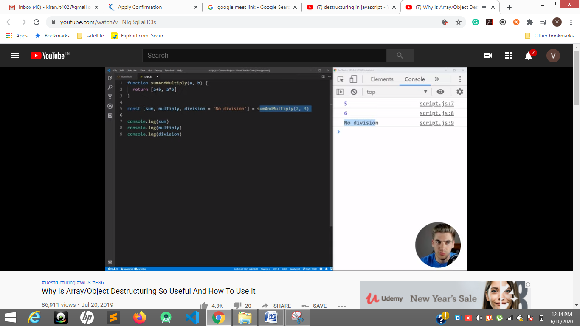

**Object de structuring**

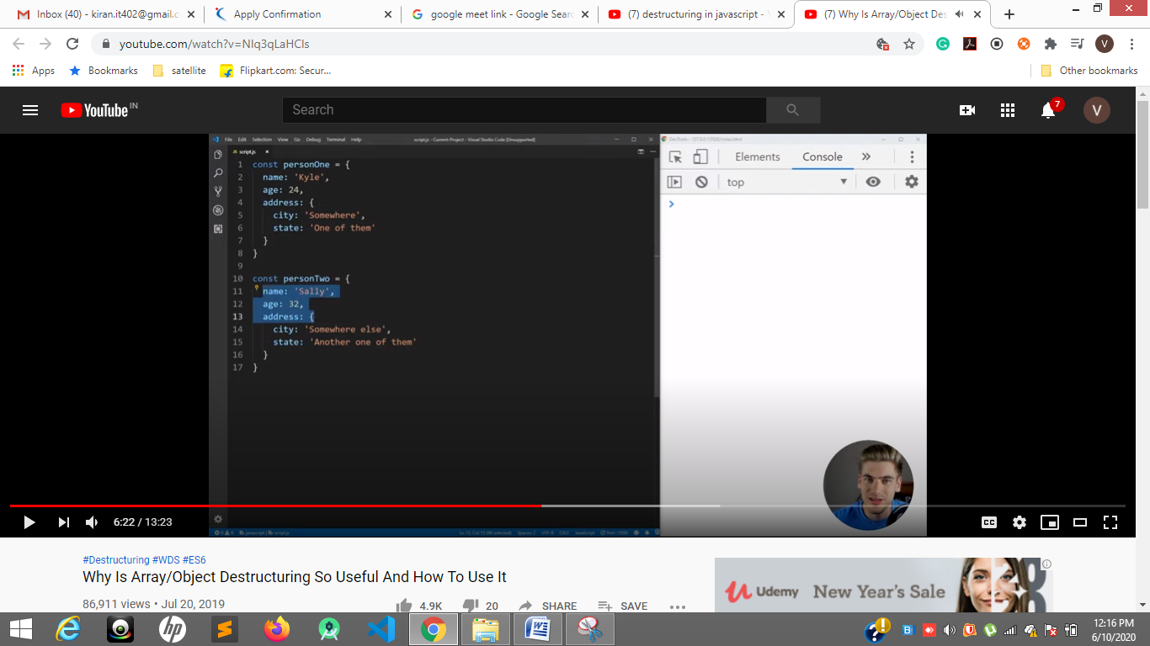

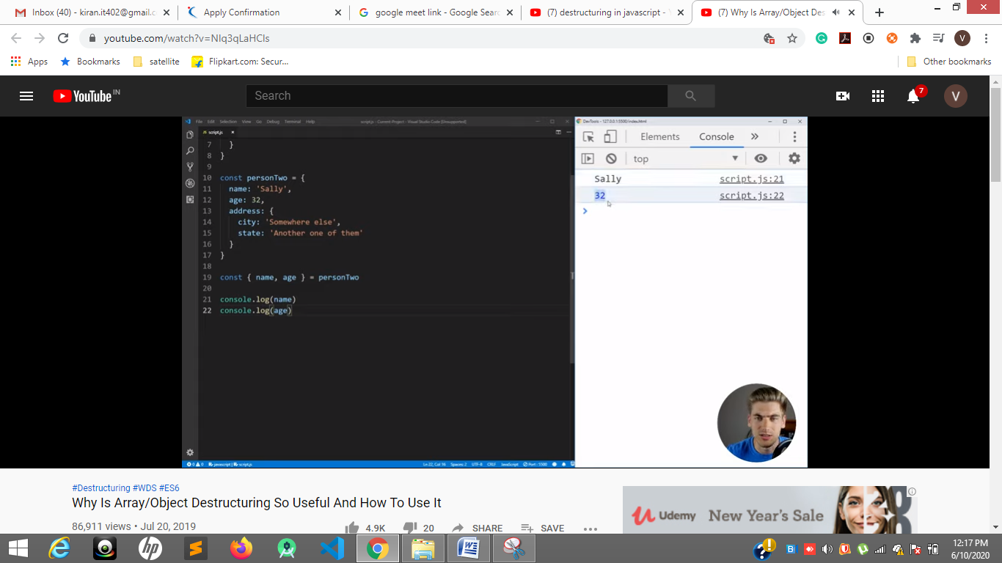

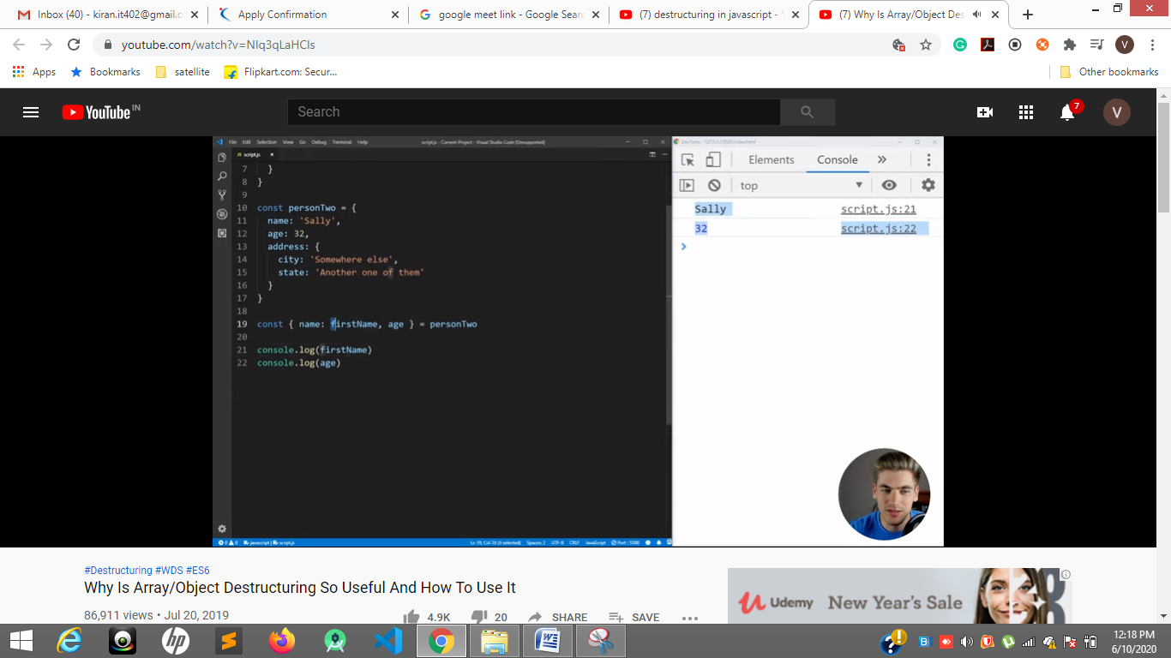

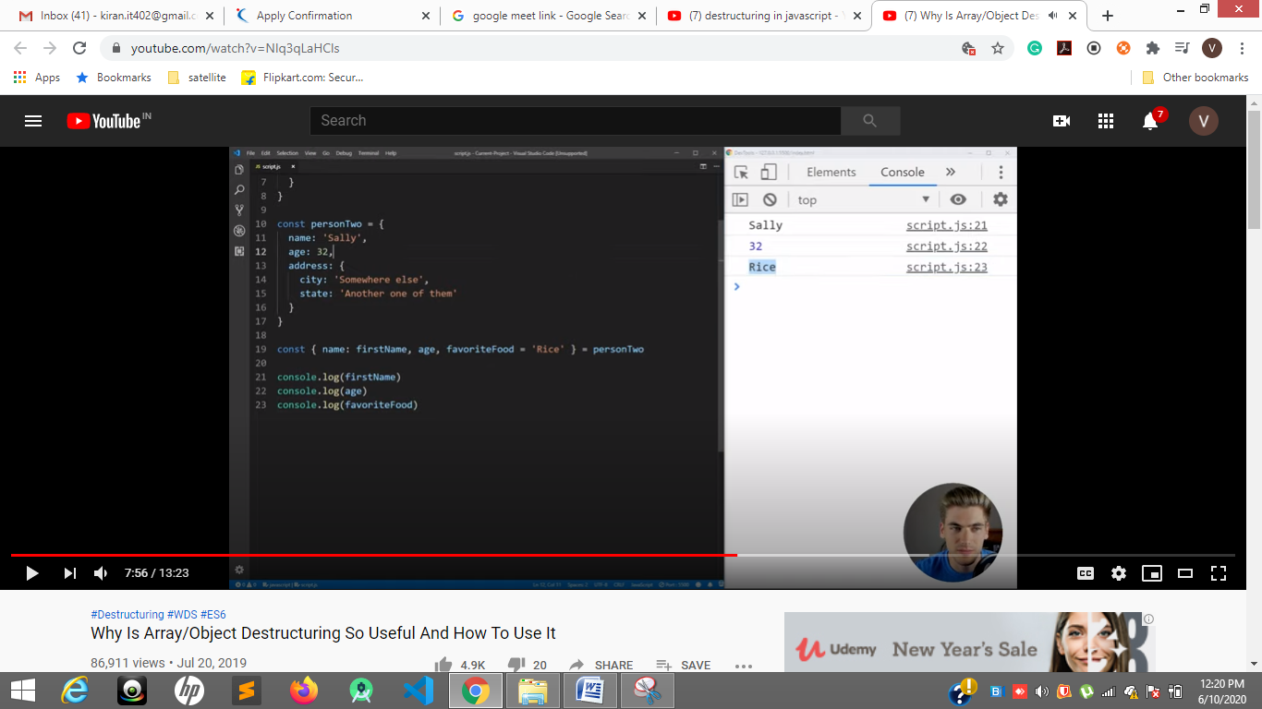

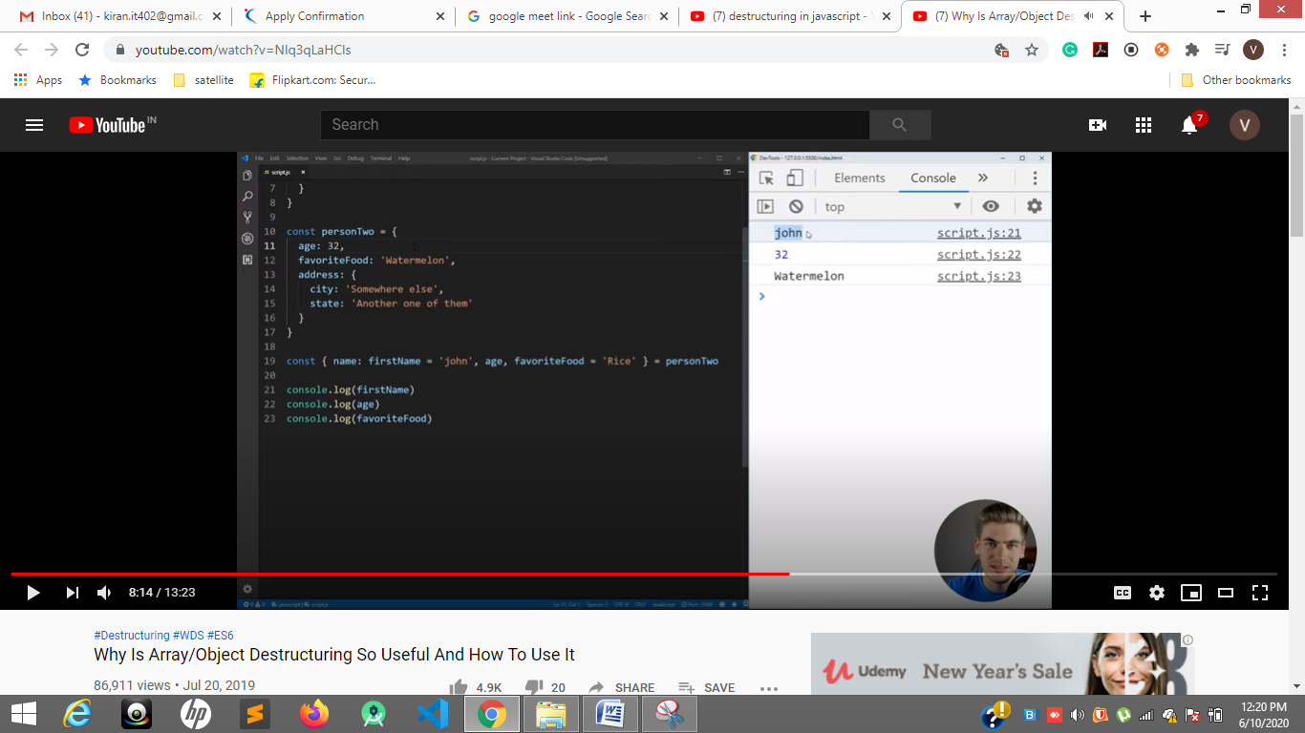

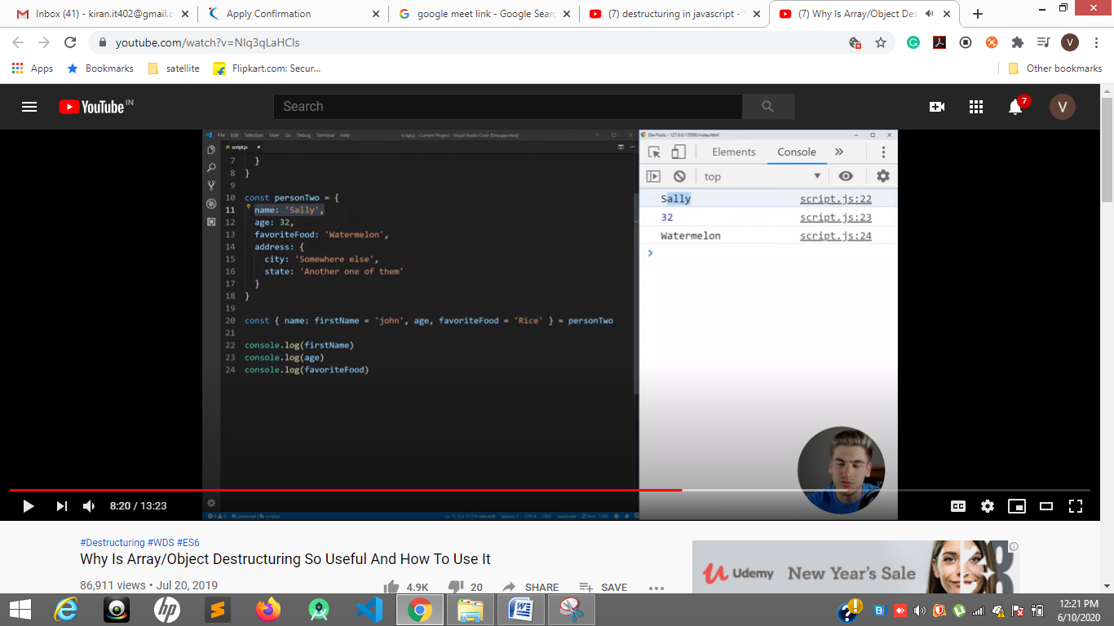

About spread operator

<https://www.geeksforgeeks.org/javascript-spread-operator/#:~:text=Spread%20operator%20allows%20an%20iterable,of%20parameters%20from%20an%20array>.

Car ---- true

David---- false ----- repeated character false

var charRepeats = function(str) {

        for (var i = 0; i <= str.length; i++) {

            for (var j = i + 1; j <= str.length; j++) {

                if (str[j] == str[i]) {

                    return false;

                }

            }

        }

        return true;

    }

    console.log(charRepeats('david'))

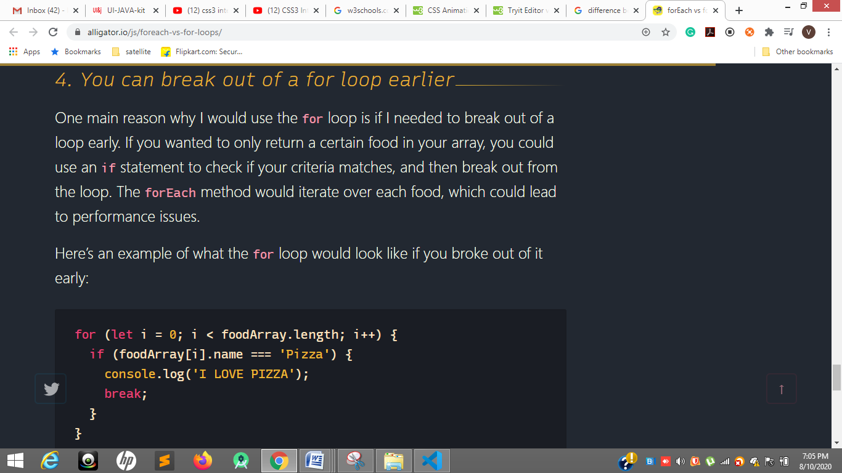

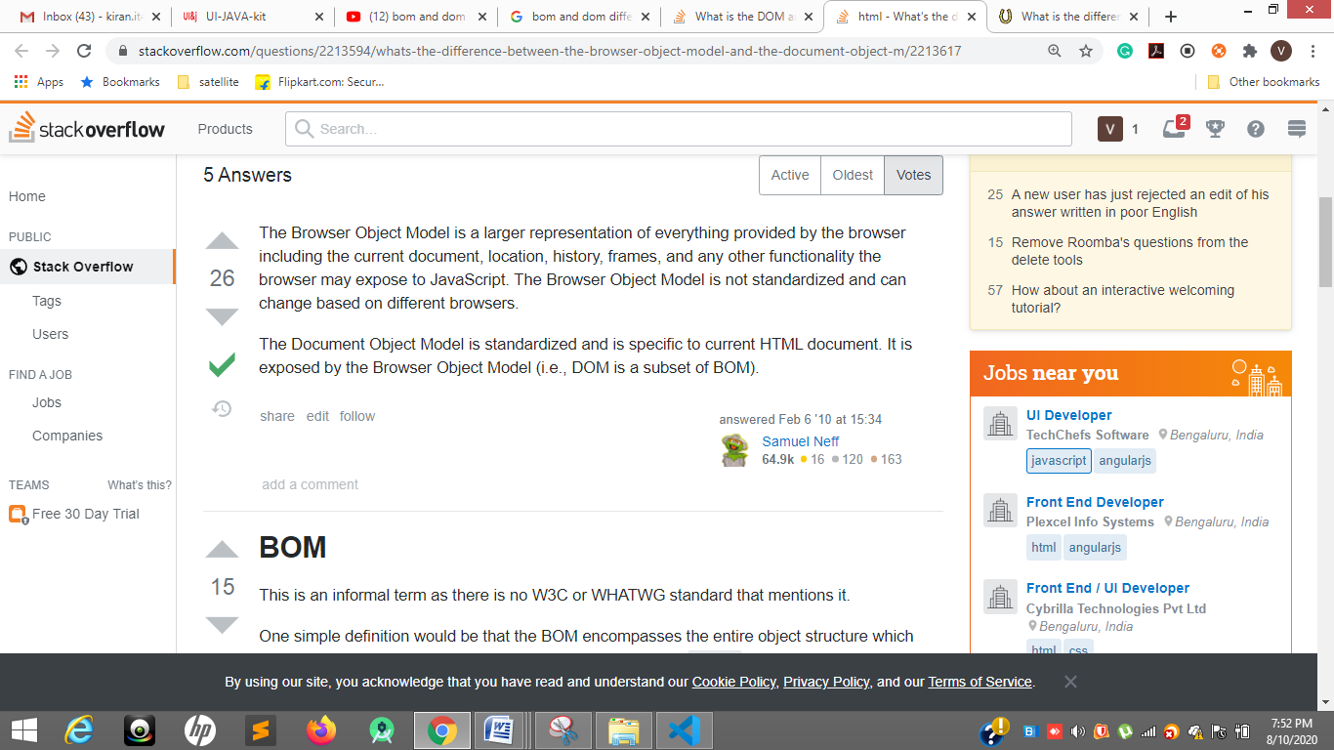

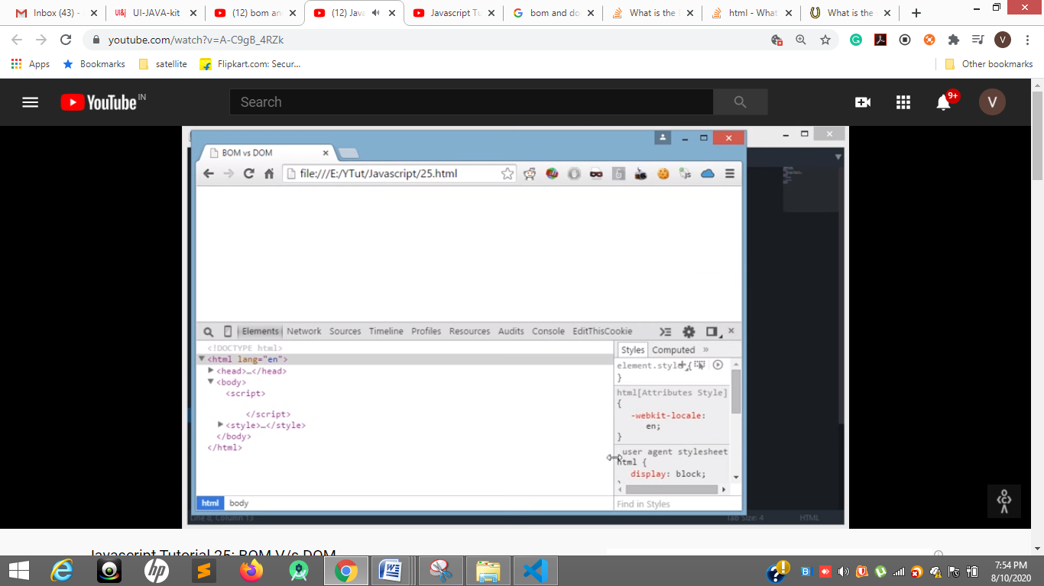

Inspect element is called the dom i.e subset of BOM

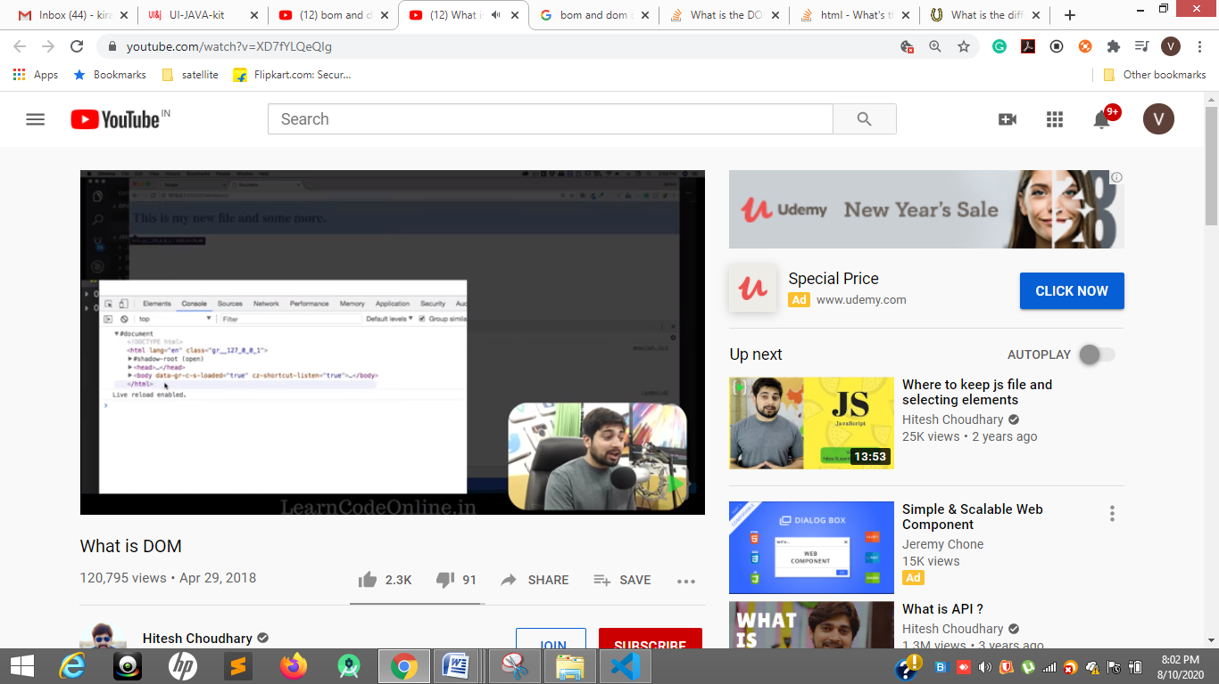

Console.log(documnet) contain head body all html elements

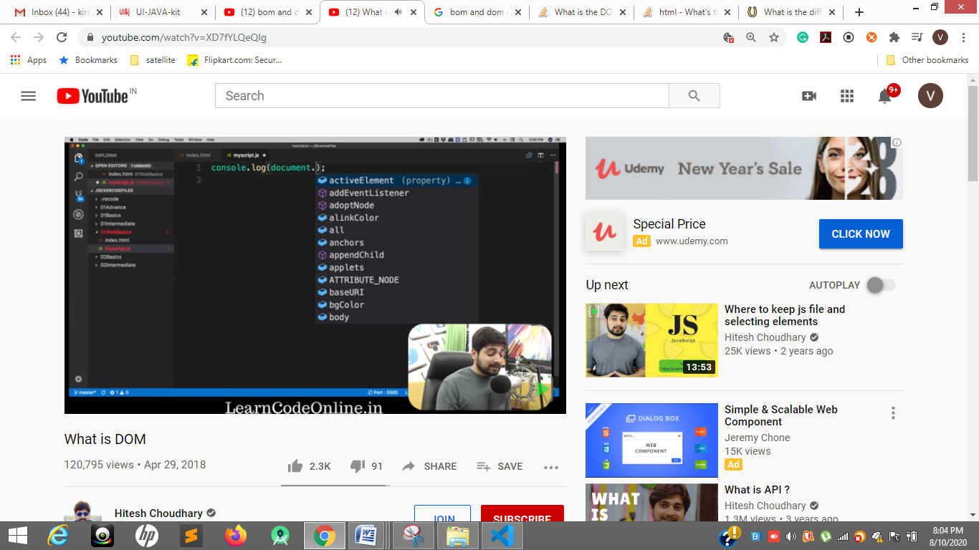



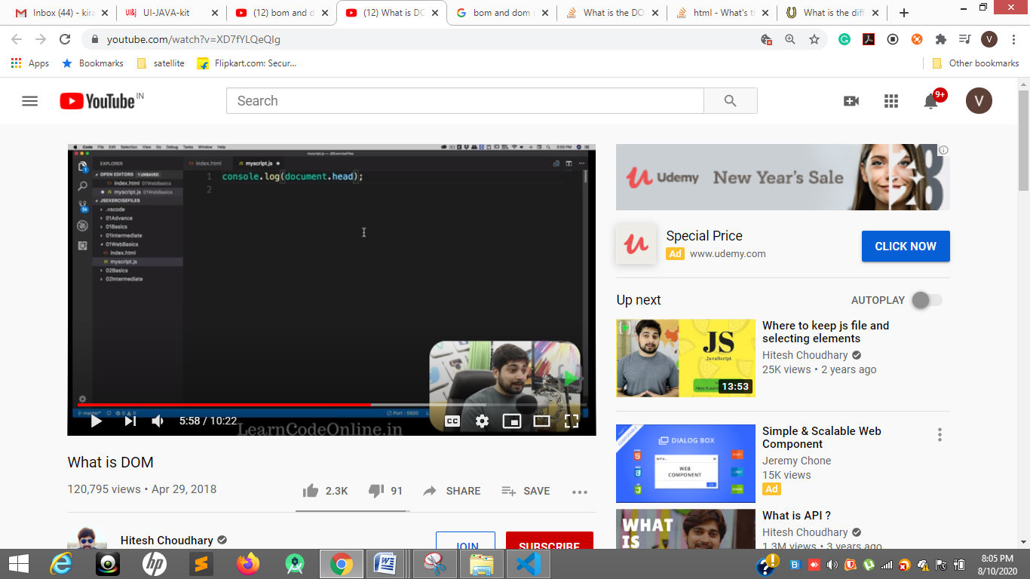

Document.head has head of the document

Document.body

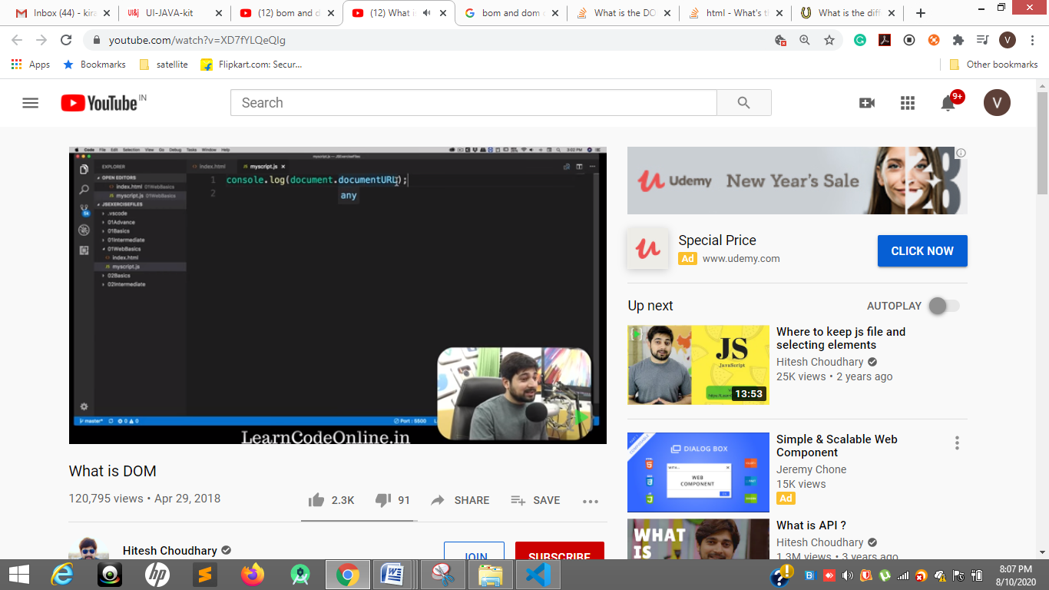

documentURL

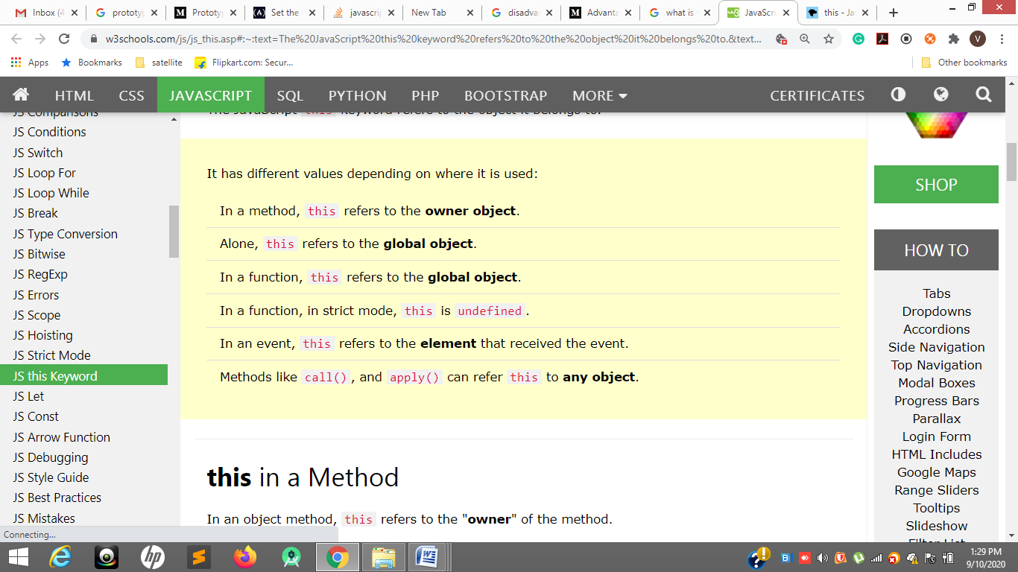

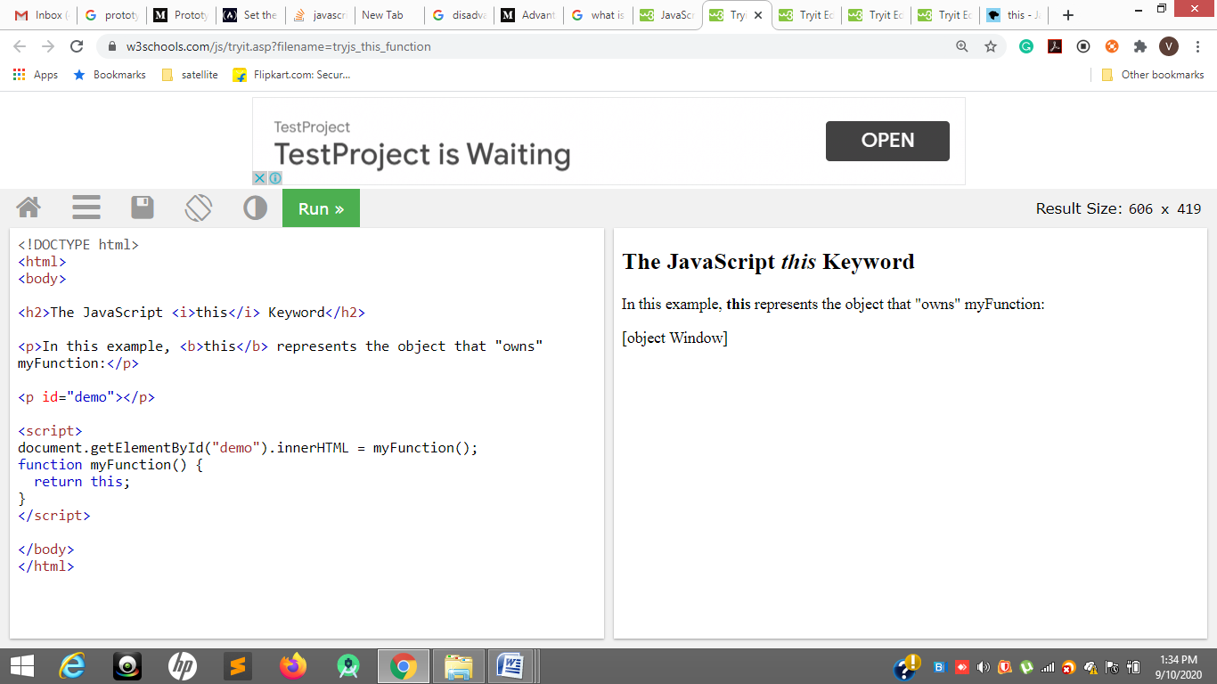

Console.log(i);

Var I = 10

funOne();

Function funOne(){

}

input = [4,6,9,10,11,12,15];

output = [5,7,8,13,14]

Create a program to find the missing number(s) from a sorted array.

Var inputArr = [4,6,9,10,11,12,15];

Var Count =0

Var opArr = [];

Function sortFun(){

For(var I = 0 ; i< inputArr.length ; i++ ){

Count = inputArr[i+1]- inputArr[i]

For( var j = ; j< Count ; j++){

opArr.push( inputArr[i] + Count)

}

}

}

}

(function() {

console.log(1);

setTimeout(function(){console.log(2)}, 1000);

setTimeout(function(){console.log(3)}, 0);

console.log(4);

})();

console.log(0.1 + 0.2);

console.log(0.1 + 0.2 == 0.3);

1

4

3

2

0.3

true

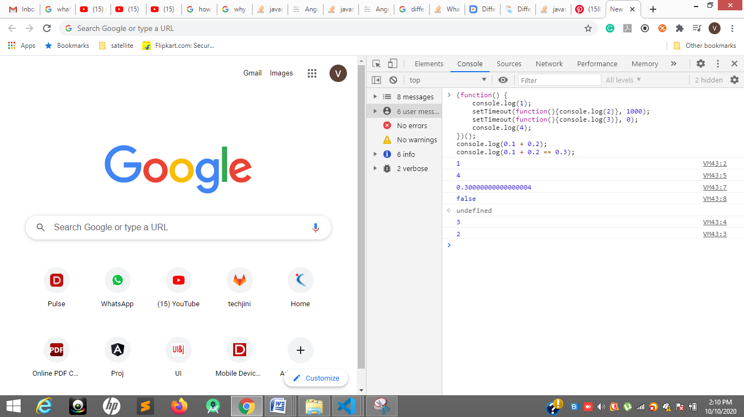

From a "collection of numbers", find a set of numbers who add up to the "SUM" Example: [1,2,3,9] Sum = 8 or [1,2,4,4] Sum = 8

Var InpArray = [1,2,4,4]

Function sumFun(){

InpArray.forEach((val, ind)=>{

For(var I = ind+1 ; i< InpArray.length ; i++){

If(val + InpArray[i] == 8){

Console.log(‘true’)

}else{

Console.log(‘flase)

}

}

})

}

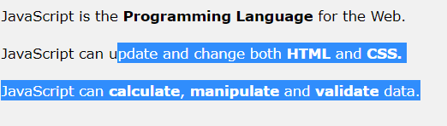

<https://www.youtube.com/watch?v=mNYo7LTuOyM>

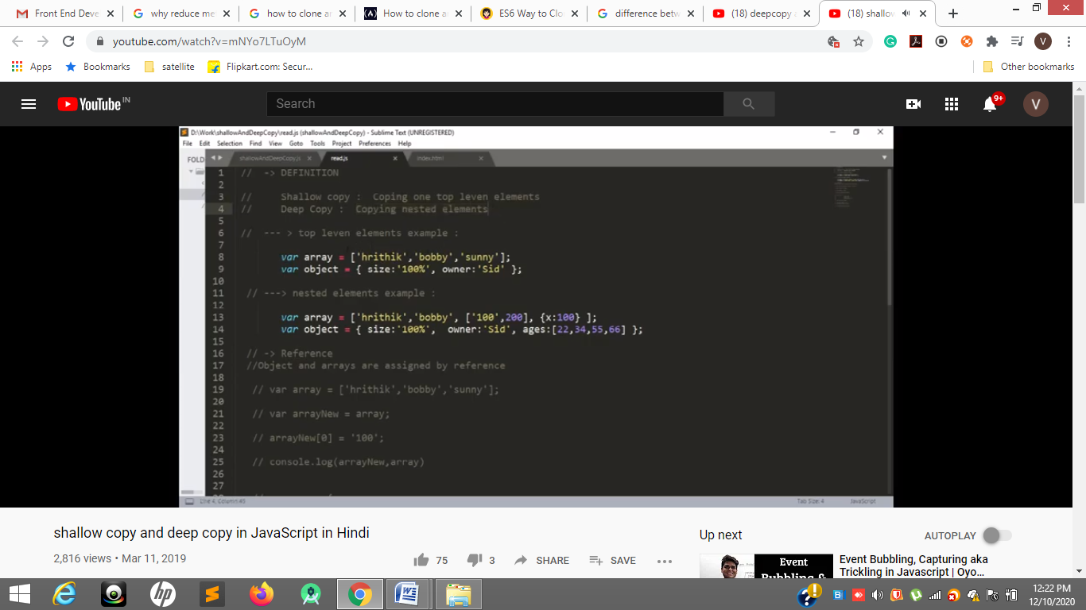

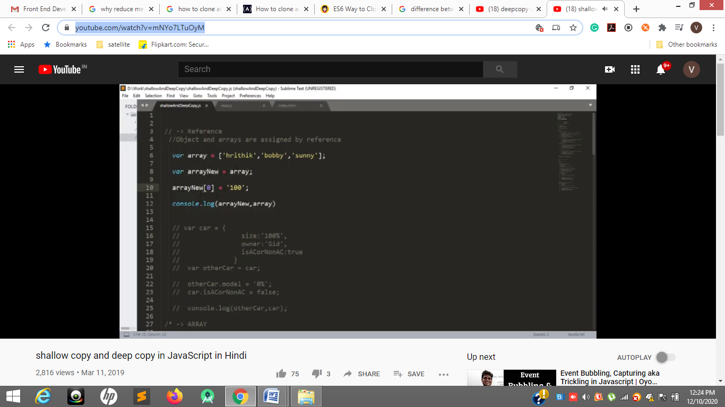

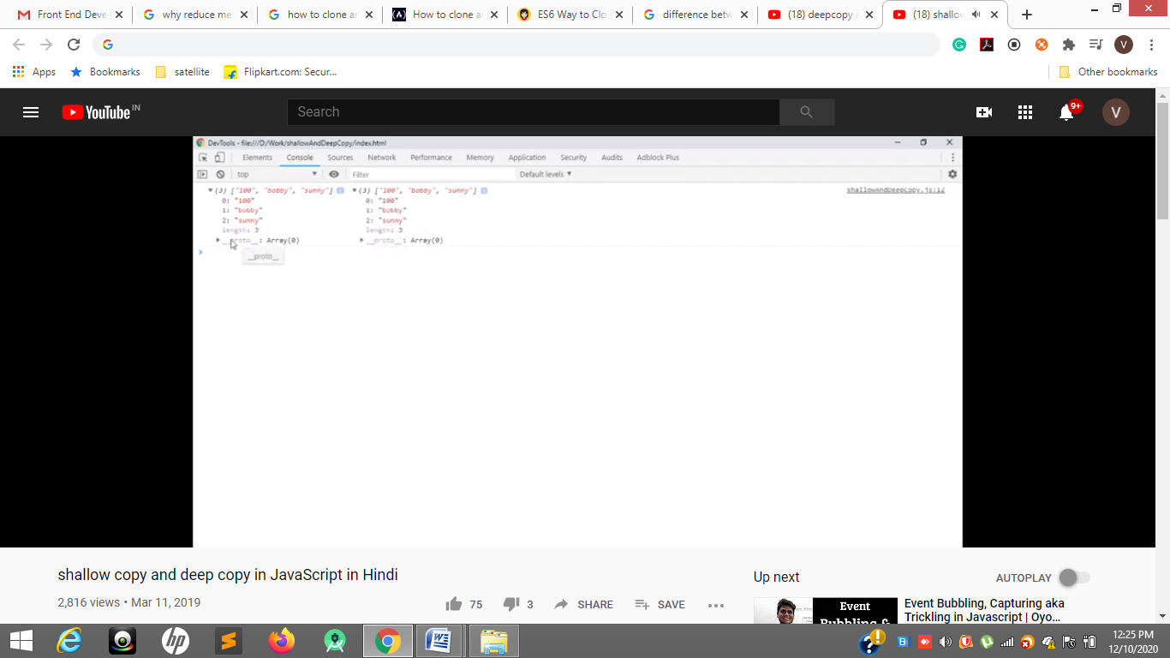

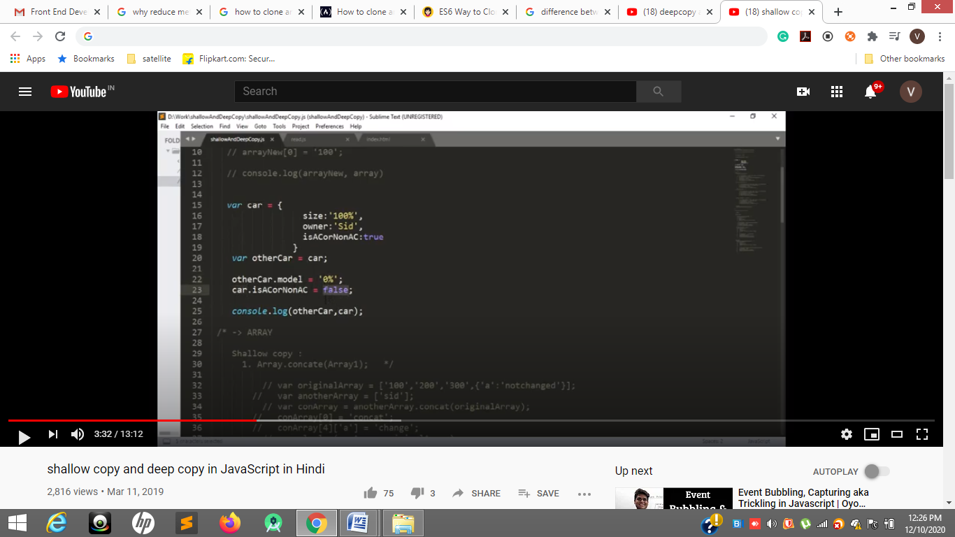

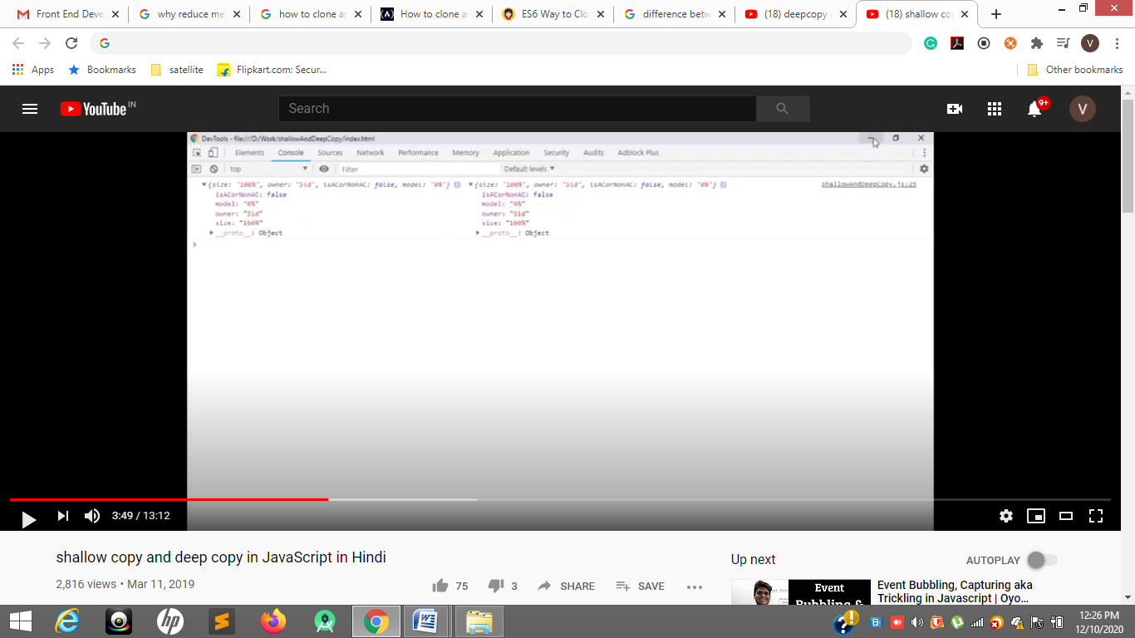

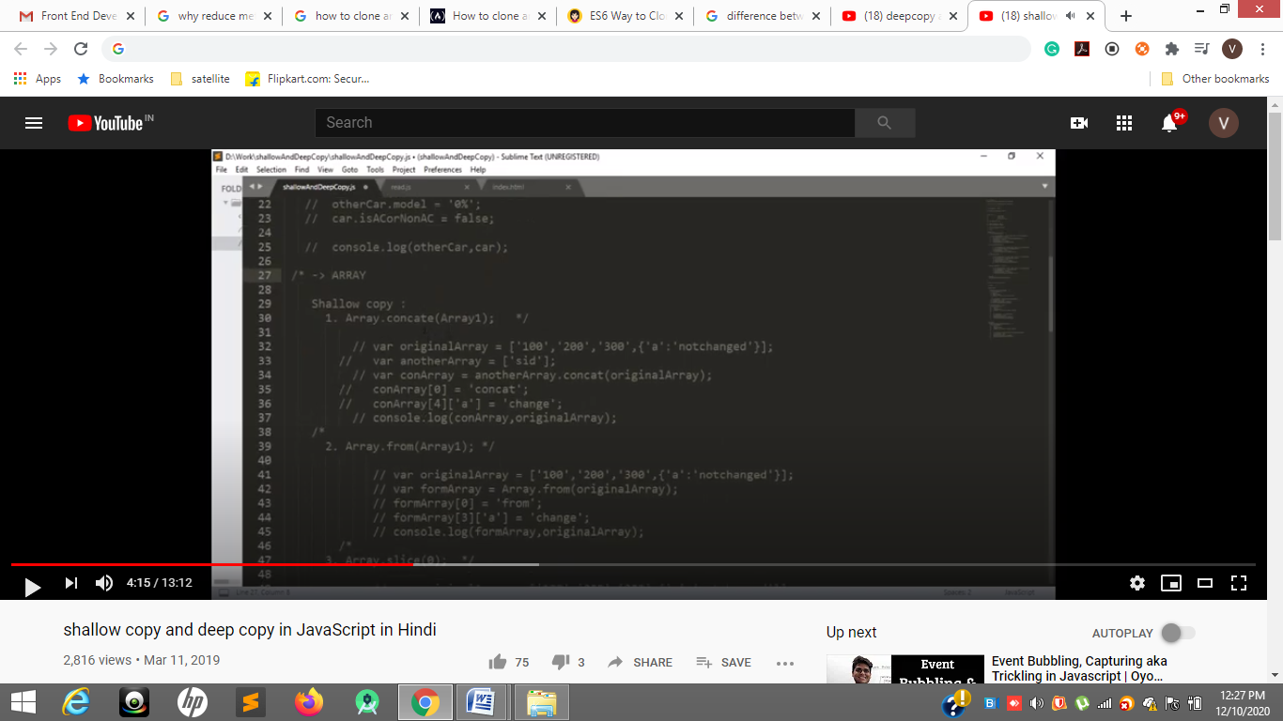

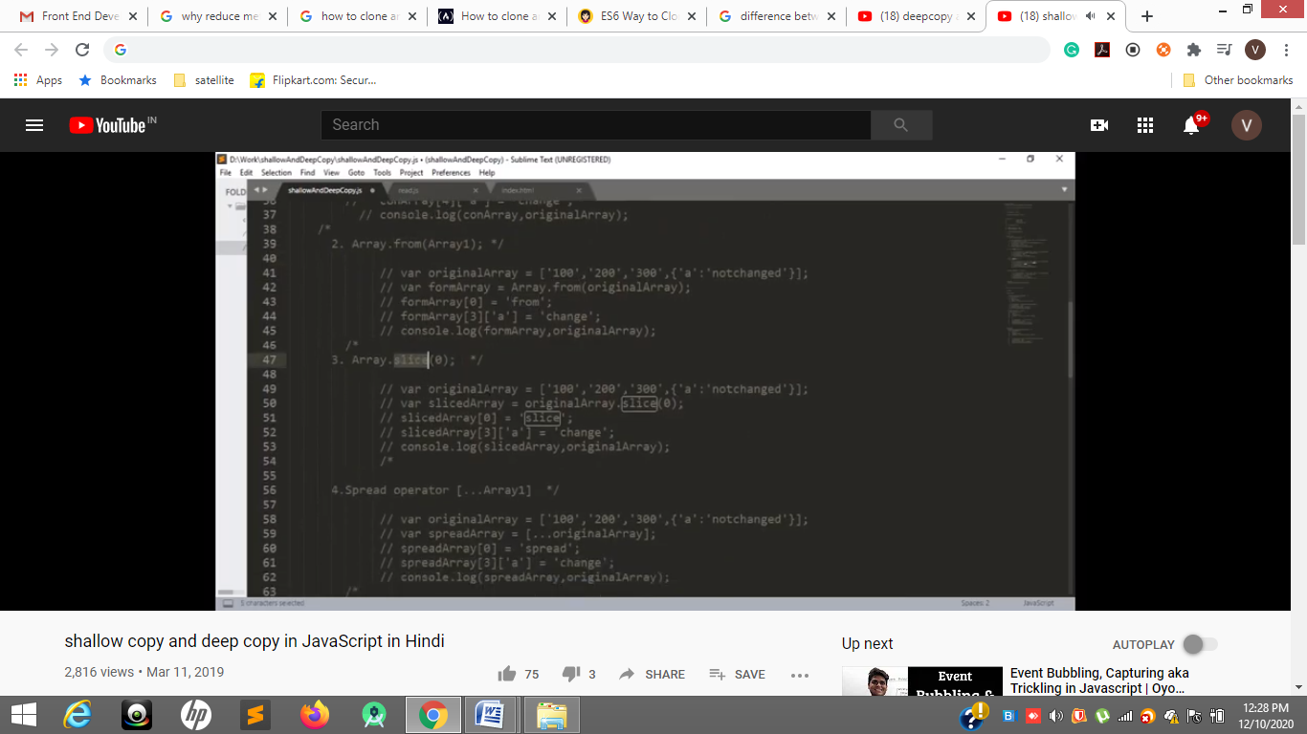

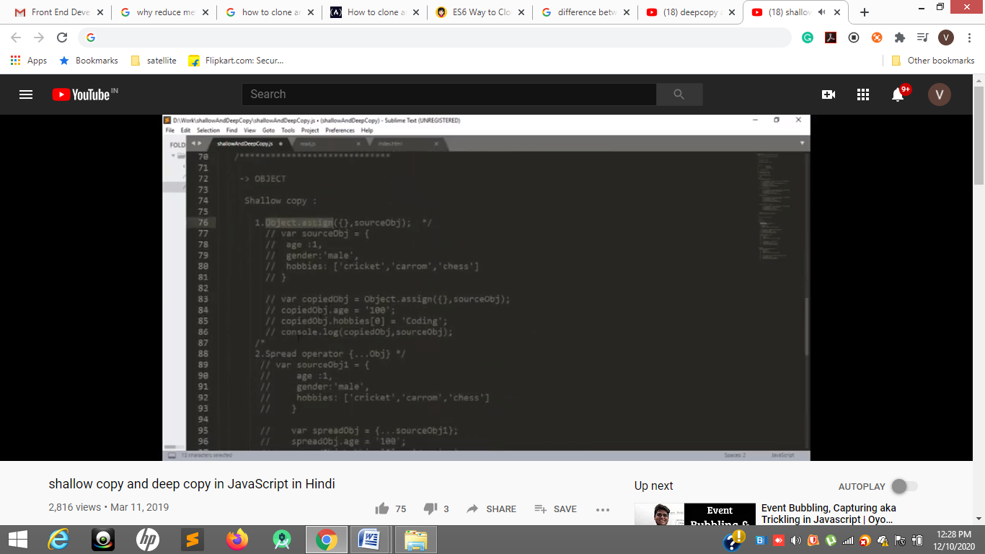

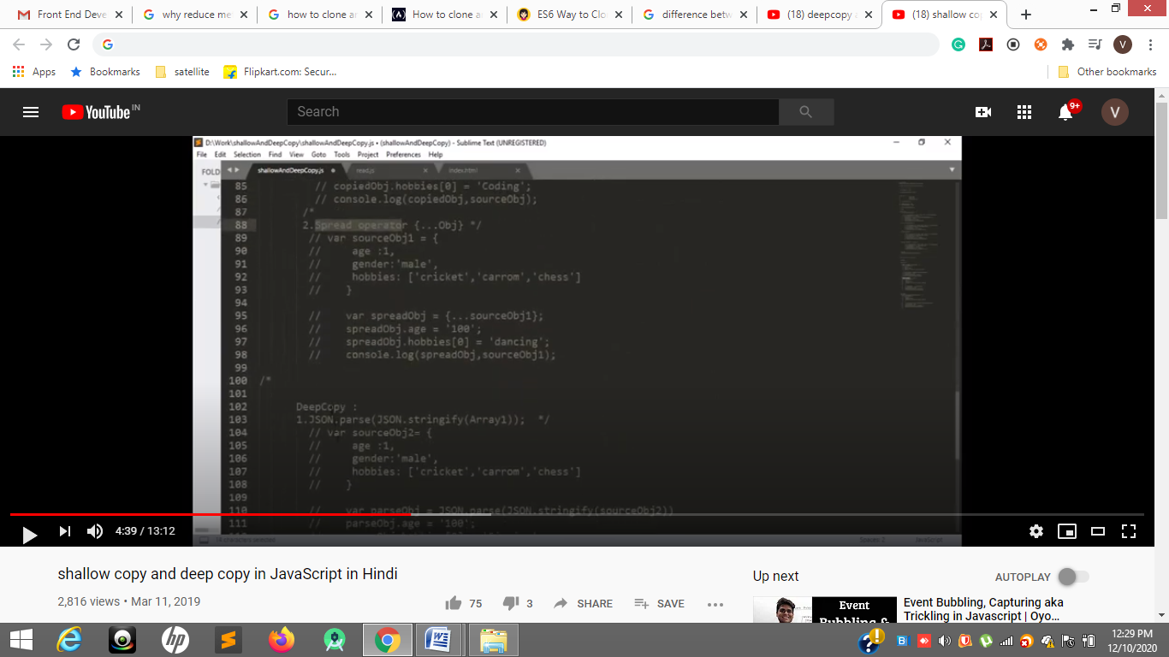

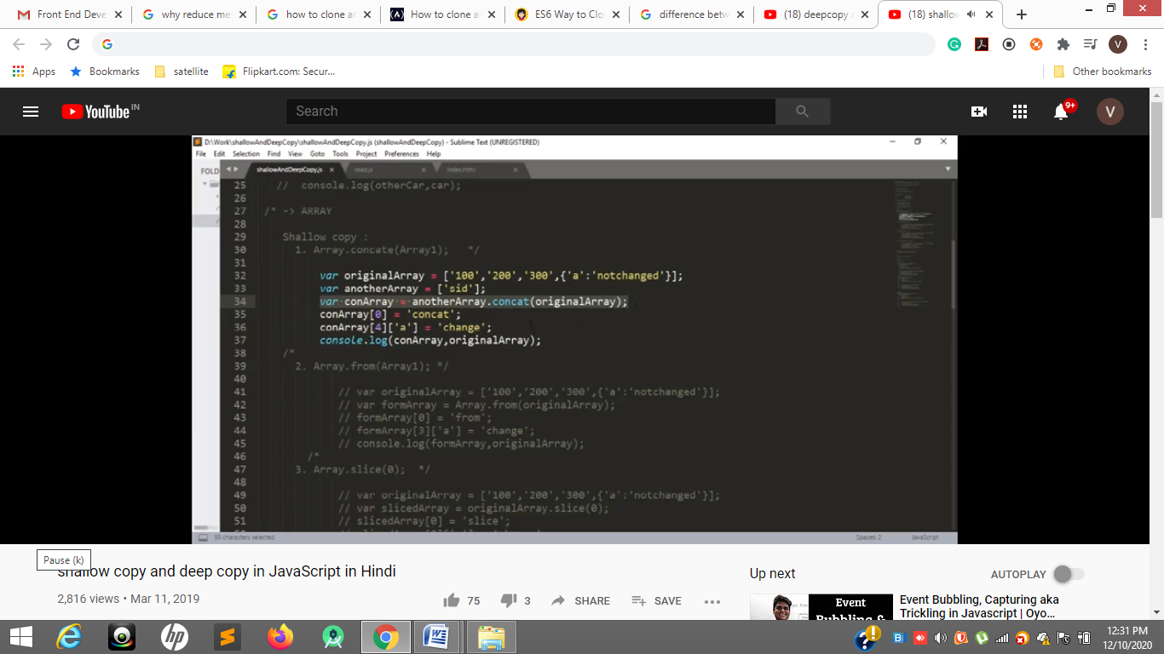

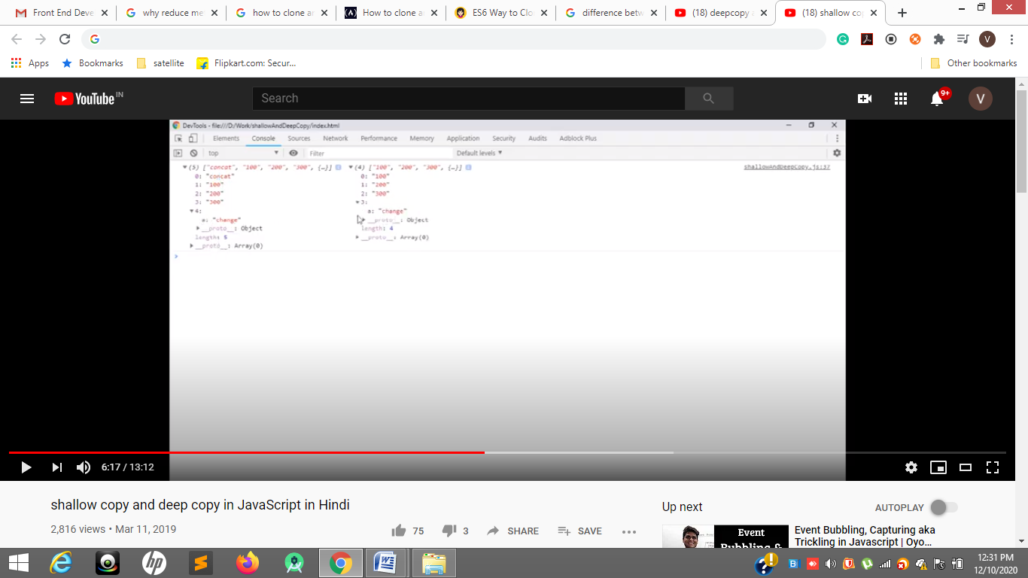

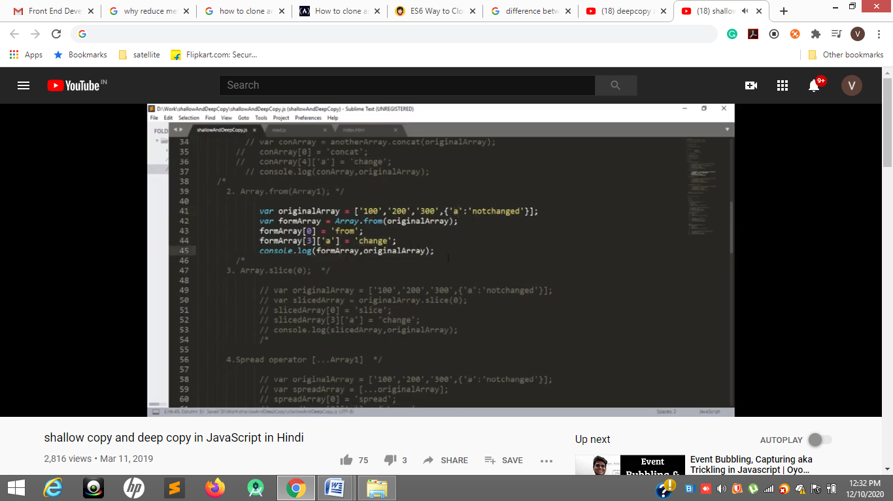

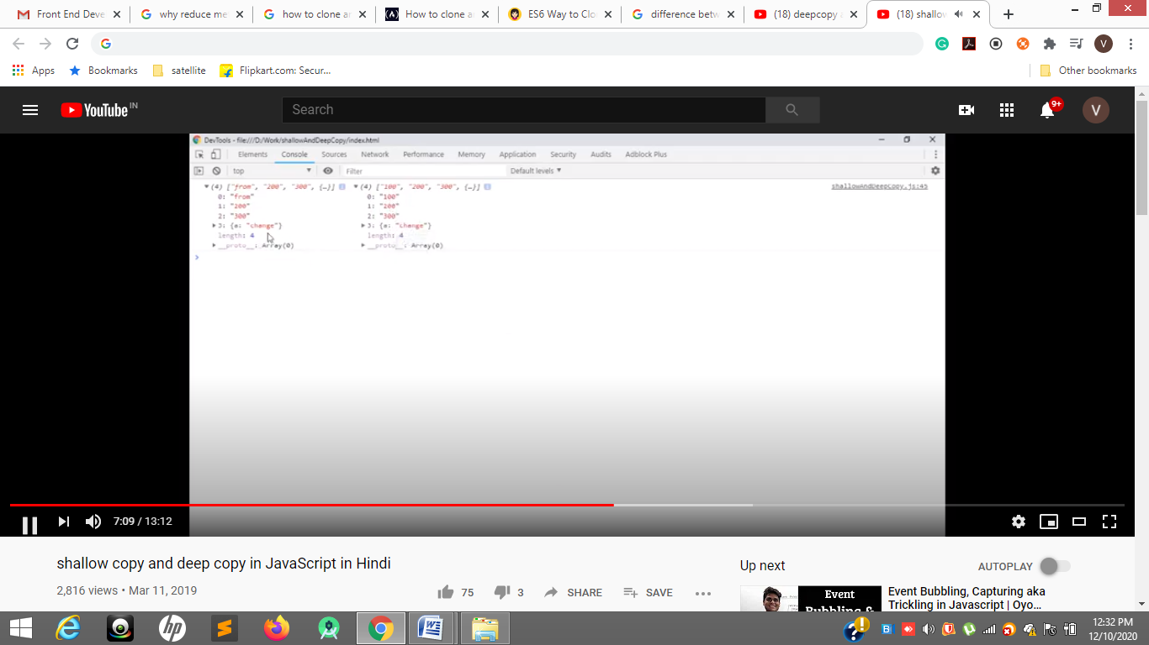

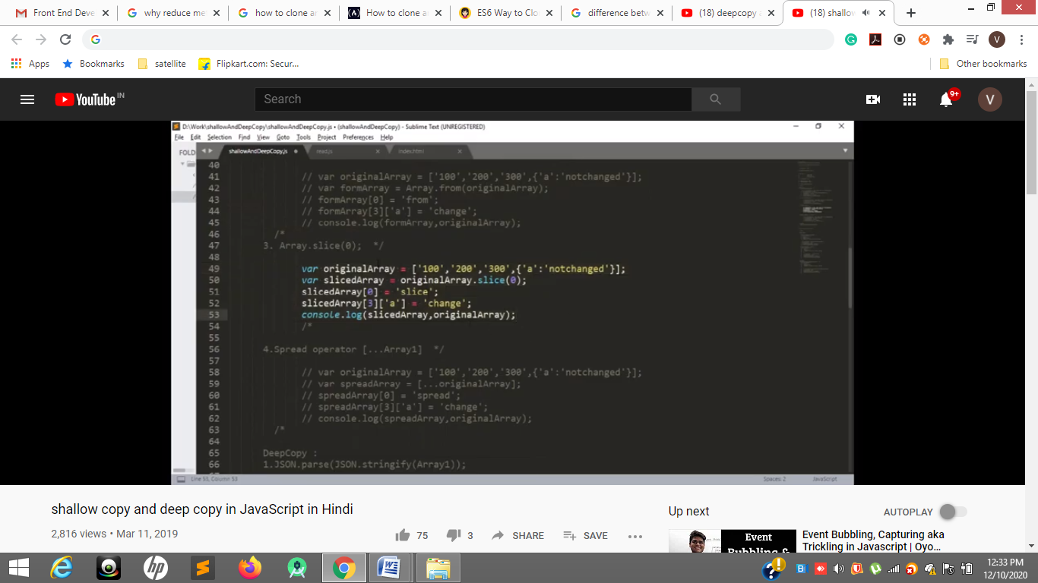

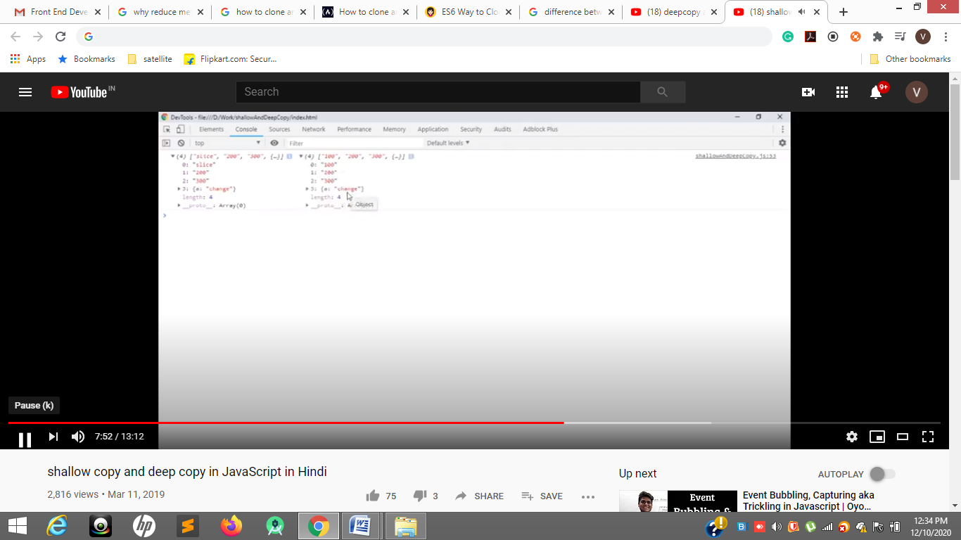

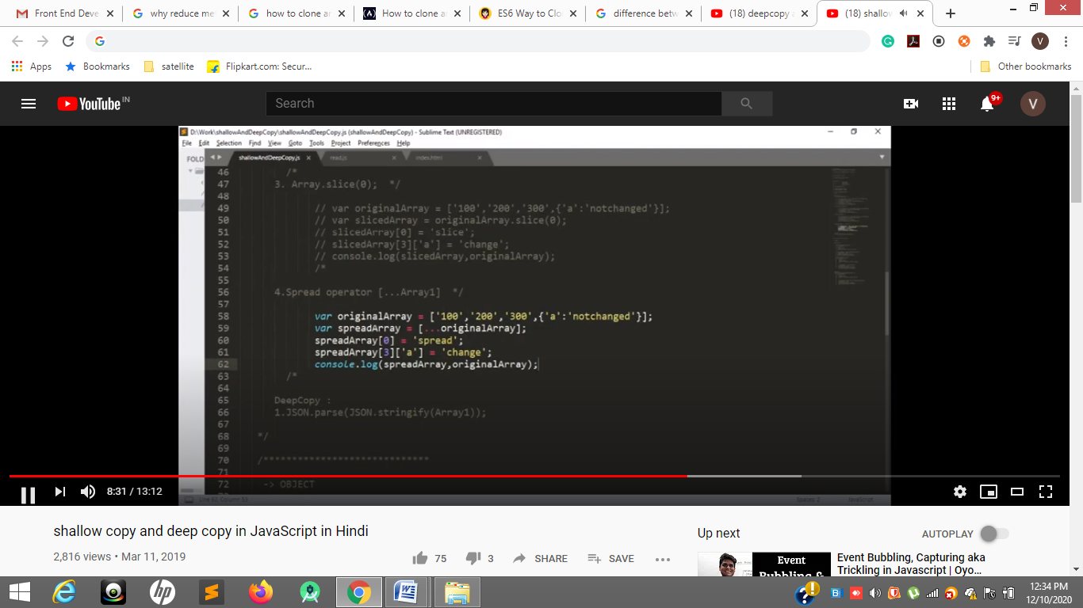

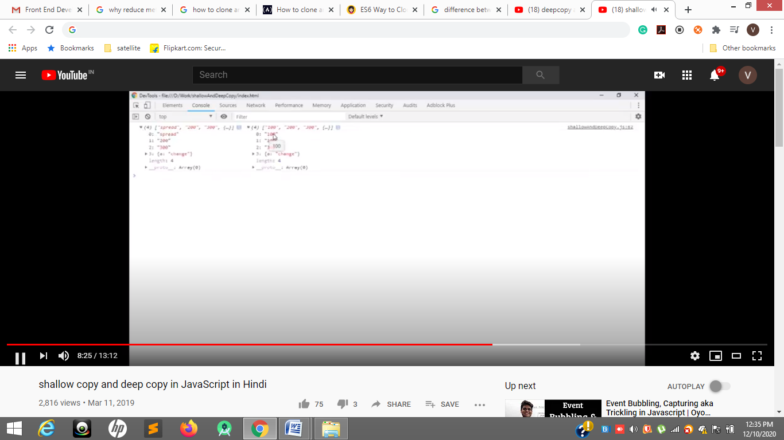

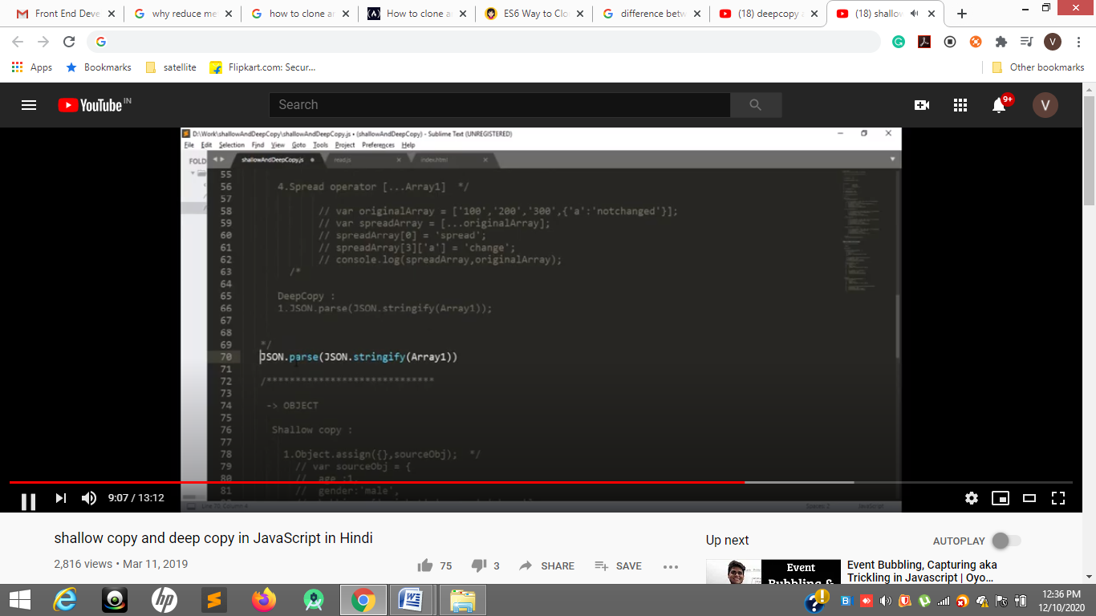

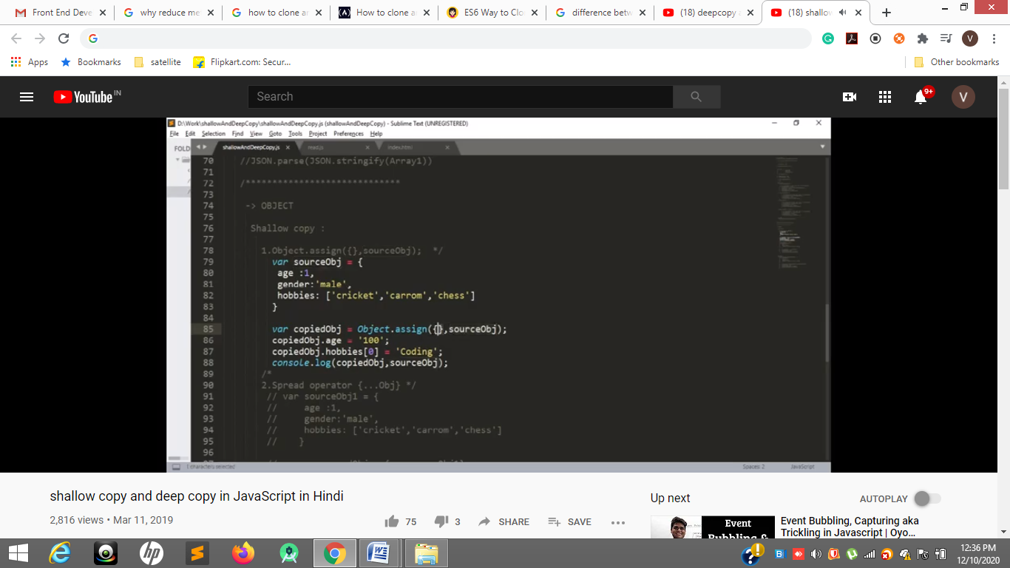

<https://www.youtube.com/watch?v=duyshh9Fs1U>

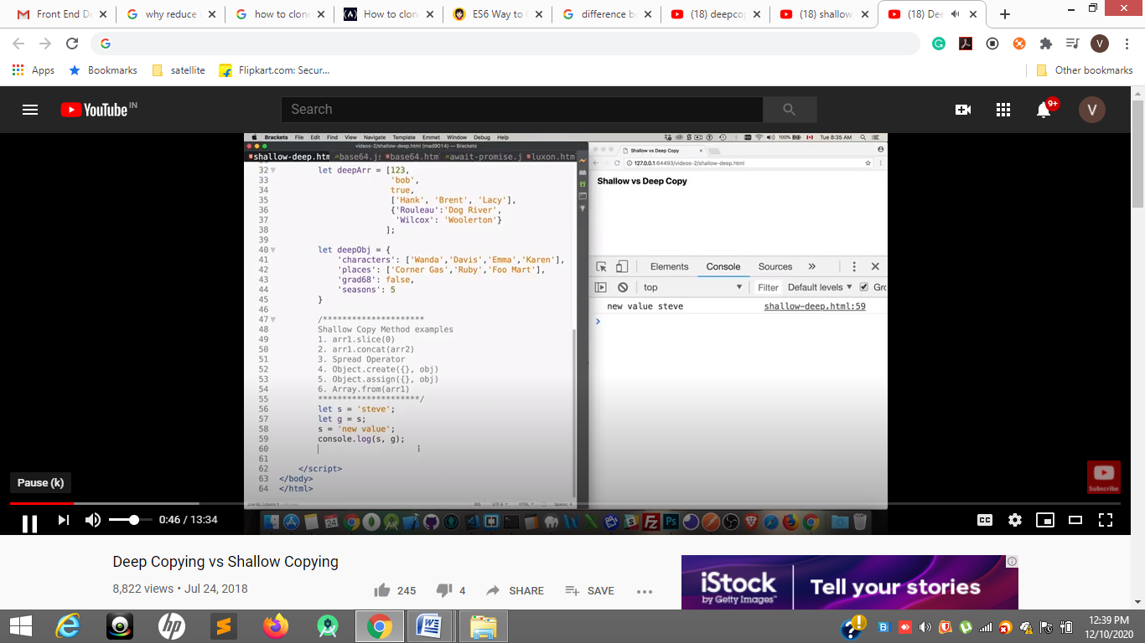

56 to 60

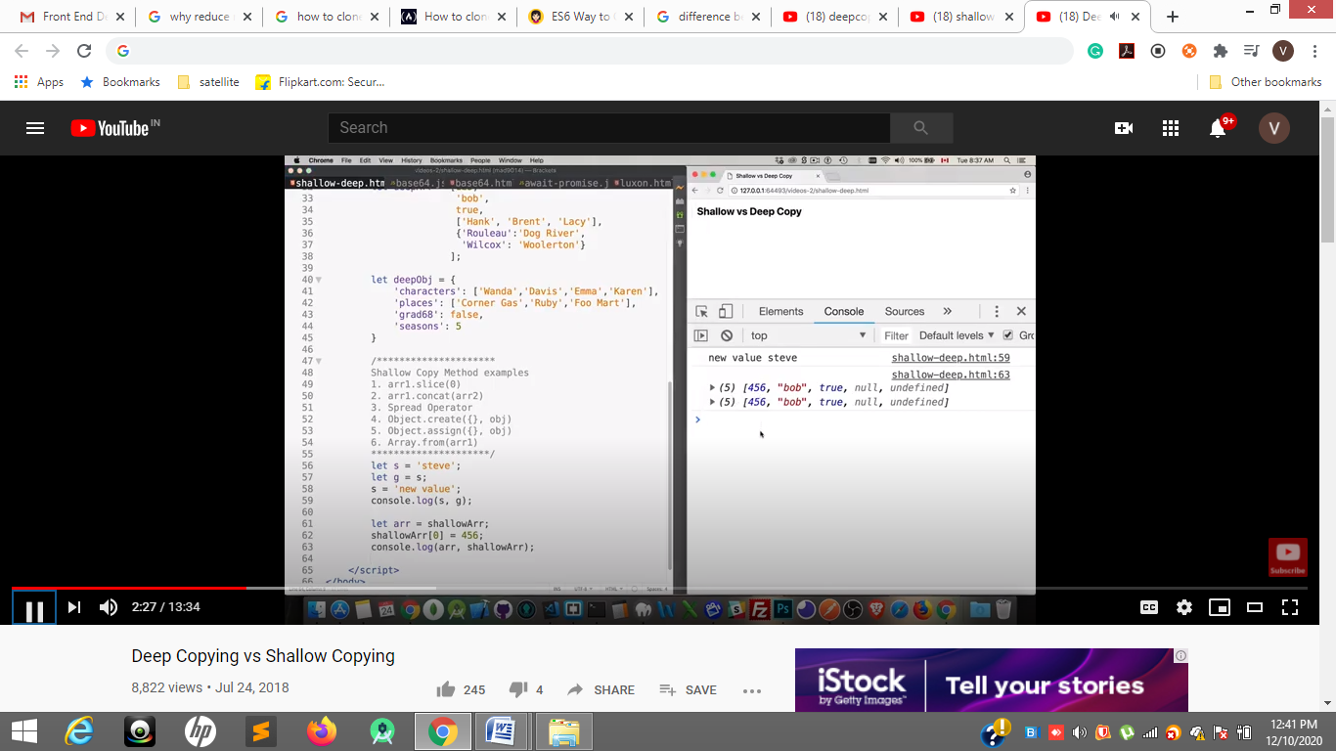

61 to 63

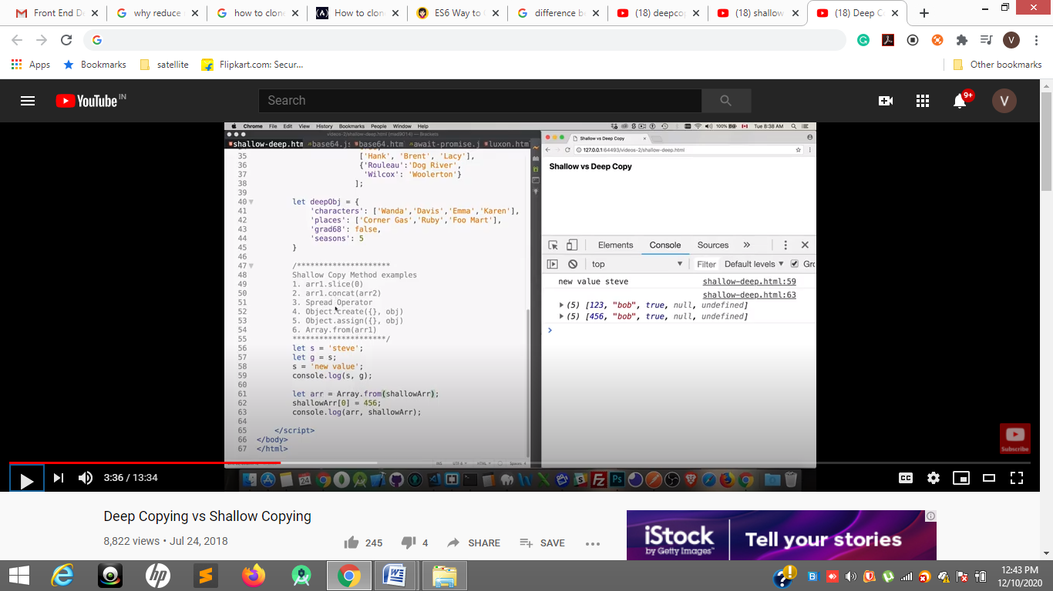

Shallow copy dosn’t change original

123 ----------456

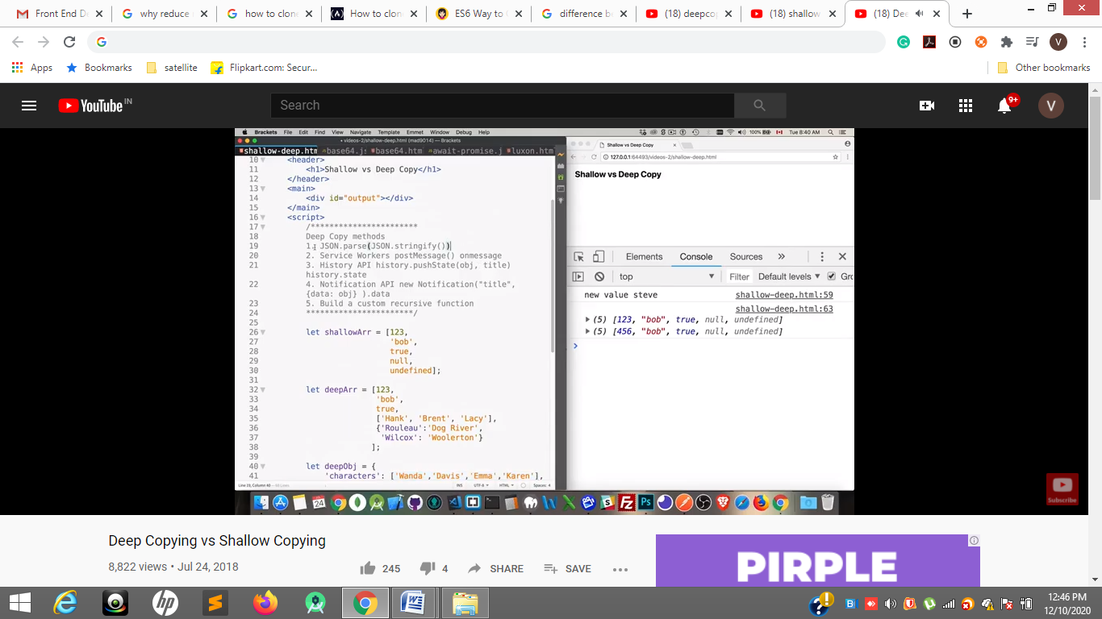

Deep objects are not primitive

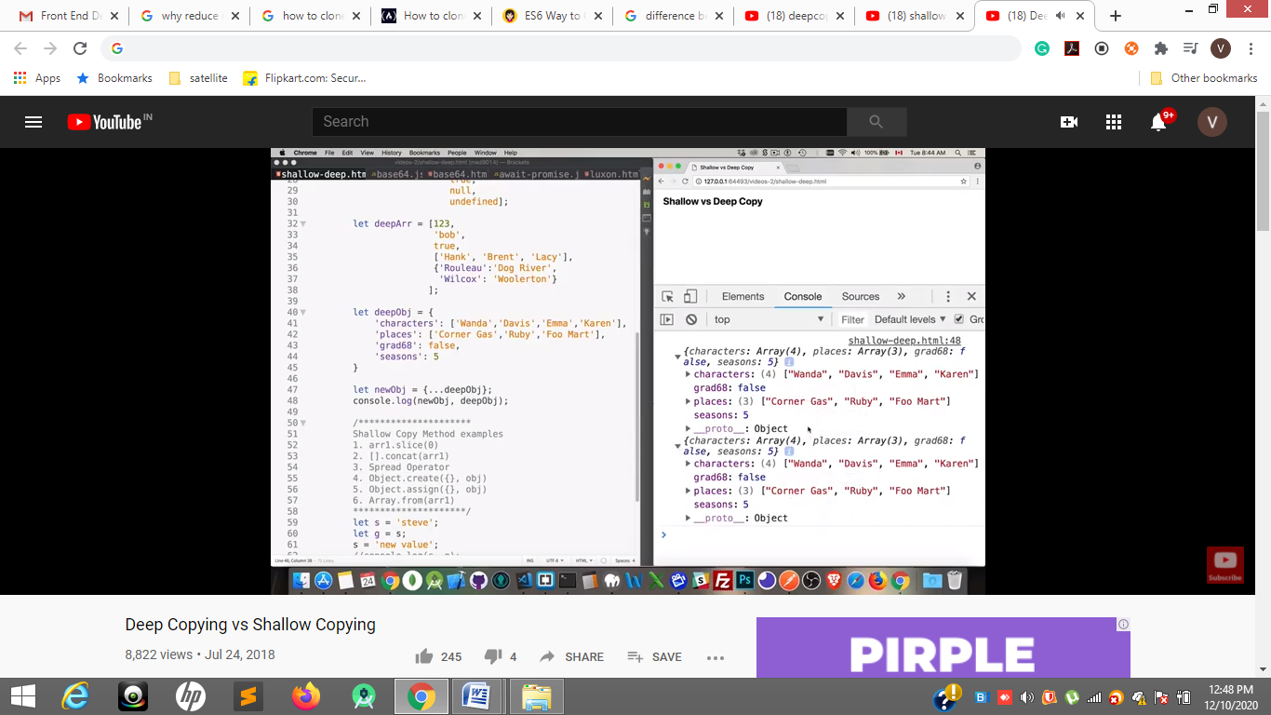

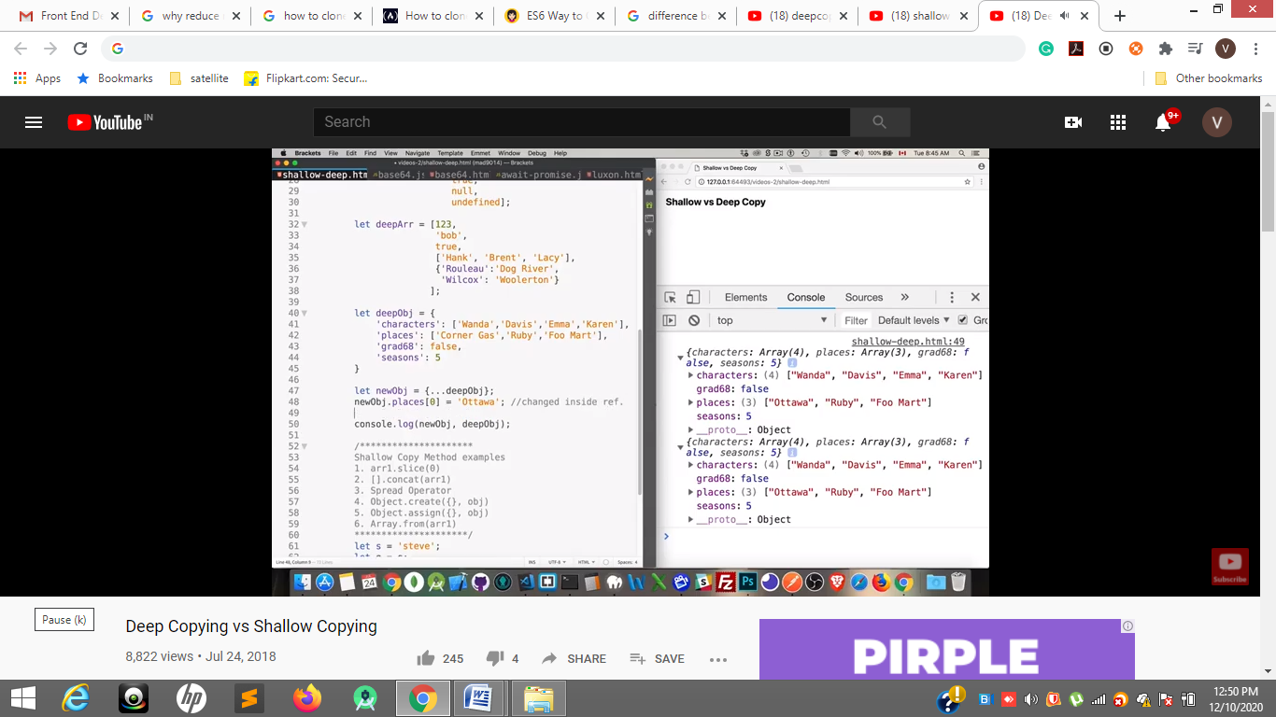

In result places original and copied one both will change in shadow coping of reference

48 line

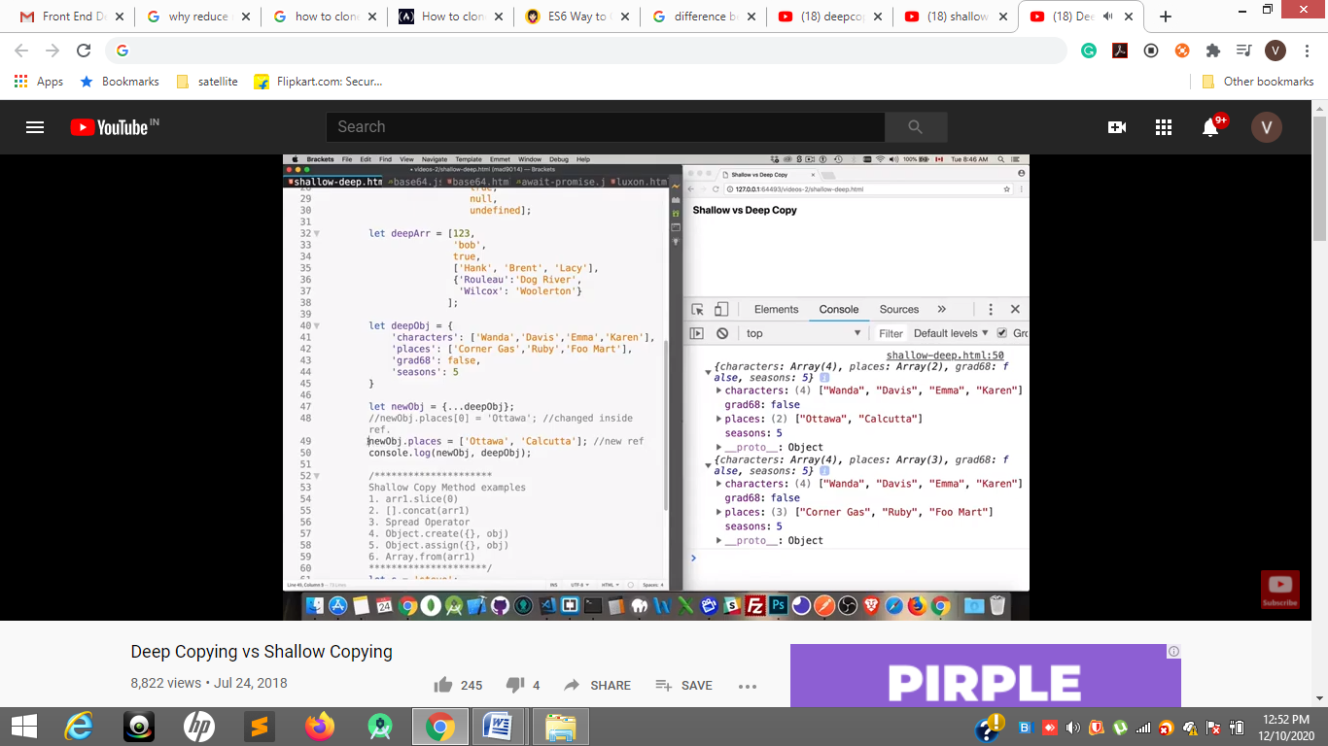

49 line

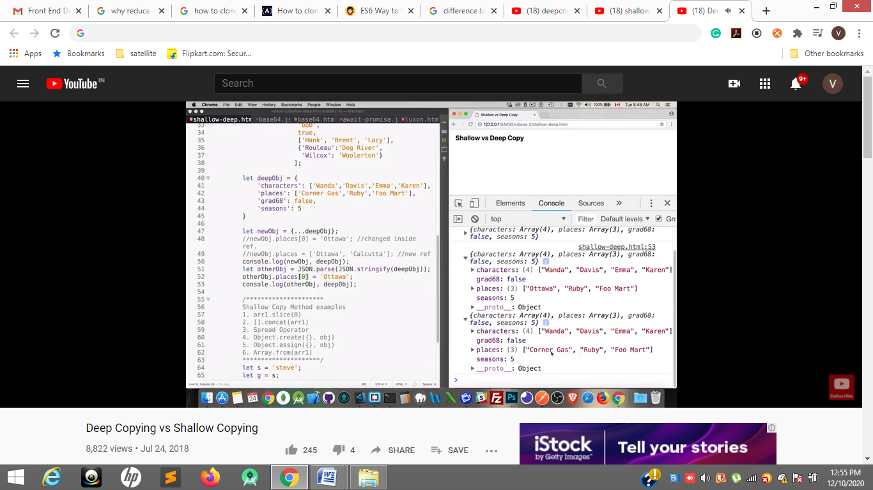

51 line deep copy JSON.parse(JSON.stringify(objectOne));

Recursive function

<https://www.javascripttutorial.net/javascript-recursive-function/>

